Java

What is Java?

Java is a **programming language** and a **platform**. Java is a high level, robust, object-oriented and secure programming language.

Java was developed by *Sun Microsystems* (which is now the subsidiary of Oracle) in the year 1995. *James Gosling* is known as the father of Java. Before Java, its name was *Oak*. Since Oak was already a registered company, so James Gosling and his team changed the name from Oak to Java.

## Types of Java Applications

There are mainly 4 types of applications that can be created using Java programming:

#### **1) Standalone Application**

Standalone applications are also known as desktop applications or window-based applications. These are traditional software that we need to install on every machine. Examples of standalone application are Media player, antivirus, etc. AWT and Swing are used in Java for creating standalone applications.

#### **2) Web Application**

An application that runs on the server side and creates a dynamic page is called a web application. Currently, [Servlet](https://www.javatpoint.com/servlet-tutorial), [JSP](https://www.javatpoint.com/jsp-tutorial), [Struts](https://www.javatpoint.com/struts-2-tutorial), [Spring](https://www.javatpoint.com/spring-tutorial), [Hibernate](https://www.javatpoint.com/hibernate-tutorial), [JSF](https://www.javatpoint.com/jsf-tutorial), etc. technologies are used for creating web applications in Java.

#### **3) Enterprise Application**

An application that is distributed in nature, such as banking applications, etc. is called an enterprise application. It has advantages like high-level security, load balancing, and clustering. In Java, [EJB](https://www.javatpoint.com/ejb-tutorial) is used for creating enterprise applications.

#### **4) Mobile Application**

An application which is created for mobile devices is called a mobile application. Currently, Android and Java ME are used for creating mobile applications.

Features of Java:

### **Simple**

Java is very easy to learn, and its syntax is simple, clean and easy to understand. According to Sun Microsystem, Java language is a simple programming language because:

* Java syntax is based on C++ (so easier for programmers to learn it after C++).
* Java has removed many complicated and rarely-used features, for example, explicit pointers, operator overloading, etc.
* There is no need to remove unreferenced objects because there is an Automatic Garbage Collection in Java.

### **Object-oriented**

Java is an [object-oriented](https://www.javatpoint.com/java-oops-concepts) programming language. Everything in Java is an object. Object-oriented means we organize our software as a combination of different types of objects that incorporate both data and behavior.

Play Videox[](https://campaign.adpushup.com/get-started/?utm_source=banner&utm_campaign=growth_hack)

Object-oriented programming (OOPs) is a methodology that simplifies software development and maintenance by providing some rules.

Basic concepts of OOPs are:

1. [Object](https://www.javatpoint.com/object-and-class-in-java)
2. [Class](https://www.javatpoint.com/object-and-class-in-java#class)
3. [Inheritance](https://www.javatpoint.com/inheritance-in-java)
4. [Polymorphism](https://www.javatpoint.com/runtime-polymorphism-in-java)
5. [Abstraction](https://www.javatpoint.com/abstract-class-in-java)
6. [Encapsulation](https://www.javatpoint.com/encapsulation)

### **Platform Independent**

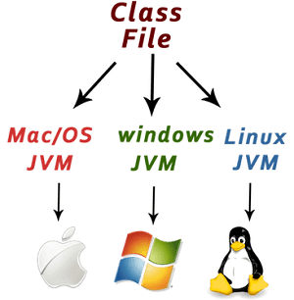

Java is platform independent because it is different from other languages like [C](https://www.javatpoint.com/c-programming-language-tutorial), [C++](https://www.javatpoint.com/cpp-tutorial), etc. which are compiled into platform specific machines while Java is a write once, run anywhere language. A platform is the hardware or software environment in which a program runs.

There are two types of platforms software-based and hardware-based. Java provides a software-based platform.

The Java platform differs from most other platforms in the sense that it is a software-based platform that runs on top of other hardware-based platforms. It has two components:

1. Runtime Environment
2. API(Application Programming Interface)

Java code can be executed on multiple platforms, for example, Windows, Linux, Sun Solaris, Mac/OS, etc. Java code is compiled by the compiler and converted into bytecode. This bytecode is a platform-independent code because it can be run on multiple platforms, i.e., Write Once and Run Anywhere (WORA).

### **Secured**

Java is best known for its security. With Java, we can develop virus-free systems. Java is secured because:

* **No explicit pointer**
* **Java Programs run inside a virtual machine sandbox**

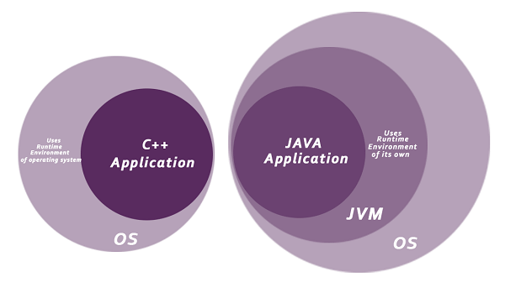

* **Classloader:** Classloader in Java is a part of the Java Runtime Environment (JRE) which is used to load Java classes into the Java Virtual Machine dynamically. It adds security by separating the package for the classes of the local file system from those that are imported from network sources.
* **Bytecode Verifier:** It checks the code fragments for illegal code that can violate access rights to objects.
* **Security Manager:** It determines what resources a class can access such as reading and writing to the local disk.

Java language provides these securities by default. Some security can also be provided by an application developer explicitly through SSL, JAAS, Cryptography, etc.

### **Robust**

The English mining of Robust is strong. Java is robust because:

* It uses strong memory management.
* There is a lack of pointers that avoids security problems.
* Java provides automatic garbage collection which runs on the Java Virtual Machine to get rid of objects which are not being used by a Java application anymore.
* There are exception handling and the type checking mechanism in Java. All these points make Java robust.

### **Architecture-neutral**

Java is architecture neutral because there are no implementation dependent features, for example, the size of primitive types is fixed.

In C programming, int data type occupies 2 bytes of memory for 32-bit architecture and 4 bytes of memory for 64-bit architecture. However, it occupies 4 bytes of memory for both 32 and 64-bit architectures in Java.

### **Portable**

Java is portable because it facilitates you to carry the Java bytecode to any platform. It doesn't require any implementation.

### **High-performance**

Java is faster than other traditional interpreted programming languages because Java bytecode is "close" to native code. It is still a little bit slower than a compiled language (e.g., C++). Java is an interpreted language that is why it is slower than compiled languages, e.g., C, C++, etc.

### **Distributed**

Java is distributed because it facilitates users to create distributed applications in Java. RMI and EJB are used for creating distributed applications. This feature of Java makes us able to access files by calling the methods from any machine on the internet.

### **Multi-threaded**

A thread is like a separate program, executing concurrently. We can write Java programs that deal with many tasks at once by defining multiple threads. The main advantage of multi-threading is that it doesn't occupy memory for each thread. It shares a common memory area. Threads are important for multi-media, Web applications, etc.

### **Dynamic**

Java is a dynamic language. It supports the dynamic loading of classes. It means classes are loaded on demand. It also supports functions from its native languages, i.e., C and C++.

### **Difference between JDK and JRE**

**JRE** : The Java Runtime Environment (JRE) provides the libraries, the Java Virtual Machine, and other components to run applets and applications written in the Java programming language. JRE does not contain tools and utilities such as compilers or debuggers for developing applets and applications.

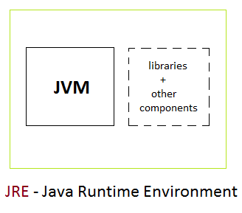

**JDK** : The JDK also called Java Development Kit is a superset of the JRE, and contains everything that is in the JRE, plus tools such as the compilers and debuggers necessary for developing applets and applications.

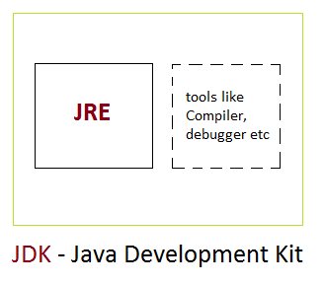

JVM:

Java virtual Machine(JVM) is a virtual Machine that provides runtime environment to execute java byte code. The JVM doesn't understand Java typo, that's why you compile your \*.java files to obtain \*.class files that contain the bytecodes understandable by the JVM.

JVM control execution of every Java program.

## JVM Architecture

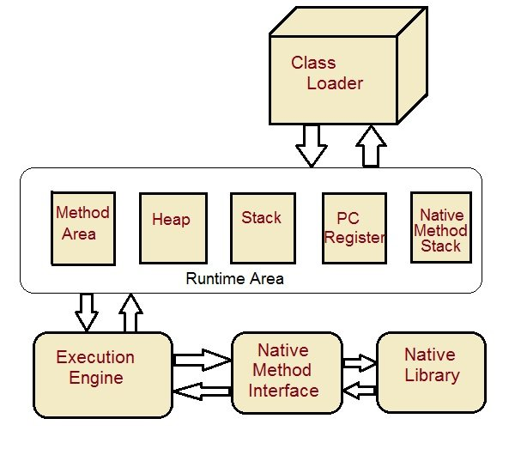

**Class Loader :** Class loader loads the Class for execution.

**Method area :** Stores pre-class structure as constant pool.

**Heap :** Heap is a memory area in which objects are allocated.

**Stack :** Local variables and partial results are store here. Each thread has a private JVM stack created when the thread is created.

**Program register :** Program register holds the address of JVM instruction currently being executed.

**Native method stack :** It contains all native used in application.

**Executive Engine :** Execution engine controls the execute of instructions contained in the methods of the classes.

**Native Method Interface :** Native method interface gives an interface between java code and native code during execution.

**Native Method Libraries :** Native Libraries consist of files required for the execution of native code.

Example:

**public** **class** Hello {

**public** **static** **void** main(String[] args) {

System.***out***.println("hello");

}

}

## Steps to Compile and Run your first Java program

**Step 1:** Open a text editor and write the code as above.

**Step 2:** Save the file as Hello.java

**Step 3:** Open command prompt and go to the directory where you saved your first java program assuming it is saved in C drive.

**Step 4:** Type javac Hello.java and press Return**(Enter KEY)** to compile your code. This command will call the Java Compiler asking it to compile the specified file. If there are no errors in the code the command prompt will take you to the next line.

**Step 5:** Now type java Hello on command prompt to run your program.

**Step 6:** You will be able to see **Hello world program** printed on your command prompt.

## Hello World Program using Eclipse

Eclipse is an IDE (Integrated Development Environment) which is used to develop applications. It is design and developed by Eclipse foundation, if you don’t have eclipse download, then download it from its official site by following this download link [Download Eclipse from here](https://www.eclipse.org/downloads/) Here we will see how to create and run **hello world** program using eclipse IDE. It require following steps that consists of **creating project, class file, writing code, running code etc**.

#### **Run Eclipse and Create Project**

Open eclipse startup and then create new project. To create project click on **File** menu and select **Java project** option. It will open a window that ask for project name. Provide the project name and click on the finish button. See the below screenshot.

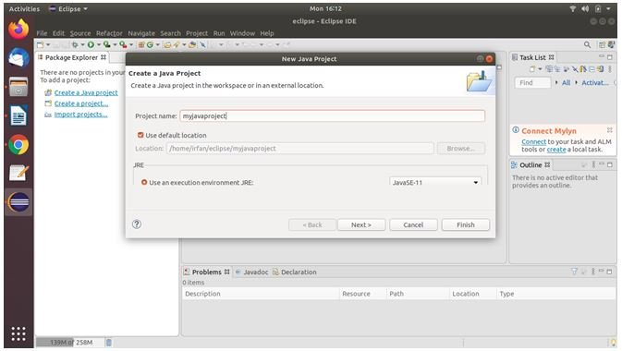

After creating project, we can see our new created project in the left side bar that looks like below.

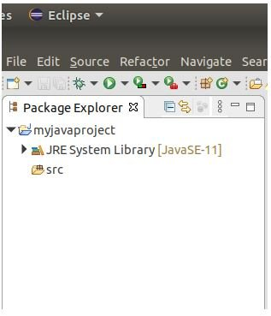

### **Create Java Class**

Now create Java class file by **right click** on the **project** and **select class** file option. It will open a window to ask for class name, provide the class name and click on finish button.

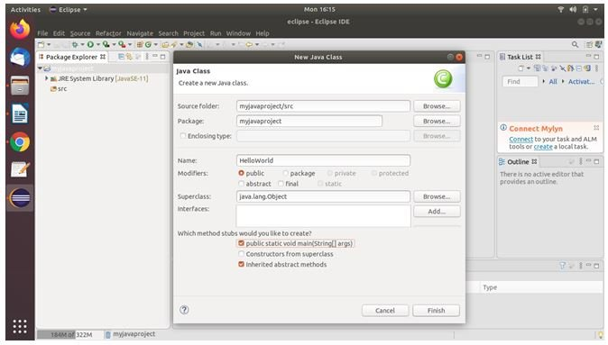

### **Write Hello World**

The above created class file includes some line of codes including main method as well. Now we need to write just print statement to print Hello World message.

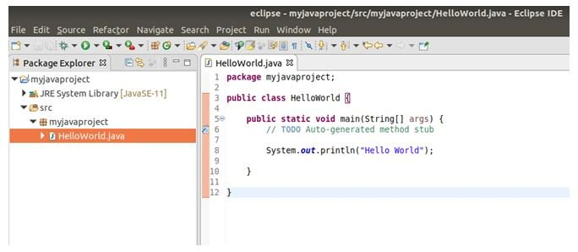

### **Run The Program**

Now run the program by selecting **Run** menu from the menu bar or use **Ctrl+F11** button combination. After running, it will print Hello World to the console which is just bottom to the program window.

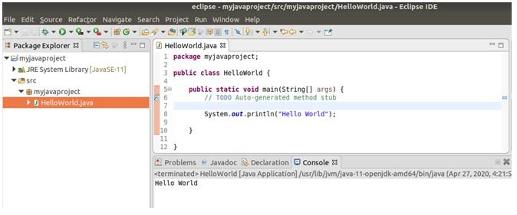

This is a simple program that we run here while using IDE we can create and build large scale of applications. If you are a beginner and not familiar to the Eclipse then don’t worry it is very easy to operate just follow the above steps to create the program.

### **Creating Hello World Example**

Let's create the hello java program:

1. **class** Simple{
2. **public** **static** **void** main(String args[]){
3. System.out.println("Hello Java");
4. }
5. }

[**Test it Now**](https://www.javatpoint.com/opr/test.jsp?filename=Simple)

Save the above file as Simple.java.

|  |  |
| --- | --- |
| **To compile:** | javac Simple.java |
| **To execute:** | java Simple |

**Output:**

Hello Java

## Parameters used in First Java Program

Let's see what is the meaning of class, public, static, void, main, String[], System.out.println().

* **class** keyword is used to declare a class in Java.
* **public** keyword is an access modifier that represents visibility. It means it is visible to all.
* **static** is a keyword. If we declare any method as static, it is known as the static method. The core advantage of the static method is that there is no need to create an object to invoke the static method. The main() method is executed by the JVM, so it doesn't require creating an object to invoke the main() method. So, it saves memory.
* **void** is the return type of the method. It means it doesn't return any value.
* **main** represents the starting point of the program.
* **String[] args** or **String args[]** is used for [command line argument](https://www.javatpoint.com/command-line-argument). We will discuss it in coming section.
* **System.out.println()** is used to print statement. Here, System is a class, out is an object of the PrintStream class, println() is a method of the PrintStream class. We will discuss the internal working of [System.out.println()](https://www.javatpoint.com/system-out-println-in-java) statement in the coming section.

## What happens at compile time?

At compile time, the Java file is compiled by Java Compiler (It does not interact with OS) and converts the Java code into bytecode.

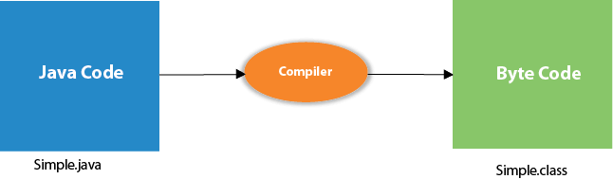

## What happens at runtime?

At runtime, the following steps are performed:

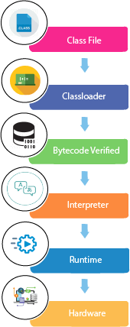

**Classloader:** It is the subsystem of JVM that is used to load class files.

Play Videox

**Bytecode Verifier:** Checks the code fragments for illegal code that can violate access rights to objects.

**Interpreter:** Read bytecode stream then execute the instructions.

Example1:

**package** com.Employee;

**public** **class** Student {

**int** rollno=20;

String address="hyd";

**int** age=28;

**void** display() {

System.***out***.println(rollno+" "+address+" "+age);

}

**static** **void** display1() {

System.***out***.println("this is static method");

}

**public** **static** **void** main(String[] args) {

Student st=**new** Student();

st.display();

Student.*display1*();

System.***out***.println(st.address);

System.***out***.println(st.age);

}

}

Day2:

Access Modifiers:

There are four types of Java access modifiers:

* 1. **Private**: The access level of a private modifier is only within the class. It cannot be accessed from outside the class.
* Example:

|  |
| --- |
| * // Java program to illustrate error while * // using class from different package with * // private modifier * **package** p1; * **class** A * { * **private** **void** display() * { * System.out.println("GeeksforGeeks"); * } * } * **class** B * { * **public** **static** **void** main(String args[]) * { * A obj = **new** A(); * // Trying to access private method * // of another class * obj.display(); * } * } |

**Output:**

error: display() has private access in A

obj.display();

**2.Public**: The access level of a public modifier is everywhere. It can be accessed from within the class, outside the class, within the package and outside the package.

Example:

|  |
| --- |
| // Java program to illustrate  // public modifier  **package** p1;  **public** **class** A  {  **public** **void** display()      {          System.out.println("GeeksforGeeks");      }  } |

* Java

|  |
| --- |
| **package** p2;  **import** p1.\*;  **class** B {  **public** **static** **void** main(String args[])      {          A obj = **new** A();          obj.display();      }  } |

**Output:**

GeeksforGeeks

**3.Default**: The access level of a default modifier is only within the package. It cannot be accessed from outside the package.

Example:

|  |
| --- |
| // Java program to illustrate default modifier  **package** p1;    // Class Geeks is having Default access modifier  **class** Geek  {  **void** display()      {          System.out.println("Hello World!");      }  } |

* Java

|  |
| --- |
| // Java program to illustrate error while  // using class from different package with  // default modifier  **package** p2;  **import** p1.\*;    // This class is having default access modifier  **class** GeekNew  {  **public** **static** **void** main(String args[])      {          // Accessing class Geek from package p1          Geeks obj = **new** Geek();            obj.display();      }  } |

**4.Protected**: The access level of a protected modifier is within the package and outside the package through child class

Example:

|  |
| --- |
| // Java program to illustrate  // protected modifier  **package** p1;    // Class A  **public** **class** A  {  **protected** **void** display()      {          System.out.println("GeeksforGeeks");      }  } |

* Java

|  |
| --- |
| // Java program to illustrate  // protected modifier  **package** p2;  **import** p1.\*; // importing all classes in package p1    // Class B is subclass of A  **class** B **extends** A  {  **public** **static** **void** main(String args[])  {      B obj = **new** B();      obj.display();  }    } |

**Output:**

GeeksforGeeks

DataTypes:

There are two types of data types in Java:

1. **Primitive data types:** The primitive data types include boolean, char, byte, short, int, long, float and double.
2. **Non-primitive data types:** The non-primitive data types include [Classes](https://www.javatpoint.com/object-and-class-in-java), [Interfaces](https://www.javatpoint.com/interface-in-java), and [Arrays](https://www.javatpoint.com/array-in-java).

## 8 Primitive Data Types

### 1. boolean type

* The boolean data type has two possible values, either true or false.
* Default value: false.
* They are usually used for **true/false** conditions.

### Example 1: Java boolean data type

class Main {

public static void main(String[] args) {

boolean flag = true;

System.out.println(flag); // prints true

}

}

[Run Code](https://www.programiz.com/java-programming/online-compiler)

### 2. byte type

* The byte data type can have values from **-128** to **127** (8-bit signed two's complement integer).
* If it's certain that the value of a variable will be within -128 to 127, then it is used instead of int to save memory.
* Default value: 0

### Example 2: Java byte data type

class Main {

public static void main(String[] args) {

byte range;

range = 124;

System.out.println(range); // prints 124

}

}

[Run Code](https://www.programiz.com/java-programming/online-compiler)

### 3. short type

* The short data type in Java can have values from **-32768** to **32767** (16-bit signed two's complement integer).
* If it's certain that the value of a variable will be within -32768 and 32767, then it is used instead of other integer data types (int, long).
* Default value: 0

### Example 3: Java short data type

class Main {

public static void main(String[] args) {

short temperature;

temperature = -200;

System.out.println(temperature); // prints -200

}

}

[Run Code](https://www.programiz.com/java-programming/online-compiler)

### 4. int type

* The int data type can have values from **-231** to **231-1** (32-bit signed two's complement integer).
* If you are using Java 8 or later, you can use an unsigned 32-bit integer. This will have a minimum value of 0 and a maximum value of 232-1. To learn more, visit [How to use the unsigned integer in java 8?](http://stackoverflow.com/questions/25556017/how-to-use-the-unsigned-integer-in-java-8)
* Default value: 0

### Example 4: Java int data type

class Main {

public static void main(String[] args) {

int range = -4250000;

System.out.println(range); // print -4250000

}

}

[Run Code](https://www.programiz.com/java-programming/online-compiler)

### 5. long type

* The long data type can have values from **-263** to **263-1** (64-bit signed two's complement integer).
* If you are using Java 8 or later, you can use an unsigned 64-bit integer with a minimum value of **0** and a maximum value of **264-1**.
* Default value: 0

### Example 5: Java long data type

class LongExample {

public static void main(String[] args) {

long range = -42332200000L;

System.out.println(range); // prints -42332200000

}

}

[Run Code](https://www.programiz.com/java-programming/online-compiler)

Notice, the use of L at the end of -42332200000. This represents that it's an integer of the long type.

### 6. double type

* The double data type is a double-precision 64-bit floating-point.
* It should never be used for precise values such as currency.
* Default value: 0.0 (0.0d)

### Example 6: Java double data type

class Main {

public static void main(String[] args) {

double number = -42.3;

System.out.println(number); // prints -42.3

}

}

[Run Code](https://www.programiz.com/java-programming/online-compiler)

### 7. float type

* The float data type is a single-precision 32-bit floating-point. Learn more about [single-precision and double-precision floating-point](http://stackoverflow.com/questions/801117/whats-the-difference-between-a-single-precision-and-double-precision-floating-p) if you are interested.
* It should never be used for precise values such as currency.
* Default value: 0.0 (0.0f)

### Example 7: Java float data type

class Main {

public static void main(String[] args) {

float number = -42.3f;

System.out.println(number); // prints -42.3

}

}

[Run Code](https://www.programiz.com/java-programming/online-compiler)

Notice that we have used -42.3f instead of -42.3in the above program. It's because -42.3 is a double literal.

To tell the compiler to treat -42.3 as float rather than double, you need to use f or F.

If you want to know about single-precision and double-precision,

### 8. char type

* It's a 16-bit Unicode character.
* The minimum value of the char data type is '\u0000' (0) and the maximum value of the is '\uffff'.
* Default value: '\u0000'

### Example 8: Java char data type

class Main {

public static void main(String[] args) {

char letter = '\u0051';

System.out.println(letter); // prints Q

}

}

[Run Code](https://www.programiz.com/java-programming/online-compiler)

Here, the Unicode value of Q is **\u0051**. Hence, we get Q as the output.

Here is another example:

class Main {

public static void main(String[] args) {

char letter1 = '9';

System.out.println(letter1); // prints 9

char letter2 = 65;

System.out.println(letter2); // prints A

}

}

[Run Code](https://www.programiz.com/java-programming/online-compiler)

Here, we have assigned 9 as a character (specified by single quotes) to the letter1 variable. However, the letter2 variable is assigned 65 as an integer number (no single quotes).

Hence, A is printed to the output. It is because Java treats characters as an integer and the ASCII value of A is 65.

### String type

Java also provides support for character strings via java.lang.String class. Strings in Java are not primitive types. Instead, they are objects. For example,

String myString = "Java Programming";

Here, myString is an object of the String class.

Methods:

Example:

**package** com.Employee;

**public** **class** Student {

**int** x=10;

**int** y=20;

**public** **void** display()

{

System.***out***.println("sssss");

}

**public** **int** add() {

**int** z=x+y;

**return** z;

}

**public** **int** sum(**int** z,**int** c)

{

**int** s=z+c;

**return** s;

}

**public** **static** **void** main(String[] args) {

Student st=**new** Student();

st.display();

**int** m= st.add();

System.***out***.println(m);

**int** d=st.sum(50,70);

System.***out***.println(d);

}

}

In Java, there are two types of methods:

* **User-defined Methods**: We can create our own method based on our requirements.
* **Standard Library Methods**: These are built-in methods in Java that are available to use.

Let's first learn about user-defined methods.

## Declaring a Java Method

The syntax to declare a method is:

returnType methodName() {

// method body

}

Here,

* **returnType** - It specifies what type of value a method returns For example if a method has an int return type then it returns an integer value.  
    
  If the method does not return a value, its return type is void.
* **methodName** - It is an [identifier](https://www.programiz.com/java-programming/keywords-identifiers#identifiers) that is used to refer to the particular method in a program.
* **method body** - It includes the programming statements that are used to perform some tasks. The method body is enclosed inside the curly braces { }.

For example,

int addNumbers() {

// code

}

In the above example, the name of the method is adddNumbers(). And, the return type is int.

This is the simple syntax of declaring a method. However, the complete syntax of declaring a method is

modifier static returnType nameOfMethod (parameter1, parameter2, ...) {

// method body

}

Here,

* **modifier** - It defines access types whether the method is public, private, and so on. To learn more, visit [Java Access Specifier](https://www.programiz.com/java-programming/access-modifiers).
* **static** - If we use the static keyword, it can be accessed without creating objects.  
    
  For example, the sqrt() method of standard [Math class](https://docs.oracle.com/javase/8/docs/api/java/lang/Math.html) is static. Hence, we can directly call Math.sqrt() without creating an instance of Math class.
* **parameter1/parameter2** - These are values passed to a method. We can pass any number of arguments to a method.

## Calling a Method in Java

In the above example, we have declared a method named addNumbers(). Now, to use the method, we need to call it.

Here's is how we can call the addNumbers() method.

// calls the method

addNumbers();

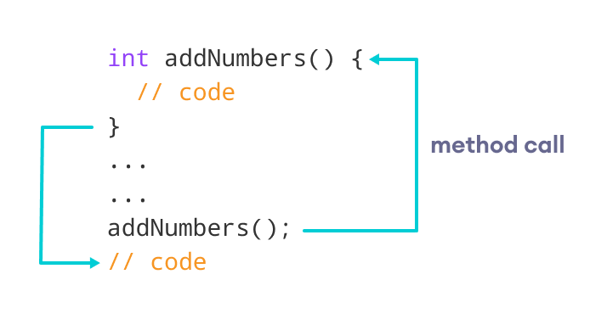Working of Java Method Call

## Example 1: Java Methods

class Main {

// create a method

public int addNumbers(int a, int b) {

int sum = a + b;

// return value

return sum;

}

public static void main(String[] args) {

int num1 = 25;

int num2 = 15;

// create an object of Main

Main obj = new Main();

// calling method

int result = obj.addNumbers(num1, num2);

System.out.println("Sum is: " + result);

}

}

[Run Code](https://www.programiz.com/java-programming/online-compiler)

**Output**

Sum is: 40

In the above example, we have created a method named addNumbers(). The method takes two parameters a and b. Notice the line,

int result = obj.addNumbers(num1, num2);

Here, we have called the method by passing two arguments num1 and num2. Since the method is returning some value, we have stored the value in the result variable.

**Note**: The method is not static. Hence, we are calling the method using the object of the class.

## Java Method Return Type

A Java method may or may not return a value to the function call. We use the **return statement** to return any value. For example,

int addNumbers() {

...

return sum;

}

Here, we are returning the variable sum. Since the return type of the function is int. The sum variable should be of int type. Otherwise, it will generate an error.

### Example 2: Method Return Type

class Main {

// create a method

public static int square(int num) {

// return statement

return num \* num;

}

public static void main(String[] args) {

int result;

// call the method

// store returned value to result

result = square(10);

System.out.println("Squared value of 10 is: " + result);

}

}

[Run Code](https://www.programiz.com/java-programming/online-compiler)

**Output**:

Squared value of 10 is: 100

In the above program, we have created a method named square(). The method takes a number as its parameter and returns the square of the number.

Here, we have mentioned the return type of the method as int. Hence, the method should always return an integer value.

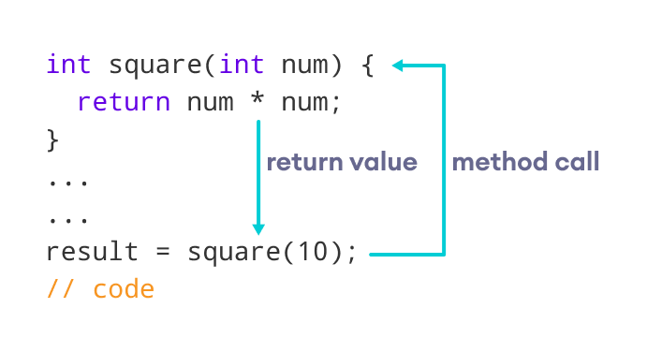Representation of the Java method returning a value

**Note**: If the method does not return any value, we use the void keyword as the return type of the method. For example,

public void square(int a) {

int square = a \* a;

System.out.println("Square is: " + square);

}

## Method Parameters in Java

A method parameter is a value accepted by the method. As mentioned earlier, a method can also have any number of parameters. For example,

// method with two parameters

int addNumbers(int a, int b) {

// code

}

// method with no parameter

int addNumbers(){

// code

}

If a method is created with parameters, we need to pass the corresponding values while calling the method. For example,

// calling the method with two parameters

addNumbers(25, 15);

// calling the method with no parameters

addNumbers()

### Example 3: Method Parameters

class Main {

// method with no parameter

public void display1() {

System.out.println("Method without parameter");

}

// method with single parameter

public void display2(int a) {

System.out.println("Method with a single parameter: " + a);

}

public static void main(String[] args) {

// create an object of Main

Main obj = new Main();

// calling method with no parameter

obj.display1();

// calling method with the single parameter

obj.display2(24);

}

}

[Run Code](https://www.programiz.com/java-programming/online-compiler)

**Output**

Method without parameter

Method with a single parameter: 24

Here, the parameter of the method is int. Hence, if we pass any other data type instead of int, the compiler will throw an error. It is because Java is a strongly typed language.

**Note**: The argument 24 passed to the display2() method during the method call is called the actual argument.

The parameter num accepted by the method definition is known as a formal argument. We need to specify the type of formal arguments. And, the type of actual arguments and formal arguments should always match.

## Standard Library Methods

The standard library methods are built-in methods in Java that are readily available for use. These standard libraries come along with the Java Class Library (JCL) in a Java archive (\*.jar) file with JVM and JRE.

For example,

* print() is a method of java.io.PrintSteam. The print("...") method prints the string inside quotation marks.
* sqrt() is a method of Math class. It returns the square root of a number.

Here's a working example:

### Example 4: Java Standard Library Method

public class Main {

public static void main(String[] args) {

// using the sqrt() method

System.out.print("Square root of 4 is: " + Math.sqrt(4));

}

}

[Run Code](https://www.programiz.com/java-programming/online-compiler)

**Output**:

Square root of 4 is: 2.0

To learn more about standard library methods, visit [Java Library Methods](https://www.programiz.com/java-programming/library).

## What are the advantages of using methods?

**1.** The main advantage is **code reusability**. We can write a method once, and use it multiple times. We do not have to rewrite the entire code each time. Think of it as, "write once, reuse multiple times".

### Example 5: Java Method for Code Reusability

public class Main {

// method defined

private static int getSquare(int x){

return x \* x;

}

public static void main(String[] args) {

for (int i = 1; i <= 5; i++) {

// method call

int result = getSquare(i);

System.out.println("Square of " + i + " is: " + result);

}

}

}

[Run Code](https://www.programiz.com/java-programming/online-compiler)

**Output**:

Square of 1 is: 1

Square of 2 is: 4

Square of 3 is: 9

Square of 4 is: 16

Square of 5 is: 25

In the above program, we have created the method named getSquare() to calculate the square of a number. Here, the method is used to calculate the square of numbers less than **6**.

Hence, the same method is used again and again.

**2.** Methods make code more **readable and easier** to debug. Here, the getSquare() method keeps the code to compute the square in a block. Hence, makes it more readable.

## What is a Constructor?

A constructor in Java is similar to a method that is invoked when an object of the class is created.

 a constructor has the same name as that of the class and does not have any return type. For example,

class Test {

Test() {

// constructor body

}

}

Here, Test() is a constructor. It has the same name as that of the class and doesn't have a return type.

It is a special type of method which is used to initialize the object.

Every time an object is created using the new() keyword, at least one constructor is called.

It calls a default constructor if there is no constructor available in the class. In such case, Java compiler provides a default constructor by default.

### **Rules for creating Java constructor**

There are two rules defined for the constructor.

1. Constructor name must be the same as its class name
2. A Constructor must have no explicit return type
3. A Java constructor cannot be abstract, static, final, and synchronized

### Types of Constructor

In Java, constructors can be divided into 3 types:

1. No-Arg Constructor
2. Parameterized Constructor
3. Default Constructor

## 1. Java No-Arg Constructors

Similar to methods, a Java constructor may or may not have any parameters (arguments).

If a constructor does not accept any parameters, it is known as a no-argument constructor. For example,

private Constructor() {

// body of the constructor

}

### Example 2: Java private no-arg constructor

class Main {

int i;

// constructor with no parameter

private Main() {

i = 5;

System.out.println("Constructor is called");

}

public static void main(String[] args) {

// calling the constructor without any parameter

Main obj = new Main();

System.out.println("Value of i: " + obj.i);

}

}

[Run Code](https://www.programiz.com/java-programming/online-compiler)

**Output**:

Constructor is called

Value of i: 5

In the above example, we have created a constructor Main(). Here, the constructor does not accept any parameters. Hence, it is known as a no-arg constructor.

**Notice that we have declared the constructor as private.**

Once a constructor is declared private, it cannot be accessed from outside the class. So, creating objects from outside the class is prohibited using the private constructor.

Here, we are creating the object inside the same class. Hence, the program is able to access the constructor.

However, if we want to create objects outside the class, then we need to declare the constructor as public.

### Example 3: Java public no-arg constructors

class Company {

String name;

// public constructor

public Company() {

name = "Programiz";

}

}

class Main {

public static void main(String[] args) {

// object is created in another class

Company obj = new Company();

System.out.println("Company name = " + obj.name);

}

}

[Run Code](https://www.programiz.com/java-programming/online-compiler)

**Output**:

Company name = Programiz

## 2. Java Parameterized Constructor

A Java constructor can also accept one or more parameters. Such constructors are known as parameterized constructors (constructor with parameters).

### Example 4: Parameterized constructor

class Main {

String languages;

// constructor accepting single value

Main(String lang) {

languages = lang;

System.out.println(languages + " Programming Language");

}

public static void main(String[] args) {

// call constructor by passing a single value

Main obj1 = new Main("Java");

Main obj2 = new Main("Python");

Main obj3 = new Main("C");

}

}

[Run Code](https://www.programiz.com/java-programming/online-compiler)

**Output**:

Java Programming Language

Python Programming Language

C Programming Language

In the above example, we have created a constructor named Main(). Here, the constructor takes a single parameter. Notice the expression,

Main obj1 = new Main("Java");

Here, we are passing the single value to the constructor. Based on the argument passed, the language variable is initialized inside the constructor.

## 3. Java Default Constructor

If we do not create any constructor, the Java compiler automatically create a no-arg constructor during the execution of the program. This constructor is called default constructor.

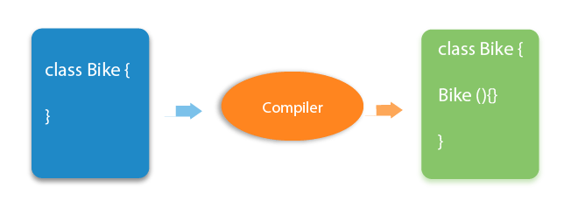

### Example 5: Default Constructor

class Main {

int a;

boolean b;

public static void main(String[] args) {

// A default constructor is called

Main obj = new Main();

System.out.println("Default Value:");

System.out.println("a = " + obj.a);

System.out.println("b = " + obj.b);

}

}

[Run Code](https://www.programiz.com/java-programming/online-compiler)

**Output**:

Default Value:

a = 0

b = false

Here, we haven't created any constructors. Hence, the Java compiler automatically creates the default constructor.

The default constructor initializes any uninitialized instance variables with default values.

|  |  |
| --- | --- |
| Type | Default Value |
| Boolean | False |
| Byte | 0 |
| Short | 0 |
| Int | 0 |
| Long | 0L |
| Char | \u0000 |
| Float | 0.0f |
| Double | 0.0d |
| Object | Reference null |

In the above program, the variables a and b are initialized with default value **0** and false respectively.

The above program is equivalent to:

class Main {

int a;

boolean b;

Main() {

a = 0;

b = false;

}

public static void main(String[] args) {

// call the constructor

Main obj = new Main();

System.out.println("Default Value:");

System.out.println("a = " + obj.a);

System.out.println("b = " + obj.b);

}

}

[Run Code](https://www.programiz.com/java-programming/online-compiler)

**The output of the program is the same as Example 5.**

## Important Notes on Java Constructors

* Constructors are invoked implicitly when you instantiate objects.
* The two rules for creating a constructor are:  
  The name of the constructor should be the same as the class.  
  A Java constructor must not have a return type.
* If a class doesn't have a constructor, the Java compiler automatically creates a **default constructor** during run-time. The default constructor initializes instance variables with default values. For example, the int variable will be initialized to 0
* Constructor types:  
  **No-Arg Constructor** - a constructor that does not accept any arguments  
  **Parameterized constructor** - a constructor that accepts arguments  
  **Default Constructor** - a constructor that is automatically created by the Java compiler if it is not explicitly defined.
* A constructor cannot be abstract or static or final.
* A constructor can be overloaded but can not be overridden.

## Constructors Overloading in Java

Similar to [Java method overloading](https://www.programiz.com/java-programming/method-overloading), we can also create two or more constructors with different parameters. This is called constructors overloading.

### Example 6: Java Constructor Overloading

class Main {

String language;

// constructor with no parameter

Main() {

this.language = "Java";

}

// constructor with a single parameter

Main(String language) {

this.language = language;

}

public void getName() {

System.out.println("Programming Langauage: " + this.language);

}

public static void main(String[] args) {

// call constructor with no parameter

Main obj1 = new Main();

// call constructor with a single parameter

Main obj2 = new Main("Python");

obj1.getName();

obj2.getName();

}

}

[Run Code](https://www.programiz.com/java-programming/online-compiler)

**Output**:

Programming Language: Java

Programming Language: Python

In the above example, we have two constructors: Main() and Main(String language). Here, both the constructor initialize the value of the variable language with different values.

## Difference between constructor and method in Java

There are many differences between constructors and methods. They are given below.

|  |  |
| --- | --- |
| **Java Constructor** | **Java Method** |
| A constructor is used to initialize the state of an object. | A method is used to expose the behavior of an object. |
| A constructor must not have a return type. | A method must have a return type. |
| The constructor is invoked implicitly. | The method is invoked explicitly. |
| The Java compiler provides a default constructor if you don't have any constructor in a class. | The method is not provided by the compiler in any case. |
| The constructor name must be same as the class name. | The method name may or may not be same as the class name. |

TypeCasting:

In Java, **type casting** is a method or process that converts a data type into another data type in both ways manually and automatically.

Type casting is when you assign a value of one primitive data type to another type.

Order:

byte -> short -> char -> int -> long -> float -> double

* **Widening Casting** (automatically) - converting a smaller type to a larger type size  
  byte -> short -> char -> int -> long -> float -> double
* **Narrowing Casting** (manually) - converting a larger type to a smaller size type  
  double -> float -> long -> int -> char -> short -> byte

**WideningTypeCastingExample.java**

1. **public** **class** WideningTypeCastingExample
2. {
3. **public** **static** **void** main(String[] args)
4. {
5. **int** x = 7;
6. //automatically converts the integer type into long type
7. **long** y = x;
8. //automatically converts the long type into float type
9. **float** z = y;
10. System.out.println("Before conversion, int value "+x);
11. System.out.println("After conversion, long value "+y);
12. System.out.println("After conversion, float value "+z);
13. }
14. }

**Output**

Before conversion, the value is: 7

After conversion, the long value is: 7

After conversion, the float value is: 7.0

In the above example, we have taken a variable x and converted it into a long type. After that, the long type is converted into the float type.

### **Narrowing Type Casting**

Converting a higher data type into a lower one is called **narrowing** type casting. It is also known as **explicit conversion** or **casting up**. It is done manually by the programmer. If we do not perform casting then the compiler reports a compile-time error.

1. **double** -> **float** -> **long** -> **int** -> **char** -> **short** -> **byte**

Let's see an example of narrowing type casting.

In the following example, we have performed the narrowing type casting two times. First, we have converted the double type into long data type after that long data type is converted into int type.

**NarrowingTypeCastingExample.java**

1. **public** **class** NarrowingTypeCastingExample
2. {
3. **public** **static** **void** main(String args[])
4. {
5. **double** d = 166.66;
6. //converting double data type into long data type
7. **long** l = (**long**)d;
8. //converting long data type into int data type
9. **int** i = (**int**)l;
10. System.out.println("Before conversion: "+d);
11. //fractional part lost
12. System.out.println("After conversion into long type: "+l);
13. //fractional part lost
14. System.out.println("After conversion into int type: "+i);
15. }
16. }

**Output**

Before conversion: 166.66

After conversion into long type: 166

After conversion into int type: 166

### **Types of Variables**

There are three types of variables in [Java](https://www.javatpoint.com/java-tutorial):

* local variable
* instance variable
* static variable

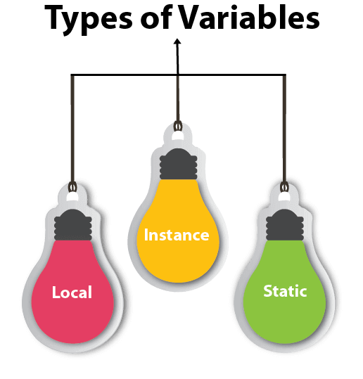

#### **1) Local Variable**

A variable declared inside the body of the method is called local variable. You can use this variable only within that method and the other methods in the class aren't even aware that the variable exists.

A local variable cannot be defined with "static" keyword.

#### **2) Instance Variable**

A variable declared inside the class but outside the body of the method, is called an

#### **3) Static variable**

A variable that is declared as static is called a static variable. It cannot be local. You can create a single copy of the static variable and share it among all the instances of the class. Memory allocation for static variables happens only once when the class is loaded in the memory.

### **Example to understand the types of variables in java**

1. **public** **class** A
2. {
3. **static** **int** m=100;//static variable
4. **void** method()
5. {
6. **int** n=90;//local variable
7. }
8. **public** **static** **void** main(String args[])
9. {
10. **int** data=50;//instance variable
11. }
12. }//end of class

### **Java Variable Example: Add Two Numbers**

1. **public** **class** Simple{
2. **public** **static** **void** main(String[] args){
3. **int** a=10;
4. **int** b=10;
5. **int** c=a+b;
6. System.out.println(c);
7. }
8. }

**Output:**

20

### **Java Variable Example: Widening**

1. **public** **class** Simple{
2. **public** **static** **void** main(String[] args){
3. **int** a=10;
4. **float** f=a;
5. System.out.println(a);
6. System.out.println(f);
7. }}

**Output:**

10

10.0

### **Java Variable Example: Narrowing (Typecasting)**

1. **public** **class** Simple{
2. **public** **static** **void** main(String[] args){
3. **float** f=10.5f;
4. //int a=f;//Compile time error
5. **int** a=(**int**)f;
6. System.out.println(f);
7. System.out.println(a);
8. }}

**Output:**

10.5

10

### **Java Variable Example: Overflow**

1. **class** Simple{
2. **public** **static** **void** main(String[] args){
3. //Overflow
4. **int** a=130;
5. **byte** b=(**byte**)a;
6. System.out.println(a);
7. System.out.println(b);
8. }}

**Output:**

130

-126

### **Java Variable Example: Adding Lower Type**

1. **class** Simple{
2. **public** **static** **void** main(String[] args){
3. **byte** a=10;
4. **byte** b=10;
5. //byte c=a+b;//Compile Time Error: because a+b=20 will be int
6. **byte** c=(**byte**)(a+b);
7. System.out.println(c);
8. }}

**Output:**

1. //Java Program to demonstrate the use of static variable
2. **class** Student{
3. **int** rollno;//instance variable
4. String name;
5. **static** String college ="ITS";//static variable
6. //constructor
7. Student(**int** r, String n){
8. rollno = r;
9. name = n;
10. }
11. //method to display the values
12. **void** display (){System.out.println(rollno+" "+name+" "+college);}
13. }
14. //Test class to show the values of objects
15. **public** **class** TestStaticVariable1{
16. **public** **static** **void** main(String args[]){
17. Student s1 = **new** Student(111,"Karan");
18. Student s2 = **new** Student(222,"Aryan");
19. //we can change the college of all objects by the single line of code
20. //Student.college="BBDIT";
21. s1.display();
22. s2.display();
23. }
24. }

[**Test it Now**](https://www.javatpoint.com/opr/test.jsp?filename=TestStaticVariable1)

Output:

111 Karan ITS

222 Aryan ITS

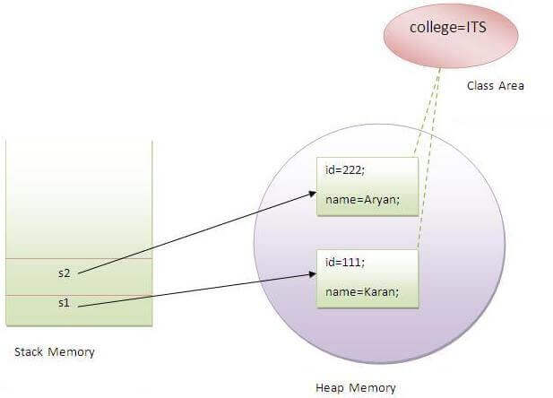

Java provides three types of control flow statements.

1. Decision Making statements
   * if statements
   * switch statement
2. Loop statements
   * do while loop
   * while loop
   * for loop
   * for-each loop
3. Jump statements
   * break statement
   * continue statement

### **Decision-Making statements:**

As the name suggests, decision-making statements decide which statement to execute and when. Decision-making statements evaluate the Boolean expression and control the program flow depending upon the result of the condition provided. There are two types of decision-making statements in Java, i.e., If statement and switch statement.

### **1) If Statement:**

In Java, the "if" statement is used to evaluate a condition. The control of the program is diverted depending upon the specific condition. The condition of the If statement gives a Boolean value, either true or false. In Java, there are four types of if-statements given below.

Play Videox[](https://campaign.adpushup.com/get-started/?utm_source=banner&utm_campaign=growth_hack)

1. Simple if statement
2. if-else statement
3. if-else-if ladder
4. Nested if-statement

Let's understand the if-statements one by one.

### **1) Simple if statement:**

It is the most basic statement among all control flow statements in Java. It evaluates a Boolean expression and enables the program to enter a block of code if the expression evaluates to true.

Syntax of if statement is given below.

1. **if**(condition) {
2. statement 1; //executes when condition is true
3. }

Consider the following example in which we have used the **if** statement in the java code.

Student.java

**Student.java**

1. **public** **class** Student {
2. **public** **static** **void** main(String[] args) {
3. **int** x = 10;
4. **int** y = 12;
5. **if**(x+y > 20) {
6. System.out.println("x + y is greater than 20");
7. }
8. }
9. }

**Output:**

x + y is greater than 20

### **2) if-else statement**

The [if-else statement](https://www.javatpoint.com/java-if-else) is an extension to the if-statement, which uses another block of code, i.e., else block. The else block is executed if the condition of the if-block is evaluated as false.

**Syntax:**

1. **if**(condition) {
2. statement 1; //executes when condition is true
3. }
4. **else**{
5. statement 2; //executes when condition is false
6. }

Consider the following example.

**Student.java**

1. **public** **class** Student {
2. **public** **static** **void** main(String[] args) {
3. **int** x = 10;
4. **int** y = 12;
5. **if**(x+y < 10) {
6. System.out.println("x + y is less than      10");
7. }   **else** {
8. System.out.println("x + y is greater than 20");
9. }
10. }
11. }

**Output:**

x + y is greater than 20

### **3) if-else-if ladder:**

The if-else-if statement contains the if-statement followed by multiple else-if statements. In other words, we can say that it is the chain of if-else statements that create a decision tree where the program may enter in the block of code where the condition is true. We can also define an else statement at the end of the chain.

Syntax of if-else-if statement is given below.

1. **if**(condition 1) {
2. statement 1; //executes when condition 1 is true
3. }
4. **else** **if**(condition 2) {
5. statement 2; //executes when condition 2 is true
6. }
7. **else** {
8. statement 2; //executes when all the conditions are false
9. }

Consider the following example.

**Student.java**

1. **public** **class** Student {
2. **public** **static** **void** main(String[] args) {
3. String city = "Delhi";
4. **if**(city == "Meerut") {
5. System.out.println("city is meerut");
6. }**else** **if** (city == "Noida") {
7. System.out.println("city is noida");
8. }**else** **if**(city == "Agra") {
9. System.out.println("city is agra");
10. }**else** {
11. System.out.println(city);
12. }
13. }
14. }

**Output:**

Delhi

### **4. Nested if-statement**

In nested if-statements, the if statement can contain a **if** or **if-else** statement inside another if or else-if statement.

Syntax of Nested if-statement is given below.

1. **if**(condition 1) {
2. statement 1; //executes when condition 1 is true
3. **if**(condition 2) {
4. statement 2; //executes when condition 2 is true
5. }
6. **else**{
7. statement 2; //executes when condition 2 is false
8. }
9. }

Consider the following example.

**Student.java**

1. **public** **class** Student {
2. **public** **static** **void** main(String[] args) {
3. String address = "Delhi, India";
5. **if**(address.endsWith("India")) {
6. **if**(address.contains("Meerut")) {
7. System.out.println("Your city is Meerut");
8. }**else** **if**(address.contains("Noida")) {
9. System.out.println("Your city is Noida");
10. }**else** {
11. System.out.println(address.split(",")[0]);
12. }
13. }**else** {
14. System.out.println("You are not living in India");
15. }
16. }
17. }

**Output:**

Delhi

### **Switch Statement:**

In Java, [Switch statements](https://www.javatpoint.com/java-switch) are similar to if-else-if statements. The switch statement contains multiple blocks of code called cases and a single case is executed based on the variable which is being switched. The switch statement is easier to use instead of if-else-if statements. It also enhances the readability of the program.

Points to be noted about switch statement:

* The case variables can be int, short, byte, char, or enumeration. String type is also supported since version 7 of Java
* Cases cannot be duplicate
* Default statement is executed when any of the case doesn't match the value of expression. It is optional.
* Break statement terminates the switch block when the condition is satisfied.  
  It is optional, if not used, next case is executed.
* While using switch statements, we must notice that the case expression will be of the same type as the variable. However, it will also be a constant value.

The syntax to use the switch statement is given below.

1. **switch** (expression){
2. **case** value1:
3. statement1;
4. **break**;
5. .
6. .
7. .
8. **case** valueN:
9. statementN;
10. **break**;
11. **default**:
12. **default** statement;
13. }

Consider the following example to understand the flow of the switch statement.

**Student.java**

1. **public** **class** Student **implements** Cloneable {
2. **public** **static** **void** main(String[] args) {
3. **int** num = 2;
4. **switch** (num){
5. **case** 0:
6. System.out.println("number is 0");
7. **break**;
8. **case** 1:
9. System.out.println("number is 1");
10. **break**;
11. **default**:
12. System.out.println(num);
13. }
14. }
15. }

**Output:**

2

While using switch statements, we must notice that the case expression will be of the same type as the variable. However, it will also be a constant value. The switch permits only int, string, and Enum type variables to be used.

### **Loop Statements**

In programming, sometimes we need to execute the block of code repeatedly while some condition evaluates to true. However, loop statements are used to execute the set of instructions in a repeated order. The execution of the set of instructions depends upon a particular condition.

In Java, we have three types of loops that execute similarly. However, there are differences in their syntax and condition checking time.

1. for loop
2. while loop
3. do-while loop

Let's understand the loop statements one by one.

### **Java for loop**

In Java, [for loop](https://www.javatpoint.com/java-for-loop) is similar to [C](https://www.javatpoint.com/c-programming-language-tutorial) and [C++](https://www.javatpoint.com/cpp-tutorial). It enables us to initialize the loop variable, check the condition, and increment/decrement in a single line of code. We use the for loop only when we exactly know the number of times, we want to execute the block of code.

1. **for**(initialization, condition, increment/decrement) {
2. //block of statements
3. }

The flow chart for the for-loop is given below.

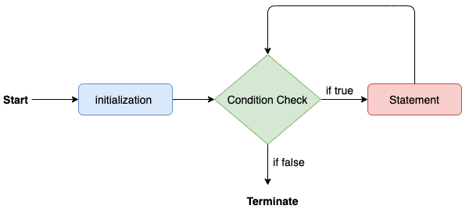

Consider the following example to understand the proper functioning of the for loop in java.

**Calculation.java**

1. **public** **class** Calculattion {
2. **public** **static** **void** main(String[] args) {
3. // TODO Auto-generated method stub
4. **int** sum = 0;
5. **for**(**int** j = 1; j<=10; j++) {
6. sum = sum + j;
7. }
8. System.out.println("The sum of first 10 natural numbers is " + sum);
9. }
10. }

**Output:**

The sum of first 10 natural numbers is 55

### **Java for-each loop**

Java provides an enhanced for loop to traverse the data structures like array or collection. In the for-each loop, we don't need to update the loop variable. The syntax to use the for-each loop in java is given below.

1. **for**(data\_type var : array\_name/collection\_name){
2. //statements
3. }

Consider the following example to understand the functioning of the for-each loop in Java.

**Calculation.java**

1. **public** **class** Calculation {
2. **public** **static** **void** main(String[] args) {
3. // TODO Auto-generated method stub
4. String[] names = {"Java","C","C++","Python","JavaScript"};
5. System.out.println("Printing the content of the array names:\n");
6. **for**(String name:names) {
7. System.out.println(name);
8. }
9. }
10. }

**Output:**

Printing the content of the array names:

Java

C

C++

Python

JavaScript

### **Java while loop**

The [while loop](https://www.javatpoint.com/java-while-loop) is also used to iterate over the number of statements multiple times. However, if we don't know the number of iterations in advance, it is recommended to use a while loop. Unlike for loop, the initialization and increment/decrement doesn't take place inside the loop statement in while loop.

It is also known as the entry-controlled loop since the condition is checked at the start of the loop. If the condition is true, then the loop body will be executed; otherwise, the statements after the loop will be executed.

The syntax of the while loop is given below.

1. **while**(condition){
2. //looping statements
3. }

The flow chart for the while loop is given in the following image.

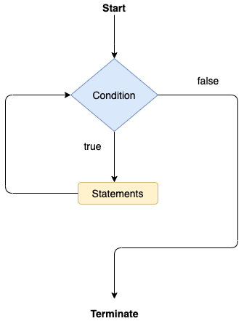

Consider the following example.

**Calculation .java**

1. **public** **class** Calculation {
2. **public** **static** **void** main(String[] args) {
3. // TODO Auto-generated method stub
4. **int** i = 0;
5. System.out.println("Printing the list of first 10 even numbers \n");
6. **while**(i<=10) {
7. System.out.println(i);
8. i = i + 2;
9. }
10. }
11. }

**Output:**

Printing the list of first 10 even numbers

0

2

4

6

8

10

### **Java do-while loop**

The [do-while loop](https://www.javatpoint.com/java-do-while-loop) checks the condition at the end of the loop after executing the loop statements. When the number of iteration is not known and we have to execute the loop at least once, we can use do-while loop.

It is also known as the exit-controlled loop since the condition is not checked in advance. The syntax of the do-while loop is given below.

1. **do**
2. {
3. //statements
4. } **while** (condition);

The flow chart of the do-while loop is given in the following image.

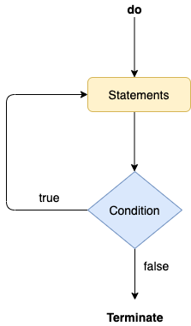

Consider the following example to understand the functioning of the do-while loop in Java.

**Calculation.java**

1. **public** **class** Calculation {
2. **public** **static** **void** main(String[] args) {
3. // TODO Auto-generated method stub
4. **int** i = 0;
5. System.out.println("Printing the list of first 10 even numbers \n");
6. **do** {
7. System.out.println(i);
8. i = i + 2;
9. }**while**(i<=10);
10. }
11. }

**Output:**

Printing the list of first 10 even numbers

0

2

4

6

8

10

### **Jump Statements**

Jump statements are used to transfer the control of the program to the specific statements. In other words, jump statements transfer the execution control to the other part of the program. There are two types of jump statements in Java, i.e., break and continue.

### **Java break statement**

As the name suggests, the [break statement](https://www.javatpoint.com/java-break) is used to break the current flow of the program and transfer the control to the next statement outside a loop or switch statement. However, it breaks only the inner loop in the case of the nested loop.

The break statement cannot be used independently in the Java program, i.e., it can only be written inside the loop or switch statement.

**The break statement example with for loop**

Consider the following example in which we have used the break statement with the for loop.

**BreakExample.java**

1. **public** **class** BreakExample {
3. **public** **static** **void** main(String[] args) {
4. // TODO Auto-generated method stub
5. **for**(**int** i = 0; i<= 10; i++) {
6. System.out.println(i);
7. **if**(i==6) {
8. **break**;
9. }
10. }
11. }
12. }

**Output:**

0

1

2

3

4

5

6

**break statement example with labeled for loop**

**Calculation.java**

1. **public** **class** Calculation {
3. **public** **static** **void** main(String[] args) {
4. // TODO Auto-generated method stub
5. a:
6. **for**(**int** i = 0; i<= 10; i++) {
7. b:
8. **for**(**int** j = 0; j<=15;j++) {
9. c:
10. **for** (**int** k = 0; k<=20; k++) {
11. System.out.println(k);
12. **if**(k==5) {
13. **break** a;
14. }
15. }
16. }
18. }
19. }

22. }

**Output:**

0

1

2

3

4

5

### **Java continue statement**

Unlike break statement, the [continue statement](https://www.javatpoint.com/java-continue) doesn't break the loop, whereas, it skips the specific part of the loop and jumps to the next iteration of the loop immediately.

Consider the following example to understand the functioning of the continue statement in Java.

1. **public** **class** ContinueExample {
3. **public** **static** **void** main(String[] args) {
4. // TODO Auto-generated method stub
6. **for**(**int** i = 0; i<= 2; i++) {
8. **for** (**int** j = i; j<=5; j++) {
10. **if**(j == 4) {
11. **continue**;
12. }
13. System.out.println(j);
14. }
15. }
16. }
18. }

**Output:**

0

1

2

3

5

1

2

3

5

2

3

5

# **Java Naming Convention:**

Naming Conventions of the Different Identifiers

The following table shows the popular conventions used for the different identifiers.

|  |  |  |
| --- | --- | --- |
| **Identifiers Type** | **Naming Rules** | **Examples** |
| Class | It should start with the uppercase letter. It should be a noun such as Color, Button, System, Thread, etc. Use appropriate words, instead of acronyms. | public class **Employee** { //code snippet } |
| Interface | It should start with the uppercase letter. It should be an adjective such as Runnable, Remote, ActionListener. Use appropriate words, instead of acronyms. | interface **Printable** { //code snippet } |
| Method | It should start with lowercase letter. It should be a verb such as main(), print(), println(). If the name contains multiple words, start it with a lowercase letter followed by an uppercase letter such as actionPerformed(). | class Employee { // method void **draw()** { //code snippet } } |
| Variable | It should start with a lowercase letter such as id, name. It should not start with the special characters like & (ampersand), $ (dollar), \_ (underscore). If the name contains multiple words, start it with the lowercase letter followed by an uppercase letter such as firstName, lastName. Avoid using one-character variables such as x, y, z. | class Employee { // variable int **id**; //code snippet } |
| Package | It should be a lowercase letter such as java, lang. If the name contains multiple words, it should be separated by dots (.) such as java.util, java.lang. | //package package **com.javapoint;** class Employee { //code snippet } |
| Constant | It should be in uppercase letters such as RED, YELLOW. If the name contains multiple words, it should be separated by an underscore(\_) such as MAX\_PRIORITY. It may contain digits but not as the first letter. | class Employee { //constant static final int **MIN\_AGE** = 18; //code snippet } |

OOPS:

1. Pillars of OOPs
   * + - Class
       - Object
   * [Abstraction](https://www.geeksforgeeks.org/abstraction-in-java-2/)
   * [Encapsulation](https://www.geeksforgeeks.org/encapsulation-in-java/)
   * [Inheritance](https://www.geeksforgeeks.org/inheritance-in-java/)
   * [Polymorphism](https://www.geeksforgeeks.org/polymorphism-in-java/)
     + Compile-time polymorphism
     + Runtime polymorphism

Inheritance:

Inheritance is one of the key features of OOP that allows us to create a new class from an existing class.

# **Inheritance in Java**

1. [Inheritance](https://www.javatpoint.com/inheritance-in-java)
2. [Types of Inheritance](https://www.javatpoint.com/inheritance-in-java#inheritancetypes)
3. [Why multiple inheritance is not possible in Java in case of class?](https://www.javatpoint.com/inheritance-in-java#inheritancenotmultiple)

**Inheritance in Java** is a mechanism in which one object acquires all the properties and behaviors of a parent object. It is an important part of [OOPs](https://www.javatpoint.com/java-oops-concepts) (Object Oriented programming system).

The idea behind inheritance in Java is that you can create new [classes](https://www.javatpoint.com/object-and-class-in-java) that are built upon existing classes. When you inherit from an existing class, you can reuse methods and fields of the parent class. Moreover, you can add new methods and fields in your current class also.

Inheritance represents the **IS-A relationship** which is also known as a parent-child relationship.

### **Why use inheritance in java**

* For [Method Overriding](https://www.javatpoint.com/method-overriding-in-java) (so [runtime polymorphism](https://www.javatpoint.com/runtime-polymorphism-in-java) can be achieved).
* For Code Reusability.

### **Terms used in Inheritance**

* **Class:** A class is a group of objects which have common properties. It is a template or blueprint from which objects are created.
* **Sub Class/Child Class:** Subclass is a class which inherits the other class. It is also called a derived class, extended class, or child class.
* **Super Class/Parent Class:** Superclass is the class from where a subclass inherits the features. It is also called a base class or a parent class.
* **Reusability:** As the name specifies, reusability is a mechanism which facilitates you to reuse the fields and methods of the existing class when you create a new class. You can use the same fields and methods already defined in the previous class.

### **The syntax of Java Inheritance**

1. **class** Subclass-name **extends** Superclass-name
2. {
3. //methods and fields
4. }

The **extends keyword** indicates that you are making a new class that derives from an existing class. The meaning of "extends" is to increase the functionality.

x

In the terminology of Java, a class which is inherited is called a parent or superclass, and the new class is called child or subclass.

### **Java Inheritance Example**

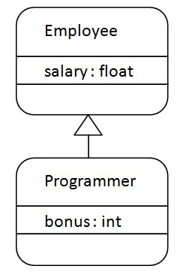

As displayed in the above figure, Programmer is the subclass and Employee is the superclass. The relationship between the two classes is **Programmer IS-A Employee**. It means that Programmer is a type of Employee.

**package** com.sample;

**public** **class** Employee {

**float** salary = 40000;

}

**class** Programmer **extends** Employee {

**int** bonus = 10000;

**public** **static** **void** main(String args[]) {

Programmer p = **new** Programmer();

System.***out***.println("Programmer salary is:" + p.salary);

System.***out***.println("Bonus of Programmer is:" + p.bonus);

}

}

[**Test it Now**](https://www.javatpoint.com/opr/test.jsp?filename=Programmer)

Programmer salary is:40000.0

Bonus of programmer is:10000

In the above example, Programmer object can access the field of own class as well as of Employee class i.e. code reusability.

## Types of inheritance in java

On the basis of class, there can be three types of inheritance in java: single, multilevel and hierarchical.

In java programming, multiple and hybrid inheritance is supported through interface only. We will learn about interfaces later.

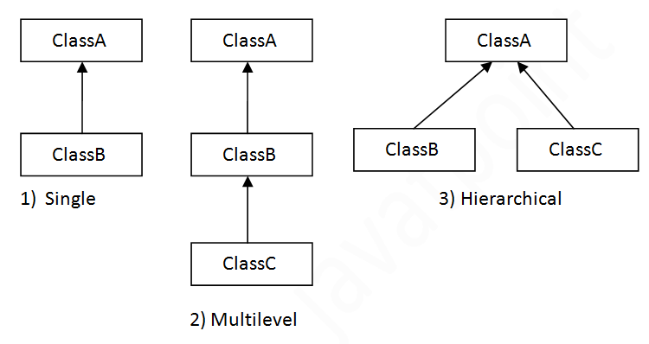

#### **Note: Multiple inheritance is not supported in Java through class.**

When one class inherits multiple classes, it is known as multiple inheritance. For Example:

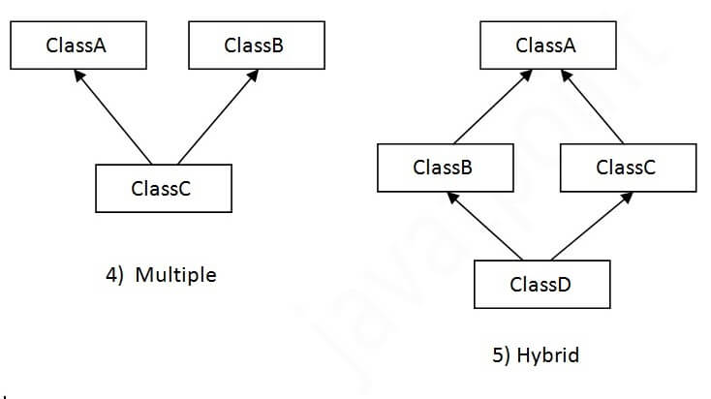

## Single Inheritance Example

When a class inherits another class, it is known as a single inheritance. In the example given below, Dog class inherits the Animal class, so there is the single inheritance.

*File: TestInheritance.java*

1. **class** Animal{
2. **void** eat(){System.out.println("eating...");}
3. }
4. **class** Dog **extends** Animal{
5. **void** bark(){System.out.println("barking...");}
6. }
7. **class** TestInheritance{
8. **public** **static** **void** main(String args[]){
9. Dog d=**new** Dog();
10. d.bark();
11. d.eat();
12. }}

Output:

barking...

eating...

## Multilevel Inheritance Example

When there is a chain of inheritance, it is known as multilevel inheritance. As you can see in the example given below, BabyDog class inherits the Dog class which again inherits the Animal class, so there is a multilevel inheritance.

*File: TestInheritance2.java*

1. **class** Animal{
2. **void** eat(){System.out.println("eating...");}
3. }
4. **class** Dog **extends** Animal{
5. **void** bark(){System.out.println("barking...");}
6. }
7. **class** BabyDog **extends** Dog{
8. **void** weep(){System.out.println("weeping...");}
9. }
10. **class** TestInheritance2{
11. **public** **static** **void** main(String args[]){
12. BabyDog d=**new** BabyDog();
13. d.weep();
14. d.bark();
15. d.eat();
16. }}

Output:

weeping...

barking...

eating...

## Hierarchical Inheritance Example

When two or more classes inherits a single class, it is known as hierarchical inheritance. In the example given below, Dog and Cat classes inherits the Animal class, so there is hierarchical inheritance.

*File: TestInheritance3.java*

1. **class** Animal{
2. **void** eat(){System.out.println("eating...");}
3. }
4. **class** Dog **extends** Animal{
5. **void** bark(){System.out.println("barking...");}
6. }
7. **class** Cat **extends** Animal{
8. **void** meow(){System.out.println("meowing...");}
9. }
10. **class** TestInheritance3{
11. **public** **static** **void** main(String args[]){
12. Cat c=**new** Cat();
13. c.meow();
14. c.eat();
15. //c.bark();//C.T.Error
16. }}

Output:

meowing...

eating...

## Q) Why multiple inheritance is not supported in java?

To reduce the complexity and simplify the language, multiple inheritance is not supported in java.

Consider a scenario where A, B, and C are three classes. The C class inherits A and B classes. If A and B classes have the same method and you call it from child class object, there will be ambiguity to call the method of A or B class.

Since compile-time errors are better than runtime errors, Java renders compile-time error if you inherit 2 classes. So whether you have same method or different, there will be compile time error.

1. **class** A{
2. **void** msg(){System.out.println("Hello");}
3. }
4. **class** B{
5. **void** msg(){System.out.println("Welcome");}
6. }
7. **class** C **extends** A,B{//suppose if it were
9. **public** **static** **void** main(String args[]){
10. C obj=**new** C();
11. obj.msg();//Now which msg() method would be invoked?
12. }
13. }

[**Test it Now**](https://www.javatpoint.com/opr/test.jsp?filename=C)

Compile Time Error

Abstraction:

Abstraction is a feature of OOPs. The feature allows us to hide the implementation detail from the user and shows only the functionality of the programming to the user.

Let's understand the abstraction with the help of a real-world example. The best example of abstraction is a car. When we derive a car, we do not know how is the car moving or how internal components are working? But we know how to derive a car. It means it is not necessary to know how the car is working, but it is important how to derive a car. The same is an abstraction.

We can achieve the abstraction in two ways:

1)Using Abstract Class

2)Using Interface

Abstract:

### **Using Abstract Class**

# **Abstract class in Java**

A class which is declared with the abstract keyword is known as an abstract class in [Java](https://www.javatpoint.com/java-tutorial). It can have abstract and non-abstract methods (method with the body).

Before learning the Java abstract class, let's understand the abstraction in Java first.

### **Abstraction in Java**

**Abstraction** is a process of hiding the implementation details and showing only functionality to the user.

Another way, it shows only essential things to the user and hides the internal details, for example, sending SMS where you type the text and send the message. You don't know the internal processing about the message delivery.

Play Videox[](https://campaign.adpushup.com/get-started/?utm_source=banner&utm_campaign=growth_hack)

Abstraction lets you focus on what the [object](https://www.javatpoint.com/object-and-class-in-java) does instead of how it does it.

### **Ways to achieve Abstraction**

There are two ways to achieve abstraction in java

1. Abstract class (0 to 100%)
2. Interface (100%)

### **Abstract class in Java**

A class which is declared as abstract is known as an **abstract class**. It can have abstract and non-abstract methods. It needs to be extended and its method implemented. It cannot be instantiated.

#### **Points to Remember**

* An abstract class must be declared with an abstract keyword.
* It can have abstract and non-abstract methods.
* It cannot be instantiated.
* It can have [constructors](https://www.javatpoint.com/java-constructor) and static methods also.
* It can have final methods which will force the subclass not to change the body of the method.

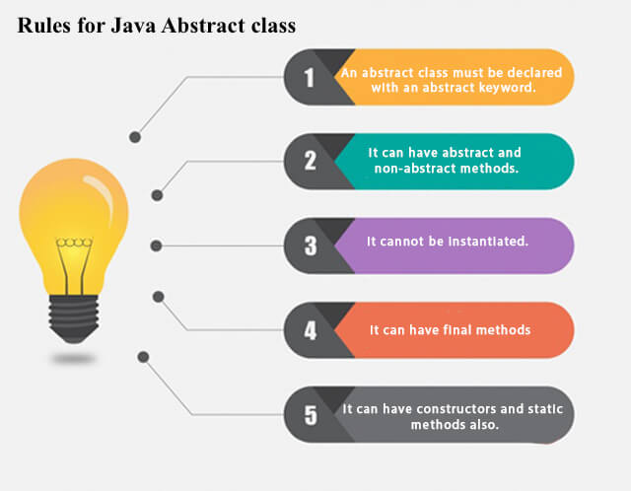

**Example of abstract class**

1. **abstract** **class** A{}

### **Abstract Method in Java**

A method which is declared as abstract and does not have implementation is known as an abstract method.

**Example of abstract method**

1. **abstract** **void** printStatus();//no method body and abstract

### **Example of Abstract class that has an abstract method**

In this example, Bike is an abstract class that contains only one abstract method run. Its implementation is provided by the Honda class.

1. **abstract** **class** Bike{
2. **abstract** **void** run();
3. }
4. **class** Honda4 **extends** Bike{
5. **void** run(){System.out.println("running safely");}
6. **public** **static** **void** main(String args[]){
7. Honda4 obj = **new** Honda4();
8. obj.run();
9. }
10. }

[**Test it Now**](https://www.javatpoint.com/opr/test.jsp?filename=Honda4)

running safely

### **Understanding the real scenario of Abstract class**

In this example, Shape is the abstract class, and its implementation is provided by the Rectangle and Circle classes.

In this example, if you create the instance of Rectangle class, draw() method of Rectangle class will be invoked.

*File: TestAbstraction1.java*

1. **abstract** **class** Shape{
2. **abstract** **void** draw();
3. }
4. //In real scenario, implementation is provided by others i.e. unknown by end user
5. **class** Rectangle **extends** Shape{
6. **void** draw(){System.out.println("drawing rectangle");}
7. }
8. **class** Circle1 **extends** Shape{
9. **void** draw(){System.out.println("drawing circle");}
10. }
11. //In real scenario, method is called by programmer or user
12. **class** TestAbstraction1{
13. **public** **static** **void** main(String args[]){
14. Circle1 s=**new** Circle1();//In a real scenario, object is provided through method, e.g., getShape() method
15. s.draw();
16. }
17. }

[**Test it Now**](https://www.javatpoint.com/opr/test.jsp?filename=TestAbstraction1)

drawing circle

### **Another example of Abstract class in java**

*File: TestBank.java*

1. **abstract** **class** Bank{
2. **abstract** **int** getRateOfInterest();
3. }
4. **class** SBI **extends** Bank{
5. **int** getRateOfInterest(){**return** 7;}
6. }
7. **class** PNB **extends** Bank{
8. **int** getRateOfInterest(){**return** 8;}
9. }
11. **class** TestBank{
12. **public** **static** **void** main(String args[]){
13. Bank b;
14. b=**new** SBI();
15. System.out.println("Rate of Interest is: "+b.getRateOfInterest()+" %");
16. b=**new** PNB();
17. System.out.println("Rate of Interest is: "+b.getRateOfInterest()+" %");
18. }}

[**Test it Now**](https://www.javatpoint.com/opr/test.jsp?filename=TestBank)

Rate of Interest is: 7 %

Rate of Interest is: 8 %

### **Abstract class having constructor, data member and methods**

An abstract class can have a data member, abstract method, method body (non-abstract method), constructor, and even main() method.

*File: TestAbstraction2.java*

1. //Example of an abstract class that has abstract and non-abstract methods
2. **abstract** **class** Bike{
3. Bike(){System.out.println("bike is created");}
4. **abstract** **void** run();
5. **void** changeGear(){System.out.println("gear changed");}
6. }
7. //Creating a Child class which inherits Abstract class
8. **class** Honda **extends** Bike{
9. **void** run(){System.out.println("running safely..");}
10. }
11. //Creating a Test class which calls abstract and non-abstract methods
12. **class** TestAbstraction2{
13. **public** **static** **void** main(String args[]){
14. Honda obj = **new** Honda();
15. obj.run();
16. obj.changeGear();
17. }
18. }

[**Test it Now**](https://www.javatpoint.com/opr/test.jsp?filename=TestAbstraction2)

bike is created

running safely..

gear changed

#### **Rule: If there is an abstract method in a class, that class must be abstract.**

1. **class** Bike12{
2. **abstract** **void** run();
3. }

[**Test it Now**](https://www.javatpoint.com/opr/test.jsp?filename=Bike12)

compile time error

#### **Rule: If you are extending an abstract class that has an abstract method, you must either provide the implementation of the method or make this class abstract.**

Interfaces:

An interface is a fully abstract class. It includes a group of abstract methods (methods without a body).

We use the interface keyword to create an interface in Java. For example,

interface Language {

public void getType();

public void getVersion();

}

Here,

* Language is an interface.
* It includes abstract methods: getType() and getVersion().

## Implementing an Interface

Like abstract classes, we cannot create objects of interfaces.

To use an interface, other classes must implement it. We use the implements keyword to implement an interface.

### Example 1: Java Interface

interface Polygon {

void getArea(int length, int breadth);

}

// implement the Polygon interface

class Rectangle implements Polygon {

// implementation of abstract method

public void getArea(int length, int breadth) {

System.out.println("The area of the rectangle is " + (length \* breadth));

}

}

class Main {

public static void main(String[] args) {

Rectangle r1 = new Rectangle();

r1.getArea(5, 6);

}

}

[Run Code](https://www.programiz.com/java-programming/online-compiler)

**Output**

The area of the rectangle is 30

In the above example, we have created an interface named Polygon. The interface contains an abstract method getArea().

Here, the Rectangle class implements Polygon. And, provides the implementation of the getArea() method.

### Example 2: Java Interface

// create an interface

interface Language {

void getName(String name);

}

// class implements interface

class ProgrammingLanguage implements Language {

// implementation of abstract method

public void getName(String name) {

System.out.println("Programming Language: " + name);

}

}

class Main {

public static void main(String[] args) {

ProgrammingLanguage language = new ProgrammingLanguage();

language.getName("Java");

}

}

[Run Code](https://www.programiz.com/java-programming/online-compiler)

**Output**

Programming Language: Java

In the above example, we have created an interface named Language. The interface includes an abstract method getName().

Here, the ProgrammingLanguage class implements the interface and provides the implementation for the method.

### Implementing Multiple Interfaces

In Java, a class can also implement multiple interfaces. For example,

interface A {

// members of A

}

interface B {

// members of B

}

class C implements A, B {

// abstract members of A

// abstract members of B

}

## Extending an Interface

Similar to classes, interfaces can extend other interfaces. The extends keyword is used for extending interfaces. For example,

interface Line {

// members of Line interface

}

// extending interface

interface Polygon extends Line {

// members of Polygon interface

// members of Line interface

}

Here, the Polygon interface extends the Line interface. Now, if any class implements Polygon, it should provide implementations for all the abstract methods of both Line and Polygon.

### Extending Multiple Interfaces

An interface can extend multiple interfaces. For example,

interface A {

...

}

interface B {

...

}

interface C extends A, B {

...

}

## Advantages of Interface in Java

Now that we know what interfaces are, let's learn about why interfaces are used in Java.

* Similar to abstract classes, interfaces help us to achieve **abstraction in Java**.  
    
  Here, we know getArea() calculates the area of polygons but the way area is calculated is different for different polygons. Hence, the implementation of getArea() is independent of one another.
* Interfaces **provide specifications** that a class (which implements it) must follow.  
    
  In our previous example, we have used getArea() as a specification inside the interface Polygon. This is like setting a rule that we should be able to get the area of every polygon.  
    
  Now any class that implements the Polygon interface must provide an implementation for the getArea() method.
* Interfaces are also used to achieve multiple inheritance in Java. For example,
* interface Line {
* …
* }
* interface Polygon {
* …
* }
* class Rectangle implements Line, Polygon {
* …

}

Here, the class Rectangle is implementing two different interfaces. This is how we achieve multiple inheritance in Java.

**Note**: All the methods inside an interface are implicitly public and all fields are implicitly public static final. For example,

interface Language {

// by default public static final

String type = "programming language";

// by default public

void getName();

}

## default methods in Java Interfaces

With the release of Java 8, we can now add methods with implementation inside an interface. These methods are called default methods.

To declare default methods inside interfaces, we use the default keyword. For example,

public default void getSides() {

// body of getSides()

}

### Why default methods?

Let's take a scenario to understand why default methods are introduced in Java.

Suppose, we need to add a new method in an interface.

We can add the method in our interface easily without implementation. However, that's not the end of the story. All our classes that implement that interface must provide an implementation for the method.

If a large number of classes were implementing this interface, we need to track all these classes and make changes to them. This is not only tedious but error-prone as well.

To resolve this, Java introduced default methods. Default methods are inherited like ordinary methods.

Let's take an example to have a better understanding of default methods.

### Example: Default Method in Java Interface

interface Polygon {

void getArea();

// default method

default void getSides() {

System.out.println("I can get sides of a polygon.");

}

}

// implements the interface

class Rectangle implements Polygon {

public void getArea() {

int length = 6;

int breadth = 5;

int area = length \* breadth;

System.out.println("The area of the rectangle is " + area);

}

// overrides the getSides()

public void getSides() {

System.out.println("I have 4 sides.");

}

}

// implements the interface

class Square implements Polygon {

public void getArea() {

int length = 5;

int area = length \* length;

System.out.println("The area of the square is " + area);

}

}

class Main {

public static void main(String[] args) {

// create an object of Rectangle

Rectangle r1 = new Rectangle();

r1.getArea();

r1.getSides();

// create an object of Square

Square s1 = new Square();

s1.getArea();

s1.getSides();

}

}

[Run Code](https://www.programiz.com/java-programming/online-compiler)

**Output**

The area of the rectangle is 30

I have 4 sides.

The area of the square is 25

I can get sides of a polygon.

In the above example, we have created an interface named Polygon. It has a default method getSides() and an abstract method getArea().

Here, we have created two classes Rectangle and Square that implement Polygon.

The Rectangle class provides the implementation of the getArea() method and overrides the getSides() method. However, the Square class only provides the implementation of the getArea() method.

Now, while calling the getSides() method using the Rectangle object, the overridden method is called. However, in the case of the Square object, the default method is called.

## private and static Methods in Interface

The Java 8 also added another feature to include static methods inside an interface.

Similar to a class, we can access static methods of an interface using its references. For example,

// create an interface

interface Polygon {

staticMethod(){..}

}

// access static method

Polygon.staticMethod();

**Note**: With the release of Java 9, private methods are also supported in interfaces.

We cannot create objects of an interface. Hence, private methods are used as helper methods that provide support to other methods in interfaces.

### Practical Example of Interface

Let's see a more practical example of Java Interface.

// To use the sqrt function

import java.lang.Math;

interface Polygon {

void getArea();

// calculate the perimeter of a Polygon

default void getPerimeter(int... sides) {

int perimeter = 0;

for (int side: sides) {

perimeter += side;

}

System.out.println("Perimeter: " + perimeter);

}

}

class Triangle implements Polygon {

private int a, b, c;

private double s, area;

// initializing sides of a triangle

Triangle(int a, int b, int c) {

this.a = a;

this.b = b;

this.c = c;

s = 0;

}

// calculate the area of a triangle

public void getArea() {

s = (double) (a + b + c)/2;

area = Math.sqrt(s\*(s-a)\*(s-b)\*(s-c));

System.out.println("Area: " + area);

}

}

class Main {

public static void main(String[] args) {

Triangle t1 = new Triangle(2, 3, 4);

// calls the method of the Triangle class

t1.getArea();

// calls the method of Polygon

t1.getPerimeter(2, 3, 4);

}

}

[Run Code](https://www.programiz.com/java-programming/online-compiler)

**Output**

Area: 2.9047375096555625

Perimeter: 9

In the above program, we have created an interface named Polygon. It includes a default method getPerimeter() and an abstract method getArea().

We can calculate the perimeter of all polygons in the same manner so we implemented the body of getPerimeter() in Polygon.

Now, all polygons that implement Polygon can use getPerimeter() to calculate perimeter.

However, the rule for calculating the area is different for different polygons. Hence, getArea() is included without implementation.

Any class that implements Polygon must provide an implementation of getArea().

# **Polymorphism in Java:**

Polymorphism is an important concept of object-oriented programming. It simply means more than one form.

That is, the same entity (method or operator or object) can perform different operations in different scenarios.

## Example: Java Polymorphism

class Polygon {

// method to render a shape

public void render() {

System.out.println("Rendering Polygon...");

}

}

class Square extends Polygon {

// renders Square

public void render() {

System.out.println("Rendering Square...");

}

}

class Circle extends Polygon {

// renders circle

public void render() {

System.out.println("Rendering Circle...");

}

}

class Main {

public static void main(String[] args) {

// create an object of Square

Square s1 = new Square();

s1.render();

// create an object of Circle

Circle c1 = new Circle();

c1.render();

}

}

[Run Code](https://www.programiz.com/java-programming/online-compiler)

**Output**

Rendering Square...

Rendering Circle...

In the above example, we have created a superclass: Polygon and two subclasses: Square and Circle. Notice the use of the render() method.

The main purpose of the render() method is to render the shape. However, the process of rendering a square is different than the process of rendering a circle.

Hence, the render() method behaves differently in different classes. Or, we can say render() is polymorphic.

### Why Polymorphism?

Polymorphism allows us to create consistent code. In the previous example, we can also create different methods: renderSquare() and renderCircle() to render Square and Circle, respectively.

This will work perfectly. However, for every shape, we need to create different methods. It will make our code inconsistent.

To solve this, polymorphism in Java allows us to create a single method render() that will behave differently for different shapes.

**Note**: The print() method is also an example of polymorphism. It is used to print values of different types like char, int, string, etc.

We can achieve polymorphism in Java using the following ways:

1. [Method Overriding](https://www.programiz.com/java-programming/method-overriding)
2. [Method Overloading](https://www.programiz.com/java-programming/method-overloading)
3. Operator Overloading

## Java Method Overriding

During [inheritance in Java](https://www.programiz.com/java-programming/inheritance), if the same method is present in both the superclass and the subclass. Then, the method in the subclass overrides the same method in the superclass. This is called method overriding.

In this case, the same method will perform one operation in the superclass and another operation in the subclass. For example,

### Example 1: Polymorphism using method overriding

class Language {

public void displayInfo() {

System.out.println("Common English Language");

}

}

class Java extends Language {

@Override

public void displayInfo() {

System.out.println("Java Programming Language");

}

}

class Main {

public static void main(String[] args) {

// create an object of Java class

Java j1 = new Java();

j1.displayInfo();

// create an object of Language class

Language l1 = new Language();

l1.displayInfo();

}

}

[Run Code](https://www.programiz.com/java-programming/online-compiler)

**Output**:

Java Programming Language

Common English Language

In the above example, we have created a superclass named Language and a subclass named Java. Here, the method displayInfo() is present in both Language and Java.

The use of displayInfo() is to print the information. However, it is printing different information in Language and Java.

Based on the object used to call the method, the corresponding information is printed.

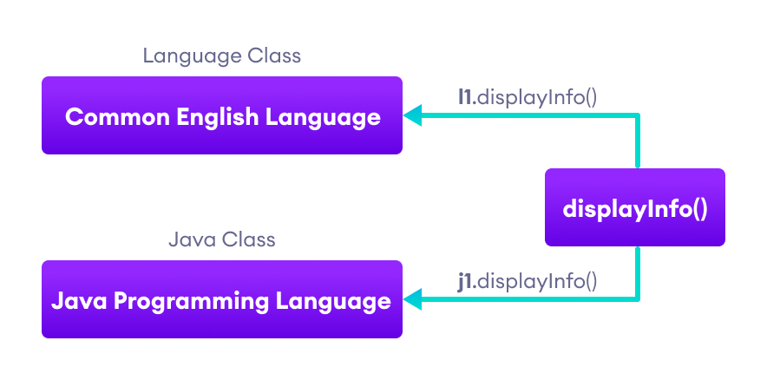Working of Java Polymorphism

**Note**: The method that is called is determined during the execution of the program. Hence, method overriding is a **run-time polymorphism**.

## 2. Java Method Overloading

In a Java class, we can create methods with the same name if they differ in parameters. For example,

void func() { ... }

void func(int a) { ... }

float func(double a) { ... }

float func(int a, float b) { ... }

This is known as method overloading in Java. Here, the same method will perform different operations based on the parameter.

### Example 3: Polymorphism using method overloading

class Pattern {

// method without parameter

public void display() {

for (int i = 0; i < 10; i++) {

System.out.print("\*");

}

}

// method with single parameter

public void display(char symbol) {

for (int i = 0; i < 10; i++) {

System.out.print(symbol);

}

}

}

class Main {

public static void main(String[] args) {

Pattern d1 = new Pattern();

// call method without any argument

d1.display();

System.out.println("\n");

// call method with a single argument

d1.display('#');

}

}

[Run Code](https://www.programiz.com/java-programming/online-compiler)

**Output**:

\*\*\*\*\*\*\*\*\*\*

##########

In the above example, we have created a class named Pattern. The class contains a method named display() that is overloaded.

// method with no arguments

display() {...}

// method with a single char type argument

display(char symbol) {...}

Here, the main function of display() is to print the pattern. However, based on the arguments passed, the method is performing different operations:

* prints a pattern of \*, if no argument is passed or
* prints pattern of the parameter, if a single char type argument is passed.

**Note**: The method that is called is determined by the compiler. Hence, it is also known as compile-time polymorphism.

## 3. Java Operator Overloading

Some operators in Java behave differently with different operands. For example,

* + operator is overloaded to perform numeric addition as well as string concatenation, and
* operators like &, |, and ! are overloaded for logical and bitwise operations.

Let's see how we can achieve polymorphism using operator overloading.

The + operator is used to add two entities. However, in Java, the + operator performs two operations.

1. When + is used with numbers (integers and floating-point numbers), it performs mathematical addition. For example,

int a = 5;

int b = 6;

// + with numbers

int sum = a + b; // Output = 11

2. When we use the + operator with strings, it will perform string concatenation (join two strings). For example,

String first = "Java ";

String second = "Programming";

// + with strings

name = first + second; // Output = Java Programming

Here, we can see that the + operator is overloaded in Java to perform two operations: **addition** and **concatenation**.

**Note**: In languages like C++, we can define operators to work differently for different operands. However, Java doesn't support user-defined operator overloading.

## Polymorphic Variables:

## A reference variable of the super class can refer to a sub class object

A variable is called polymorphic if it refers to different values under different conditions.

Object variables (instance variables) represent the behavior of polymorphic variables in Java. It is because object variables of a class can refer to objects of its class as well as objects of its subclasses.

### Example: Polymorphic Variables

class ProgrammingLanguage {

public void display() {

System.out.println("I am Programming Language.");

}

}

class Java extends ProgrammingLanguage {

@Override

public void display() {

System.out.println("I am Object-Oriented Programming Language.");

}

}

class Main {

public static void main(String[] args) {

// declare an object variable

ProgrammingLanguage pl;

// create object of ProgrammingLanguage

pl = new ProgrammingLanguage();

pl.display();

// create object of Java class

pl = new Java();

pl.display();

}

}

[Run Code](https://www.programiz.com/java-programming/online-compiler)

**Output**:

I am Programming Language.

I am Object-Oriented Programming Language.

In the above example, we have created an object variable pl of the ProgrammingLanguage class. Here, pl is a polymorphic variable. This is because,

* In statement pl = new ProgrammingLanguage(), pl refer to the object of the ProgrammingLanguage class.
* And, in statement pl = new Java(), pl refer to the object of the Java class.

We have one parent class, ‘Account’ with function of deposit and withdraw. Account has 2 child classes

The operation of deposit and withdraw is same for Saving and Checking accounts. So the inherited methods from Account class will work.

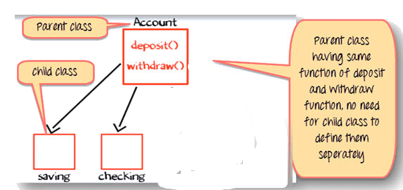

Java Polymorphism Example

### Change in Software Requirement

There is a change in the requirement specification, something that is so common in the software industry. You are supposed to add functionality privileged Banking Account with Overdraft Facility.

For a background, overdraft is a facility where you can withdraw an amount more than available the balance in your account.

So, withdraw method for privileged needs to implemented afresh. But you do not change the tested piece of code in Savings and Checking account. This is advantage of OOPS

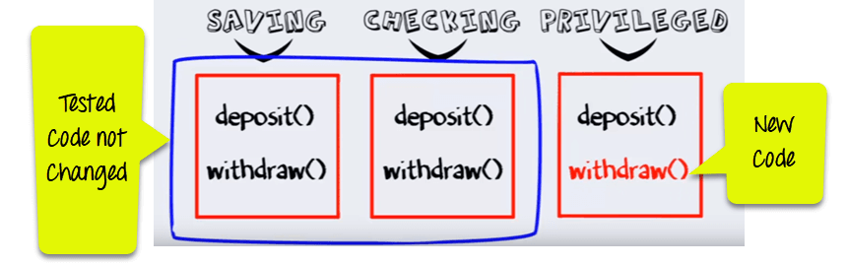

**Step 1)** Such that when the “withdrawn” method for saving account is called a method from parent account class is executed

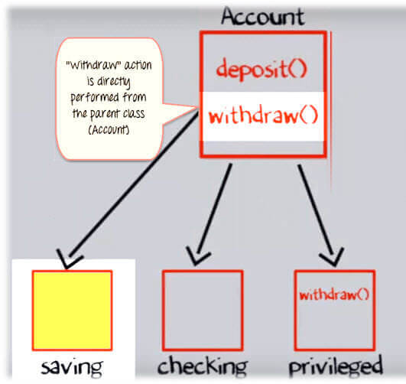

**Step 2)**But when the “Withdraw” method for the privileged account (overdraft facility) is called withdraw method defined in the privileged class is executed. This is **Polymorphism in OOPs.**

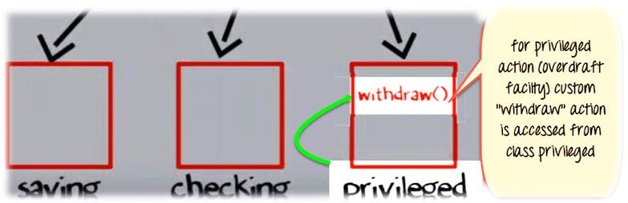

## Method Overriding in Java

Method Overriding is redefining a super class method in a sub class.

### Rules for Method Overriding

* The method signature i.e. method name, parameter list and return type have to match exactly.
* The overridden method can widen the accessibility but not narrow it, i.e. if it is private in the base class, the child class can make it public but not vice versa.

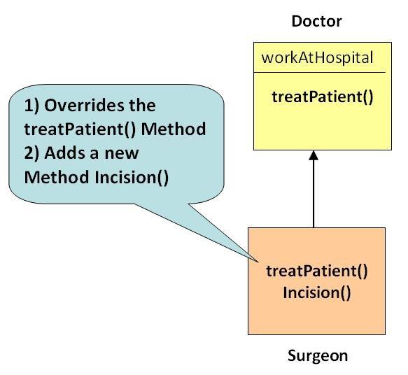

**Example**

class Doctor{

public void treatPatient(){

// treatPatient method

}

class Surgeon extends Doctor{

public void treatPatient(){

// treatPatient method

}

}

Class run{

public static void main (String args[]){

Doctor doctorObj = new Doctor()

// treatPatient method in class Doctor will be executed

doctorObj.treatPatient();

Surgeon surgeonObj = new Surgeon();

// treatPatient method in class Surgeon will be executed

surgeonObj.treatPatient();

}

}

## Difference between Overloading and Overriding

| **Method Overloading** | **Method Overriding** |
| --- | --- |
| Method overloading is in the same class, where more than 1 1 method have the same name but different signatures. | Method overriding is when one of the  methods in the super class is  redefined in the sub-class. In this case, the signature of the method remains the same. |
| **Ex:**  void sum (int a , int b);  void sum (int a , int b, int c);  void sum (float a, double b); | **Ex:**  class X{  public int sum(){  // some code  }  }  class Y extends X{  public int sum(){  //overridden method  //signature is same  }  } |

## What is Dynamic Polymorphism?

Dynamic Polymorphism in OOPs is the mechanism by which multiple methods can be defined with same name and signature in the superclass and subclass. The call to an overridden method are resolved at run time.

### Dynamic Polymorphism Example:

A reference variable of the super class can refer to a sub class object

Doctor obj = new Surgeon();

Consider the statement

obj.treatPatient();

Here the reference variable “obj” is of the parent class, but the object it is pointing to is of the child class (as shown in the below diagram example of Polymorphism).

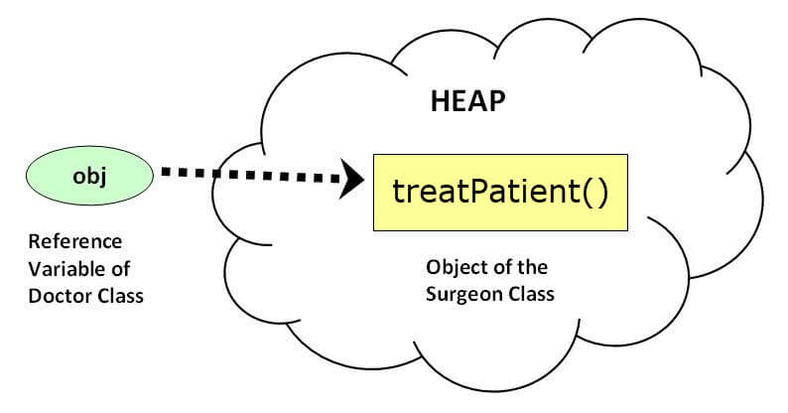

obj.treatPatient() will execute treatPatient() method of the sub-class – Surgeon

If a base class reference is used to call a method, the method to be invoked is decided by the JVM, depending on the object the reference is pointing to

For example, even though obj is a reference to Doctor, it calls the method of Surgeon, as it points to a Surgeon object

This is decided during run-time and hence termed **dynamic**or **run-time polymorphism**

## What is encapsulation:

**Encapsulation in Java** is a *process of wrapping code and data together into a single unit*, for example, a capsule which is mixed of several medicines.



We can create a fully encapsulated class in Java by making all the data members of the class private. Now we can use setter and getter methods to set and get the data in it.

The whole idea behind encapsulation is to hide the implementation details from users. If a data member is private it means it can only be accessed within the same class. No outside class can access private data member (variable) of other class.

However if we setup public getter and setter methods to update (for example void setSSN(int ssn))and read (for example  int getSSN()) the private data fields then the outside class can access those private data fields via public methods.

This way data can only be accessed by public methods thus making the private fields and their implementation hidden for outside classes. That’s why encapsulation is known as **data hiding.**Lets see an example to understand this concept better.

## Example of Encapsulation in Java

How to implement encapsulation in java:  
1) Make the instance variables private so that they cannot be accessed directly from outside the class. You can only set and get values of these variables through the methods of the class.  
2) Have getter and setter methods in the class to set and get the values of the fields.

class EncapsulationDemo{

private int ssn;

private String empName;

private int empAge;

//Getter and Setter methods

public int getEmpSSN(){

return ssn;

}

public String getEmpName(){

return empName;

}

public int getEmpAge(){

return empAge;

}

public void setEmpAge(int newValue){

empAge = newValue;

}

public void setEmpName(String newValue){

empName = newValue;

}

public void setEmpSSN(int newValue){

ssn = newValue;

}

}

public class EncapsTest{

public static void main(String args[]){

EncapsulationDemo obj = new EncapsulationDemo();

obj.setEmpName("Mario");

obj.setEmpAge(32);

obj.setEmpSSN(112233);

System.out.println("Employee Name: " + obj.getEmpName());

System.out.println("Employee SSN: " + obj.getEmpSSN());

System.out.println("Employee Age: " + obj.getEmpAge());

}

}

**Output:**

Employee Name: Mario

Employee SSN: 112233

Employee Age: 32

In above example all the three data members (or data fields) are private(see: [**Access Modifiers in Java**](https://beginnersbook.com/2013/05/java-access-modifiers/)) which cannot be accessed directly. These fields can be accessed via public methods only. Fields empName, ssn and empAge are made hidden data fields using encapsulation technique of OOPs.

## Advantages of encapsulation

1. It improves maintainability and flexibility and re-usability: for e.g. In the above code the implementation code of void setEmpName(String name) and String getEmpName() can be changed at any point of time. Since the implementation is purely hidden for outside classes they would still be accessing the private field empName using the same methods (setEmpName(String name) and getEmpName()). Hence the code can be maintained at any point of time without breaking the classes that uses the code. This improves the re-usability of the underlying class.
2. The fields can be made read-only (If we don’t define setter methods in the class) or write-only (If we don’t define the getter methods in the class). For e.g. If we have a field(or variable) that we don’t want to be changed so we simply define the variable as private and instead of set and get both we just need to define the get method for that variable. Since the set method is not present there is no way an outside class can modify the value of that field.
3. User would not be knowing what is going on behind the scene. They would only be knowing that to update a field call set method and to read a field call get method but what these set and get methods are doing is purely hidden from them.

Encapsulation is also known as “**data Hiding**“.

# **Super Keyword in Java**

The **super** keyword in Java is a reference variable which is used to refer immediate parent class object.

Whenever you create the instance of subclass, an instance of parent class is created implicitly which is referred by super reference variable.

## Usage of Java super Keyword

1. super can be used to refer immediate parent class instance variable.
2. super can be used to invoke immediate parent class method.
3. super() can be used to invoke immediate parent class constructor.

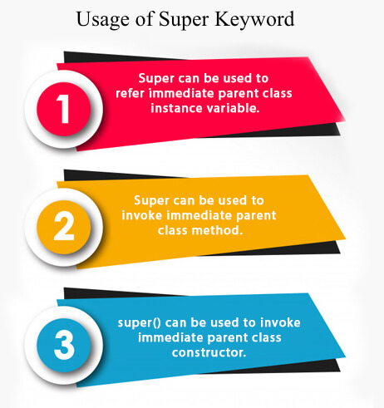

## 1) super is used to refer immediate parent class instance variable.

We can use super keyword to access the data member or field of parent class. It is used if parent class and child class have same fields.

1. **class** Animal{
2. String color="white";
3. }
4. **class** Dog **extends** Animal{
5. String color="black";
6. **void** printColor(){
7. System.out.println(color);//prints color of Dog class
8. System.out.println(**super**.color);//prints color of Animal class
9. }
10. }
11. **class** TestSuper1{
12. **public** **static** **void** main(String args[]){
13. Dog d=**new** Dog();
14. d.printColor();
15. }}

**[Test it Now](https://www.javatpoint.com/opr/test.jsp?filename=TestSuper1" \t "_blank)**

Output:

Play Videox[[](https://campaign.adpushup.com/get-started/?utm_source=banner&utm_campaign=growth_hack)](https://campaign.adpushup.com/get-started/?utm_source=banner&utm_campaign=growth_hack" \t "_blank)

black

white

In the above example, Animal and Dog both classes have a common property color. If we print color property, it will print the color of current class by default. To access the parent property, we need to use super keyword.

## 2) super can be used to invoke parent class method

The super keyword can also be used to invoke parent class method. It should be used if subclass contains the same method as parent class. In other words, it is used if method is overridden.

1. **class** Animal{
2. **void** eat(){System.out.println("eating...");}
3. }
4. **class** Dog **extends** Animal{
5. **void** eat(){System.out.println("eating bread...");}
6. **void** bark(){System.out.println("barking...");}
7. **void** work(){
8. **super**.eat();
9. bark();
10. }
11. }
12. **class** TestSuper2{
13. **public** **static** **void** main(String args[]){
14. Dog d=**new** Dog();
15. d.work();
16. }}

**[Test it Now](https://www.javatpoint.com/opr/test.jsp?filename=TestSuper2" \t "_blank)**

Output:

eating...

barking...

In the above example Animal and Dog both classes have eat() method if we call eat() method from Dog class, it will call the eat() method of Dog class by default because priority is given to local.

To call the parent class method, we need to use super keyword.

## 3) super is used to invoke parent class constructor.

The super keyword can also be used to invoke the parent class constructor. Let's see a simple example:

1. **class** Animal{
2. Animal(){System.out.println("animal is created");}
3. }
4. **class** Dog **extends** Animal{
5. Dog(){
6. **super**();
7. System.out.println("dog is created");
8. }
9. }
10. **class** TestSuper3{
11. **public** **static** **void** main(String args[]){
12. Dog d=**new** Dog();
13. }}

**[Test it Now](https://www.javatpoint.com/opr/test.jsp?filename=TestSuper3" \t "_blank)**

Output:

animal is created

dog is created

#### **Note: super() is added in each class constructor automatically by compiler if there is no super() or this().**

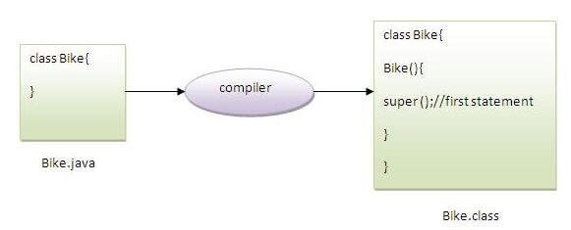

As we know well that default constructor is provided by compiler automatically if there is no constructor. But, it also adds super() as the first statement.

**Another example of super keyword where super() is provided by the compiler implicitly.**

1. **class** Animal{
2. Animal(){System.out.println("animal is created");}
3. }
4. **class** Dog **extends** Animal{
5. Dog(){
6. System.out.println("dog is created");
7. }
8. }
9. **class** TestSuper4{
10. **public** **static** **void** main(String args[]){
11. Dog d=**new** Dog();
12. }}

**[Test it Now](https://www.javatpoint.com/opr/test.jsp?filename=TestSuper4" \t "_blank)**

Output:

animal is created

dog is created

## super example: real use

Let's see the real use of super keyword. Here, Emp class inherits Person class so all the properties of Person will be inherited to Emp by default. To initialize all the property, we are using parent class constructor from child class. In such way, we are reusing the parent class constructor.

1. **class** Person{
2. **int** id;
3. String name;
4. Person(**int** id,String name){
5. **this**.id=id;
6. **this**.name=name;
7. }
8. }
9. **class** Emp **extends** Person{
10. **float** salary;
11. Emp(**int** id,String name,**float** salary){
12. **super**(id,name);//reusing parent constructor
13. **this**.salary=salary;
14. }
15. **void** display(){System.out.println(id+" "+name+" "+salary);}
16. }
17. **class** TestSuper5{
18. **public** **static** **void** main(String[] args){
19. Emp e1=**new** Emp(1,"ankit",45000f);
20. e1.display();
21. }}

**[Test it Now](https://www.javatpoint.com/opr/test.jsp?filename=TestSuper5" \t "_blank)**

Output:

1 ankit 45000

# **Java this keyword:**

## Usage of Java this keyword

Here is given the 6 usage of java this keyword.

1. [this can be used to refer current class instance variable.](https://www.javatpoint.com/this1)
2. [this can be used to invoke current class method (implicitly)](https://www.javatpoint.com/this2)
3. [this() can be used to invoke current class constructor.](https://www.javatpoint.com/this3)
4. [this can be passed as an argument in the method call.](https://www.javatpoint.com/this4)
5. [this can be passed as argument in the constructor call.](https://www.javatpoint.com/this5)
6. [this can be used to return the current class instance from the method.](https://www.javatpoint.com/this6)

**Suggestion:** If you are beginner to java, lookup only three usages of this keyword.

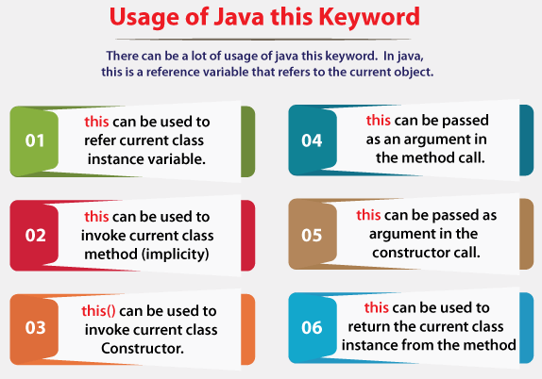

### **1) this: to refer current class instance variable**

The this keyword can be used to refer current class instance variable. If there is ambiguity between the instance variables and parameters, this keyword resolves the problem of ambiguity.

Play Videox[](https://campaign.adpushup.com/get-started/?utm_source=banner&utm_campaign=growth_hack)

#### **Understanding the problem without this keyword**

Let's understand the problem if we don't use this keyword by the example given below:

1. **class** Student{
2. **int** rollno;
3. String name;
4. **float** fee;
5. Student(**int** rollno,String name,**float** fee){
6. rollno=rollno;
7. name=name;
8. fee=fee;
9. }
10. **void** display(){
11. System.out.println(rollno+" "+name+" "+fee);
12. }
13. }
14. **class** TestThis1{
15. **public** **static** **void** main(String args[]){
16. Student s1=**new** Student(111,"ankit",5000f);
17. Student s2=**new** Student(112,"sumit",6000f);
18. s1.display();
19. s2.display();
20. }}

[**Test it Now**](https://www.javatpoint.com/opr/test.jsp?filename=TestThis1)

**Output:**

0 null 0.0

0 null 0.0

In the above example, parameters (formal arguments) and instance variables are same. So, we are using this keyword to distinguish local variable and instance variable.

#### **Solution of the above problem by this keyword**

1. **class** Student{
2. **int** rollno;
3. String name;
4. **float** fee;
5. Student(**int** rollno,String name,**float** fee){
6. **this**.rollno=rollno;
7. **this**.name=name;
8. **this**.fee=fee;
9. }
10. **void** display(){System.out.println(rollno+" "+name+" "+fee);}
11. }
13. **class** TestThis2{
14. **public** **static** **void** main(String args[]){
15. Student s1=**new** Student(111,"ankit",5000f);
16. Student s2=**new** Student(112,"sumit",6000f);
17. s1.display();
18. s2.display();
19. }}

[**Test it Now**](https://www.javatpoint.com/opr/test.jsp?filename=TestThis2)

**Output:**

111 ankit 5000.0

112 sumit 6000.0

If local variables(formal arguments) and instance variables are different, there is no need to use this keyword like in the following program:

#### **Program where this keyword is not required**

1. **class** Student{
2. **int** rollno;
3. String name;
4. **float** fee;
5. Student(**int** r,String n,**float** f){
6. rollno=r;
7. name=n;
8. fee=f;
9. }
10. **void** display(){System.out.println(rollno+" "+name+" "+fee);}
11. }
13. **class** TestThis3{
14. **public** **static** **void** main(String args[]){
15. Student s1=**new** Student(111,"ankit",5000f);
16. Student s2=**new** Student(112,"sumit",6000f);
17. s1.display();
18. s2.display();
19. }}

[**Test it Now**](https://www.javatpoint.com/opr/test.jsp?filename=TestThis3)

**Output:**

111 ankit 5000.0

112 sumit 6000.0

#### **It is better approach to use meaningful names for variables. So we use same name for instance variables and parameters in real time, and always use this keyword.**

### **2) this: to invoke current class method**

You may invoke the method of the current class by using the this keyword. If you don't use the this keyword, compiler automatically adds this keyword while invoking the method. Let's see the example

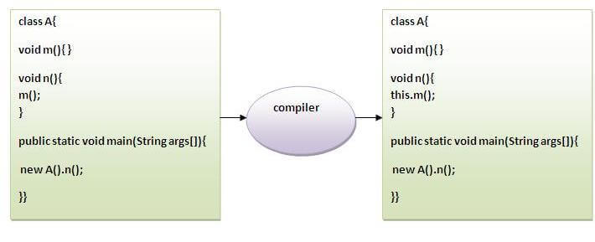

1. **class** A{
2. **void** m(){System.out.println("hello m");}
3. **void** n(){
4. System.out.println("hello n");
5. //m();//same as this.m()
6. **this**.m();
7. }
8. }
9. **class** TestThis4{
10. **public** **static** **void** main(String args[]){
11. A a=**new** A();
12. a.n();
13. }}

[**Test it Now**](https://www.javatpoint.com/opr/test.jsp?filename=TestThis4)

**Output:**

hello n

hello m

### **3) this() : to invoke current class constructor**

The this() constructor call can be used to invoke the current class constructor. It is used to reuse the constructor. In other words, it is used for constructor chaining.

**Calling default constructor from parameterized constructor:**

1. **class** A{
2. A(){System.out.println("hello a");}
3. A(**int** x){
4. **this**();
5. System.out.println(x);
6. }
7. }
8. **class** TestThis5{
9. **public** **static** **void** main(String args[]){
10. A a=**new** A(10);
11. }}

[**Test it Now**](https://www.javatpoint.com/opr/test.jsp?filename=TestThis5)

**Output:**

hello a

10

**Calling parameterized constructor from default constructor:**

1. **class** A{
2. A(){
3. **this**(5);
4. System.out.println("hello a");
5. }
6. A(**int** x){
7. System.out.println(x);
8. }
9. }
10. **class** TestThis6{
11. **public** **static** **void** main(String args[]){
12. A a=**new** A();
13. }}

[**Test it Now**](https://www.javatpoint.com/opr/test.jsp?filename=TestThis6)

**Output:**

5

hello a

### **Real usage of this() constructor call**

The this() constructor call should be used to reuse the constructor from the constructor. It maintains the chain between the constructors i.e. it is used for constructor chaining. Let's see the example given below that displays the actual use of this keyword.

1. **class** Student{
2. **int** rollno;
3. String name,course;
4. **float** fee;
5. Student(**int** rollno,String name,String course){
6. **this**.rollno=rollno;
7. **this**.name=name;
8. **this**.course=course;
9. }
10. Student(**int** rollno,String name,String course,**float** fee){
11. **this**(rollno,name,course);//reusing constructor
12. **this**.fee=fee;
13. }
14. **void** display(){System.out.println(rollno+" "+name+" "+course+" "+fee);}
15. }
16. **class** TestThis7{
17. **public** **static** **void** main(String args[]){
18. Student s1=**new** Student(111,"ankit","java");
19. Student s2=**new** Student(112,"sumit","java",6000f);
20. s1.display();
21. s2.display();
22. }}

[**Test it Now**](https://www.javatpoint.com/opr/test.jsp?filename=TestThis7)

**Output:**

111 ankit java 0.0

112 sumit java 6000.0

#### **Rule: Call to this() must be the first statement in constructor.**

1. **class** Student{
2. **int** rollno;
3. String name,course;
4. **float** fee;
5. Student(**int** rollno,String name,String course){
6. **this**.rollno=rollno;
7. **this**.name=name;
8. **this**.course=course;
9. }
10. Student(**int** rollno,String name,String course,**float** fee){
11. **this**.fee=fee;
12. **this**(rollno,name,course);//C.T.Error
13. }
14. **void** display(){System.out.println(rollno+" "+name+" "+course+" "+fee);}
15. }
16. **class** TestThis8{
17. **public** **static** **void** main(String args[]){
18. Student s1=**new** Student(111,"ankit","java");
19. Student s2=**new** Student(112,"sumit","java",6000f);
20. s1.display();
21. s2.display();
22. }}

[**Test it Now**](https://www.javatpoint.com/opr/test.jsp?filename=TestThis8)

**Output:**

Compile Time Error: Call to this must be first statement in constructor

# Java final keyword

In Java, the final keyword is used to denote constants. It can be used with variables, methods, and classes.

Once any entity (variable, method or class) is declared final, it can be assigned only once. That is,

* the final variable cannot be reinitialized with another value
* the final method cannot be overridden
* the final class cannot be extended

## 1. Java final Variable

In Java, we cannot change the value of a final variable. For example,

class Main {

public static void main(String[] args) {

// create a final variable

final int AGE = 32;

// try to change the final variable

AGE = 45;

System.out.println("Age: " + AGE);

}

}

[Run Code](https://www.programiz.com/java-programming/online-compiler)

In the above program, we have created a final variable named age. And we have tried to change the value of the final variable.

When we run the program, we will get a compilation error with the following message.

cannot assign a value to final variable AGE

AGE = 45;

^

**Note**: It is recommended to use uppercase to declare final variables in Java.

## 2. Java final Method

Before you learn about final methods and final classes, make sure you know about the [Java Inheritance](https://www.programiz.com/java-programming/inheritance).

In Java, the final method cannot be overridden by the child class. For example,

class FinalDemo {

// create a final method

public final void display() {

System.out.println("This is a final method.");

}

}

class Main extends FinalDemo {

// try to override final method

public final void display() {

System.out.println("The final method is overridden.");

}

public static void main(String[] args) {

Main obj = new Main();

obj.display();

}

}

[Run Code](https://www.programiz.com/java-programming/online-compiler)

In the above example, we have created a final method named display() inside the FinalDemo class. Here, the Main class inherits the FinalDemo class.

We have tried to override the final method in the Main class. When we run the program, we will get a compilation error with the following message.

display() in Main cannot override display() in FinalDemo

public final void display() {

^

overridden method is final

## 3. Java final Class

In Java, the final class cannot be inherited by another class. For example,

// create a final class

final class FinalClass {

public void display() {

System.out.println("This is a final method.");

}

}

// try to extend the final class

class Main extends FinalClass {

public void display() {

System.out.println("The final method is overridden.");

}

public static void main(String[] args) {

Main obj = new Main();

obj.display();

}

}

[Run Code](https://www.programiz.com/java-programming/online-compiler)

In the above example, we have created a final class named FinalClass. Here, we have tried to inherit the final class by the Main class.

When we run the program, we will get a compilation error with the following message.

cannot inherit from final FinalClass

class Main extends FinalClass {

^

## IS-A Relationship (Inheritance) and has-a relationship

**IS-A Relationship (Inheritance)**

IS-A Relationship can be formed with a minimum of two classes with a relation. This is referred as Inheritance in java.  
Let us take a simple example for our understanding. We know every four-wheeler Car is a Vehicle.  
Honda is a Car  
Suziki is a Car  
Toyota is a Car  
benz is a Car  
  
So, From these examples all four wheeler brands are Cars and all have some common features such as color, max speed, gears type etc. These common features will be in Car class and car specific features will be in Car Brand car.  
  
IS-A relationship is implemented by using the "extends" keyword in java inheritance. Whenever you find the "extends" keyword anywhere in your application that is IS-A Relationship.  
  
Creating one is Car class and many car specific classes.

**IS-A Relationship Example**

// Common features class

class Car {

int avgSpeed;

int currentSpeed;

public int getCurrentSpeed() {

return currentSpeed;

}

public void setCurrentSpeed(int currentSpeed) {

this.currentSpeed = currentSpeed;

}

public int getAvgSpeed() {

return avgSpeed;

}

public void setAvgSpeed(int maxSpeed) {

this.avgSpeed = maxSpeed;

}

public int getNoOfGears() {

return 6;

}

public String getDefaultColor() {

return "White";

}

}

In-Car class, it has common methods which are used by all its subclasses. It has default no of gears, colour, can be set the current speed.  
  
Below is a Honda car which is a subclass of Car. It has its own specific max speed is 120. Inside the Honda car, we can use all methods of Car class.

// Honda specific implementation class

class Honda extends Car {

public void startHondaCar() {

setAvgSpeed(70);

System.out.println("Started Honda Car with average speed : " + getAvgSpeed());

}

public int getMaxSpeed() {

return 120;

}

public void stopHondaCar() {

System.out.println("Honda Car has stopped");

}

}

Below is a Maruthi car which is a subclass of Car. It has its own specific max speed is 100. Inside the Honda car, we can use all methods of Car class.

// Maruthi specific implementation class

class Maruthi extends Car {

public void startHondaCar() {

setAvgSpeed(100);

System.out.println("Started Maruthi Car with average speed : " + getAvgSpeed());

}

public int getMaxSpeed() {

return 100;

}

public void stopHondaCar() {

System.out.println("Maruthi Car has stopped");

}

}

In these two Honda, Maruthi classes have access to Car class and all Car methods are accessible from these subclasses.  
  
**Main class of IS-A relationship.**

// Main method for IS-A Relationship

public class IsARelationShip {

public static void main(String[] args) {

System.out.println("Honda specific implementation.");

Honda hondaCar = new Honda();

hondaCar.startHondaCar();

System.out.println("Honda car max speed: " + hondaCar.getMaxSpeed());

hondaCar.stopHondaCar();

System.out.println("\nMaruthi specific implementation.");

Maruthi maruthiCar = new Maruthi();

maruthiCar.startHondaCar();

System.out.println("Honda car max speed: " + maruthiCar.getMaxSpeed());

maruthiCar.stopHondaCar();

}

}

**Output:**

Honda specific implementation.

Started Honda Car with average speed : 70

Honda car max speed: 120

Honda Car has stopped

Maruthi specific implementation.

Started Maruthi Car with average speed : 100

Honda car max speed: 100

Maruthi Car has stopped

In this example program, Car class has all the common features of a car which all are required by all its implementation cars which can be default features. If Honda wants its own specific then they have the ability to provide its own implementation for those methods which is called as Method Overriding.  
  
Please go through the above program and leave your questions in the comments section.

**HAS-A Relationship (Association)**

HAS-A relationship also can be formed by a minimum of two classes. If any class has an instance variable that referring another class.

Let us break them down into examples for better understanding. Honda car has an Engine, Maruthi car has an Engine.

**HAS-A Relationship Example**

Creating an Engine class that has engine related functions.

// Engine specific implementation class

class Engine {

public void startWithDieselEngine() {

System.out.println("Diesel engine has added and it's started");

}

public void startWithPetrolEngine() {

System.out.println("Petrol engine has added and it's started");

}

public void startWithAutomaticEngine() {

System.out.println("Automatic engine has added and it's started");

}

}

Creating ToyotaDiesel class which has instance variable of Engine class. Instance variable engine calls startWithDieselEngine() method and ignore the remaining methods in the Engine class.

// Toyota Diesel car

class ToyotaDiesel {

public Engine engine;

public Engine getEngine() {

return engine;

}

public void setEngine(Engine engine) {

this.engine = engine;

}

public ToyotaDiesel() {

System.out.println("Toyota Diesel car has constructed");

}

public void startEngine() {

engine.startWithDieselEngine();

}

}

Another class, instance variable referring to Engine class. Invoking benz automatic engine startWithDieselEngine().

// Benz Automatic car

class BenzAutomatic {

public Engine engine;

public Engine getEngine() {

return engine;

}

public void setEngine(Engine engine) {

this.engine = engine;

}

public BenzAutomatic() {

System.out.println("Benz Automatic car has constructed");

}

public void startEngine() {

engine.startWithDieselEngine();

}

}

Main method IS-A relationship class:

// Main method for IS-A Relationship

public class HasARelationShip {

public static void main(String[] args) {

// Creating Engine Object

Engine engine = new Engine();

// Toyota diesel car

System.out.println("ToyotaDiesel specific implementation.");

ToyotaDiesel toyotaDieselCar = new ToyotaDiesel();

toyotaDieselCar.setEngine(engine);

toyotaDieselCar.startEngine();

// Benz Automatic car

System.out.println("\nBenzAutomatic specific implementation.");

BenzAutomatic benzAutomatic = new BenzAutomatic();

benzAutomatic.setEngine(engine);

benzAutomatic.startEngine();

}

}

**Output:**

ToyotaDiesel specific implementation.

Toyota Diesel car has constructed

Diesel engine has added and it's started

BenzAutomatic specific implementation.

Benz Automatic car has constructed

Diesel engine has added and it's started

Object Class:

# **Object class in Java**

The **Object class** is the parent class of all the classes in java by default. In other words, it is the topmost class of java.

The Object class is beneficial if you want to refer any object whose type you don't know. Notice that parent class reference variable can refer the child class object, know as upcasting.

Let's take an example, there is getObject() method that returns an object but it can be of any type like Employee,Student etc, we can use Object class reference to refer that object. For example:

1. Object obj=getObject();//we don't know what object will be returned from this method

The Object class provides some common behaviors to all the objects such as object can be compared, object can be cloned, object can be notified etc.

Play Videox[](https://campaign.adpushup.com/get-started/?utm_source=banner&utm_campaign=growth_hack)

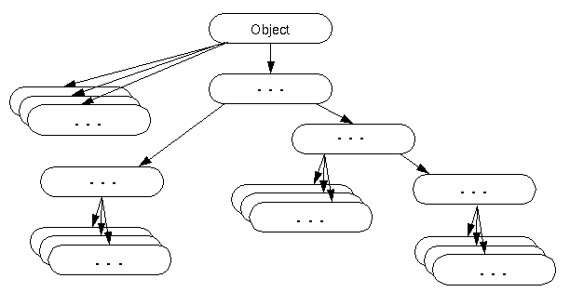

### **Methods of Object class**

|  |
| --- |
| The Object class provides many methods. They are as follows: |

|  |  |
| --- | --- |
| **Method** | **Description** |
| public final Class getClass() | returns the Class class object of this object. The Class class can further be used to get the metadata of this class. |
| public int hashCode() | returns the hashcode number for this object. |
| public boolean equals(Object obj) | compares the given object to this object. |
| protected Object clone() throws CloneNotSupportedException | creates and returns the exact copy (clone) of this object. |
| public String toString() | returns the string representation of this object. |
| public final void notify() | wakes up single thread, waiting on this object's monitor. |
| public final void notifyAll() | wakes up all the threads, waiting on this object's monitor. |
| public final void wait(long timeout)throws InterruptedException | causes the current thread to wait for the specified milliseconds, until another thread notifies (invokes notify() or notifyAll() method). |
| public final void wait(long timeout,int nanos)throws InterruptedException | causes the current thread to wait for the specified milliseconds and nanoseconds, until another thread notifies (invokes notify() or notifyAll() method). |
| public final void wait()throws InterruptedException | causes the current thread to wait, until another thread notifies (invokes notify() or notifyAll() method). |
| protected void finalize()throws Throwable | is invoked by the garbage collector before object is being garbage collected. |

String:

### **What is String in Java?**

Generally, String is a sequence of characters. But in Java, string is an object that represents a sequence of characters. The java.lang.String class is used to create a string object.

### **How to create a string object?**

There are two ways to create String object:

1. By string literal
2. By new keyword

### **1) String Literal**

Java String literal is created by using double quotes. For Example:

1. String s="welcome";

Each time you create a string literal, the JVM checks the "string constant pool" first. If the string already exists in the pool, a reference to the pooled instance is returned. If the string doesn't exist in the pool, a new string instance is created and placed in the pool. For example:

1. String s1="Welcome";
2. String s2="Welcome";//It doesn't create a new instance

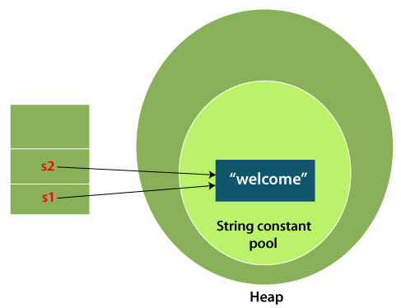

In the above example, only one object will be created. Firstly, JVM will not find any string object with the value "Welcome" in string constant pool that is why it will create a new object. After that it will find the string with the value "Welcome" in the pool, it will not create a new object but will return the reference to the same instance.

#### **Note: String objects are stored in a special memory area known as the "string constant pool".**

### **Why Java uses the concept of String literal?**

To make Java more memory efficient (because no new objects are created if it exists already in the string constant pool).

### **2) By new keyword**

1. String s=**new** String("Welcome");//creates two objects and one reference variable

In such case, [JVM](https://www.javatpoint.com/jvm-java-virtual-machine)

will create a new string object in normal (non-pool) heap memory, and the literal "Welcome" will be placed in the string constant pool. The variable s will refer to the object in a heap (non-pool).

### **Java String Example**

**StringExample.java**

1. **public** **class** StringExample{
2. **public** **static** **void** main(String args[]){
3. String s1="java";//creating string by Java string literal
4. **char** ch[]={'s','t','r','i','n','g','s'};
5. String s2=**new** String(ch);//converting char array to string
6. String s3=**new** String("example");//creating Java string by new keyword
7. System.out.println(s1);
8. System.out.println(s2);
9. System.out.println(s3);
10. }}

**[Test it Now](https://www.javatpoint.com/opr/test.jsp?filename=StringExample" \t "_blank)**

**Output:**

java

strings

example

The above code, converts a **char** array into a **String** object. And displays the String objects **s1, s2**, and **s3** on console using **println()** method.

### **Java String class methods**

The java.lang.String class provides many useful methods to perform operations on sequence of char values.

|  |  |  |
| --- | --- | --- |
| **No.** | **Method** | **Description** |
| 1 | [char charAt(int index)](https://www.javatpoint.com/java-string-charat) | It returns char value for the particular index |
| 2 | [int length()](https://www.javatpoint.com/java-string-length) | It returns string length |
| 3 | [static String format(String format, Object... args)](https://www.javatpoint.com/java-string-format) | It returns a formatted string. |
| 4 | [static String format(Locale l, String format, Object... args)](https://www.javatpoint.com/java-string-format) | It returns formatted string with given locale. |
| 5 | [String substring(int beginIndex)](https://www.javatpoint.com/java-string-substring) | It returns substring for given begin index. |
| 6 | [String substring(int beginIndex, int endIndex)](https://www.javatpoint.com/java-string-substring) | It returns substring for given begin index and end index. |
| 7 | [boolean contains(CharSequence s)](https://www.javatpoint.com/java-string-contains) | It returns true or false after matching the sequence of char value. |
| 8 | [static String join(CharSequence delimiter, CharSequence... elements)](https://www.javatpoint.com/java-string-join) | It returns a joined string. |
| 9 | [static String join(CharSequence delimiter, Iterable<? extends CharSequence> elements)](https://www.javatpoint.com/java-string-join) | It returns a joined string. |
| 10 | [boolean equals(Object another)](https://www.javatpoint.com/java-string-equals) | It checks the equality of string with the given object. |
| 11 | [boolean isEmpty()](https://www.javatpoint.com/java-string-isempty) | It checks if string is empty. |
| 12 | [String concat(String str)](https://www.javatpoint.com/java-string-concat) | It concatenates the specified string. |
| 13 | [String replace(char old, char new)](https://www.javatpoint.com/java-string-replace) | It replaces all occurrences of the specified char value. |
| 14 | [String replace(CharSequence old, CharSequence new)](https://www.javatpoint.com/java-string-replace) | It replaces all occurrences of the specified CharSequence. |
| 15 | [static String equalsIgnoreCase(String another)](https://www.javatpoint.com/java-string-equalsignorecase) | It compares another string. It doesn't check case. |
| 16 | [String[] split(String regex)](https://www.javatpoint.com/java-string-split) | It returns a split string matching regex. |
| 17 | [String[] split(String regex, int limit)](https://www.javatpoint.com/java-string-split) | It returns a split string matching regex and limit. |
| 18 | [String intern()](https://www.javatpoint.com/java-string-intern) | It returns an interned string. |
| 19 | [int indexOf(int ch)](https://www.javatpoint.com/java-string-indexof) | It returns the specified char value index. |
| 20 | [int indexOf(int ch, int fromIndex)](https://www.javatpoint.com/java-string-indexof) | It returns the specified char value index starting with given index. |
| 21 | [int indexOf(String substring)](https://www.javatpoint.com/java-string-indexof) | It returns the specified substring index. |
| 22 | [int indexOf(String substring, int fromIndex)](https://www.javatpoint.com/java-string-indexof) | It returns the specified substring index starting with given index. |
| 23 | [String toLowerCase()](https://www.javatpoint.com/java-string-tolowercase) | It returns a string in lowercase. |
| 24 | [String toLowerCase(Locale l)](https://www.javatpoint.com/java-string-tolowercase) | It returns a string in lowercase using specified locale. |
| 25 | [String toUpperCase()](https://www.javatpoint.com/java-string-touppercase) | It returns a string in uppercase. |
| 26 | [String toUpperCase(Locale l)](https://www.javatpoint.com/java-string-touppercase) | It returns a string in uppercase using specified locale. |
| 27 | [String trim()](https://www.javatpoint.com/java-string-trim) | It removes beginning and ending spaces of this string. |
| 28 | [static String valueOf(int value)](https://www.javatpoint.com/java-string-valueof) | It converts given type into string. It is an overloaded method. |

Let's use some important methods of String class.

### **Java String toUpperCase() and toLowerCase() method**

The Java String toUpperCase() method converts this String into uppercase letter and String toLowerCase() method into lowercase letter.

63.5M

1.3K

Features of Java - Javatpoint

**Next**

**Stay**

**Stringoperation1.java**

1. **public** **class** Stringoperation1
2. {
3. **public** **static** **void** main(String ar[])
4. {
5. String s="Sachin";
6. System.out.println(s.toUpperCase());//SACHIN
7. System.out.println(s.toLowerCase());//sachin
8. System.out.println(s);//Sachin(no change in original)
9. }
10. }

[**Test it Now**](https://www.javatpoint.com/opr/test.jsp?filename=Testmethodofstringclass)

**Output:**

SACHIN

sachin

Sachin

### **Java String trim() method**

The String class trim() method eliminates white spaces before and after the String.

**Stringoperation2.java**

1. **public** **class** Stringoperation2
2. {
3. **public** **static** **void** main(String ar[])
4. {
5. String s="  Sachin  ";
6. System.out.println(s);//  Sachin
7. System.out.println(s.trim());//Sachin
8. }
9. }

[**Test it Now**](https://www.javatpoint.com/opr/test.jsp?filename=Testmethodofstringclass1)

**Output:**

Sachin

Sachin

### **Java String startsWith() and endsWith() method**

The method startsWith() checks whether the String starts with the letters passed as arguments and endsWith() method checks whether the String ends with the letters passed as arguments.

**Stringoperation3.java**

1. **public** **class** Stringoperation3
2. {
3. **public** **static** **void** main(String ar[])
4. {
5. String s="Sachin";
6. System.out.println(s.startsWith("Sa"));//true
7. System.out.println(s.endsWith("n"));//true
8. }
9. }

[**Test it Now**](https://www.javatpoint.com/opr/test.jsp?filename=Testmethodofstringclass2)

**Output:**

true

true

### **Java String charAt() Method**

The String class charAt() method returns a character at specified index.

**Stringoperation4.java**

1. **public** **class** Stringoperation4
2. {
3. **public** **static** **void** main(String ar[])
4. {
5. String s="Sachin";
6. System.out.println(s.charAt(0));//S
7. System.out.println(s.charAt(3));//h
8. }
9. }

[**Test it Now**](https://www.javatpoint.com/opr/test.jsp?filename=Testmethodofstringclass3)

**Output:**

S

h

### **Java String length() Method**

The String class length() method returns length of the specified String.

**Stringoperation5.java**

1. **public** **class** Stringoperation5
2. {
3. **public** **static** **void** main(String ar[])
4. {
5. String s="Sachin";
6. System.out.println(s.length());//6
7. }
8. }

[**Test it Now**](https://www.javatpoint.com/opr/test.jsp?filename=Testmethodofstringclass4)

**Output:**

6

### **Java String intern() Method**

A pool of strings, initially empty, is maintained privately by the class String.

When the intern method is invoked, if the pool already contains a String equal to this String object as determined by the equals(Object) method, then the String from the pool is returned. Otherwise, this String object is added to the pool and a reference to this String object is returned.

**Stringoperation6.java**

1. **public** **class** Stringoperation6
2. {
3. **public** **static** **void** main(String ar[])
4. {
5. String s=**new** String("Sachin");
6. String s2=s.intern();
7. System.out.println(s2);//Sachin
8. }
9. }

[**Test it Now**](https://www.javatpoint.com/opr/test.jsp?filename=Testmethodofstringclass5)

**Output:**

Sachin

### **Java String valueOf() Method**

The String class valueOf() method coverts given type such as int, long, float, double, boolean, char and char array into String.

**Stringoperation7.java**

1. **public** **class** Stringoperation7
2. {
3. **public** **static** **void** main(String ar[])
4. {
5. **int** a=10;
6. String s=String.valueOf(a);
7. System.out.println(s+10);
8. }
9. }

**Output:**

1010

### **Java String replace() Method**

The String class replace() method replaces all occurrence of first sequence of character with second sequence of character.

**Stringoperation8.java**

1. **public** **class** Stringoperation8
2. {
3. **public** **static** **void** main(String ar[])
4. {
5. String s1="Java is a programming language. Java is a platform. Java is an Island.";
6. String replaceString=s1.replace("Java","Kava");//replaces all occurrences of "Java" to "Kava"
7. System.out.println(replaceString);
8. }
9. }

**Output:**

Kava is a programming language. Kava is a platform. Kava is an Island.

# **Immutable String in Java:**

A String is an unavoidable type of variable while writing any application program. String references are used to store various attributes like username, password, etc. In Java, **String objects are immutable**. Immutable simply means unmodifiable or unchangeable.

Once String object is created its data or state can't be changed but a new String object is created.

Let's try to understand the concept of immutability by the example given below:

**Testimmutablestring.java**

3M

The Laowa 100mm Macro lens has ZERO FLARE!

1. **class** Testimmutablestring{
2. **public** **static** **void** main(String args[]){
3. String s="Sachin";
4. s.concat(" Tendulkar");//concat() method appends the string at the end
5. System.out.println(s);//will print Sachin because strings are immutable objects
6. }
7. }

**[Test it Now](https://www.javatpoint.com/opr/test.jsp?filename=Testimmutablestring" \t "_blank)**

**Output:**

Sachin

Now it can be understood by the diagram given below. Here Sachin is not changed but a new object is created with Sachin Tendulkar. That is why String is known as immutable.

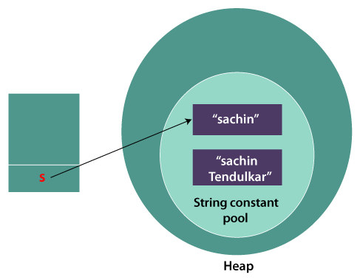

As you can see in the above figure that two objects are created but **s** reference variable still refers to "Sachin" not to "Sachin Tendulkar".

But if we explicitly assign it to the reference variable, it will refer to "Sachin Tendulkar" object.

For example:

**Testimmutablestring1.java**

1. **class** Testimmutablestring1{
2. **public** **static** **void** main(String args[]){
3. String s="Sachin";
4. s=s.concat(" Tendulkar");
5. System.out.println(s);
6. }
7. }

**[Test it Now](https://www.javatpoint.com/opr/test.jsp?filename=Testimmutablestring1" \t "_blank)**

**Output:**

Sachin Tendulkar

In such a case, s points to the "Sachin Tendulkar". Please notice that still Sachin object is not modified.

### **Why String objects are immutable in Java?**

As Java uses the concept of String literal. Suppose there are 5 reference variables, all refer to one object "Sachin". If one reference variable changes the value of the object, it will be affected by all the reference variables. That is why String objects are immutable in Java.

Following are some features of String which makes String objects immutable.

# **Java String compare**

We can compare String in Java on the basis of content and reference.

1. By Using equals() Method
2. By Using == Operator

## 1) By Using equals() Method

The String class equals() method compares the original content of the string. It compares values of string for equality. String class provides the following two methods:

* **public boolean equals(Object another)** compares this string to the specified object.
* **public boolean equalsIgnoreCase(String another)** compares this string to another string, ignoring case.

**Teststringcomparison1.java**

1. **class** Teststringcomparison1{
2. **public** **static** **void** main(String args[]){
3. String s1="Sachin";
4. String s2="Sachin";
5. String s3=**new** String("Sachin");
6. String s4="Saurav";
7. System.out.println(s1.equals(s2));//true
8. System.out.println(s1.equals(s3));//true
9. System.out.println(s1.equals(s4));//false
10. }
11. }

[**Test it Now**](https://www.javatpoint.com/opr/test.jsp?filename=Teststringcomparison1)

**Output:**

true

true

false

In the above code, two strings are compared using **equals()** method of **String** class. And the result is printed as boolean values, **true** or **false**.

**Teststringcomparison2.java**

1. **class** Teststringcomparison2{
2. **public** **static** **void** main(String args[]){
3. String s1="Sachin";
4. String s2="SACHIN";
6. System.out.println(s1.equals(s2));//false
7. System.out.println(s1.equalsIgnoreCase(s2));//true
8. }
9. }

[**Test it Now**](https://www.javatpoint.com/opr/test.jsp?filename=Teststringcomparison2)

**Output:**

false

true

In the above program, the methods of **String** class are used. The **equals()** method returns true if String objects are matching and both strings are of same case. **equalsIgnoreCase()** returns true regardless of cases of strings.

[Click here for more about equals() method](https://www.javatpoint.com/java-string-equals)

## 2) By Using == operator

The == operator compares references not values.

**Teststringcomparison3.java**

1. **class** Teststringcomparison3{
2. **public** **static** **void** main(String args[]){
3. String s1="Sachin";
4. String s2="Sachin";
5. String s3=**new** String("Sachin");
6. System.out.println(s1==s2);//true (because both refer to same instance)
7. System.out.println(s1==s3);//false(because s3 refers to instance created in nonpool)
8. }
9. }

[**Test it Now**](https://www.javatpoint.com/opr/test.jsp?filename=Teststringcomparison3)

**Output:**

true

false

# **Substring in Java**

A part of String is called **substring**. In other words, substring is a subset of another String. Java String class provides the built-in substring() method that extract a substring from the given string by using the index values passed as an argument. In case of substring() method startIndex is inclusive and endIndex is exclusive.

Suppose the string is "**computer**", then the substring will be com, compu, ter, etc.

#### **Note: Index starts from 0.**

You can get substring from the given String object by one of the two methods:

1. **public String substring(int startIndex):**  
   This method returns new String object containing the substring of the given string from specified startIndex (inclusive). The method throws an IndexOutOfBoundException when the startIndex is larger than the length of String or less than zero.
2. **public String substring(int startIndex, int endIndex):**  
   This method returns new String object containing the substring of the given string from specified startIndex to endIndex. The method throws an IndexOutOfBoundException when the startIndex is less than zero or startIndex is greater than endIndex or endIndex is greater than length of String.

In case of String:

Play Videox[](https://campaign.adpushup.com/get-started/?utm_source=banner&utm_campaign=growth_hack)

* **startIndex:** inclusive
* **endIndex:** exclusive

Let's understand the startIndex and endIndex by the code given below.

1. String s="hello";
2. System.out.println(s.substring(0,2)); //returns he  as a substring

In the above substring, 0 points the first letter and 2 points the second letter i.e., e (because end index is exclusive).

### **Example of Java substring() method**

**TestSubstring.java**

1. **public** **class** TestSubstring{
2. **public** **static** **void** main(String args[]){
3. String s="SachinTendulkar";
4. System.out.println("Original String: " + s);
5. System.out.println("Substring starting from index 6: " +s.substring(6));//Tendulkar
6. System.out.println("Substring starting from index 0 to 6: "+s.substring(0,6)); //Sachin
7. }
8. }

**Output:**

Original String: SachinTendulkar

Substring starting from index 6: Tendulkar

Substring starting from index 0 to 6: Sachin

The above [Java programs](https://www.javatpoint.com/java-programs), demonstrates variants of the **substring()** method of **String** class. The startindex is inclusive and endindex is exclusive.

### **Using String.split() method:**

The split() method of String class can be used to extract a substring from a sentence. It accepts arguments in the form of a regular expression.

**TestSubstring2.java**

1. **import** java.util.\*;
3. **public** **class** TestSubstring2
4. {
5. /\* Driver Code \*/
6. **public** **static** **void** main(String args[])
7. {
8. String text= **new** String("Hello, My name is Sachin");
9. /\* Splits the sentence by the delimeter passed as an argument \*/
10. String[] sentences = text.split("\\.");
11. System.out.println(Arrays.toString(sentences));
12. }
13. }

**Output:**

[Hello, My name is Sachin]

In the above program, we have used the split() method. It accepts an argument \\. that checks a in the sentence and splits the string into another string. It is stored in an array of String objects sentences.

# **Java StringBuffer Class**

Java StringBuffer class is used to create mutable (modifiable) String objects. The StringBuffer class in Java is the same as String class except it is mutable i.e. it can be changed.

#### **Note: Java StringBuffer class is thread-safe i.e. multiple threads cannot access it simultaneously. So it is safe and will result in an order.**

### **Important Constructors of StringBuffer Class**

|  |  |
| --- | --- |
| **Constructor** | **Description** |
| StringBuffer() | It creates an empty String buffer with the initial capacity of 16. |
| StringBuffer(String str) | It creates a String buffer with the specified string.. |
| StringBuffer(int capacity) | It creates an empty String buffer with the specified capacity as length. |

### **Important methods of StringBuffer class**

|  |  |  |
| --- | --- | --- |
| **Modifier and Type** | **Method** | **Description** |
| public synchronized StringBuffer | append(String s) | It is used to append the specified string with this string. The append() method is overloaded like append(char), append(boolean), append(int), append(float), append(double) etc. |
| public synchronized StringBuffer | insert(int offset, String s) | It is used to insert the specified string with this string at the specified position. The insert() method is overloaded like insert(int, char), insert(int, boolean), insert(int, int), insert(int, float), insert(int, double) etc. |
| public synchronized StringBuffer | replace(int startIndex, int endIndex, String str) | It is used to replace the string from specified startIndex and endIndex. |
| public synchronized StringBuffer | delete(int startIndex, int endIndex) | It is used to delete the string from specified startIndex and endIndex. |
| public synchronized StringBuffer | reverse() | is used to reverse the string. |
| public int | capacity() | It is used to return the current capacity. |
| public void | ensureCapacity(int minimumCapacity) | It is used to ensure the capacity at least equal to the given minimum. |
| public char | charAt(int index) | It is used to return the character at the specified position. |
| public int | length() | It is used to return the length of the string i.e. total number of characters. |
| public String | substring(int beginIndex) | It is used to return the substring from the specified beginIndex. |
| public String | substring(int beginIndex, int endIndex) | It is used to return the substring from the specified beginIndex and endIndex. |

# **Java StringBuilder Class**

Java StringBuilder class is used to create mutable (modifiable) String. The Java StringBuilder class is same as StringBuffer class except that it is non-synchronized. It is available since JDK 1.5.

## Important Constructors of StringBuilder class

|  |  |
| --- | --- |
| **Constructor** | **Description** |
| StringBuilder() | It creates an empty String Builder with the initial capacity of 16. |
| StringBuilder(String str) | It creates a String Builder with the specified string. |
| StringBuilder(int length) | It creates an empty String Builder with the specified capacity as length. |

## Important methods of StringBuilder class

|  |  |
| --- | --- |
| **Method** | **Description** |
| public StringBuilder append(String s) | It is used to append the specified string with this string. The append() method is overloaded like append(char), append(boolean), append(int), append(float), append(double) etc. |
| public StringBuilder insert(int offset, String s) | It is used to insert the specified string with this string at the specified position. The insert() method is overloaded like insert(int, char), insert(int, boolean), insert(int, int), insert(int, float), insert(int, double) etc. |
| public StringBuilder replace(int startIndex, int endIndex, String str) | It is used to replace the string from specified startIndex and endIndex. |
| public StringBuilder delete(int startIndex, int endIndex) | It is used to delete the string from specified startIndex and endIndex. |
| public StringBuilder reverse() | It is used to reverse the string. |
| public int capacity() | It is used to return the current capacity. |
| public void ensureCapacity(int minimumCapacity) | It is used to ensure the capacity at least equal to the given minimum. |
| public char charAt(int index) | It is used to return the character at the specified position. |
| public int length() | It is used to return the length of the string i.e. total number of characters. |
| public String substring(int beginIndex) | It is used to return the substring from the specified beginIndex. |
| public String substring(int beginIndex, int endIndex) | It is used to return the substring from the specified beginIndex and endIndex. |

# **How to create Immutable class?**

There are many immutable classes like String, Boolean, Byte, Short, Integer, Long, Float, Double etc. In short, all the wrapper classes and String class is immutable. We can also create immutable class by creating final class that have final data members as the example given below:

### **Example to create Immutable class**

In this example, we have created a final class named Employee. It have one final datamember, a parameterized constructor and getter method.

**ImmutableDemo.java**

1. **public** **final** **class** Employee
2. {
3. **final** String pancardNumber;
4. **public** Employee(String pancardNumber)
5. {
6. **this**.pancardNumber=pancardNumber;
7. }
8. **public** String getPancardNumber(){
9. **return** pancardNumber;
10. }
11. }
12. **public** **class** ImmutableDemo
13. {
14. **public** **static** **void** main(String ar[])
15. {
16. Employee e = **new** Employee("ABC123");
17. String s1 = e.getPancardNumber();
18. System.out.println("Pancard Number: " + s1);
19. }
20. }

**Output:**

Play Videox[](https://campaign.adpushup.com/get-started/?utm_source=banner&utm_campaign=growth_hack)

Pancard Number: ABC123

The above class is immutable because:

* The instance variable of the class is final i.e. we cannot change the value of it after creating an object.
* The class is final so we cannot create the subclass.
* There is no setter methods i.e. we have no option to change the value of the instance variable.

These points makes this class as immutable.

# **Java toString() Method**

If you want to represent any object as a string, **toString() method** comes into existence.

The toString() method returns the String representation of the object.

If you print any object, Java compiler internally invokes the toString() method on the object. So overriding the toString() method, returns the desired output, it can be the state of an object etc. depending on your implementation.

### **Advantage of Java toString() method**

By overriding the toString() method of the Object class, we can return values of the object, so we don't need to write much code.

3.2M

### **Understanding problem without toString() method**

Let's see the simple code that prints reference.

**Student.java**

1. **class** Student{
2. **int** rollno;
3. String name;
4. String city;
6. Student(**int** rollno, String name, String city){
7. **this**.rollno=rollno;
8. **this**.name=name;
9. **this**.city=city;
10. }
12. **public** **static** **void** main(String args[]){
13. Student s1=**new** Student(101,"Raj","lucknow");
14. Student s2=**new** Student(102,"Vijay","ghaziabad");
16. System.out.println(s1);//compiler writes here s1.toString()
17. System.out.println(s2);//compiler writes here s2.toString()
18. }
19. }

**Output:**

Student@1fee6fc

Student@1eed786

As you can see in the above example, printing s1 and s2 prints the hashcode values of the objects but I want to print the values of these objects. Since Java compiler internally calls toString() method, overriding this method will return the specified values. Let's understand it with the example given below:

## Example of Java toString() method

Let's see an example of toString() method.

**Student.java**

1. **class** Student{
2. **int** rollno;
3. String name;
4. String city;
6. Student(**int** rollno, String name, String city){
7. **this**.rollno=rollno;
8. **this**.name=name;
9. **this**.city=city;
10. }
12. **public** String toString(){//overriding the toString() method
13. **return** rollno+" "+name+" "+city;
14. }
15. **public** **static** **void** main(String args[]){
16. Student s1=**new** Student(101,"Raj","lucknow");
17. Student s2=**new** Student(102,"Vijay","ghaziabad");
19. System.out.println(s1);//compiler writes here s1.toString()
20. System.out.println(s2);//compiler writes here s2.toString()
21. }
22. }

**Output:**

101 Raj lucknow

102 Vijay ghaziabad

In the above program, Java compiler internally calls **toString()** method, overriding this method will return the specified values of **s1** and **s2** objects of Student class.

# **Java Regex:**

A regular expression is a sequence of characters that forms a search pattern. When you search for data in a text, you can use this search pattern to describe what you are searching for.

The **Java Regex** or Regular Expression is an API to define a pattern for searching or manipulating strings.

It is widely used to define the constraint on strings such as password and email validation. After learning Java regex tutorial, you will be able to test your regular expressions by the Java Regex Tester Tool.

Java Regex API provides 1 interface and 3 classes in **java.util.regex** package.

#### **java.util.regex package**

The Matcher and Pattern classes provide the facility of Java regular expression. The java.util.regex package provides following classes and interfaces for regular expressions.

64.7M

1.2K

Exception Handling in Java - Javatpoint

1. MatchResult interface
2. Matcher class
3. Pattern class
4. PatternSyntaxException class

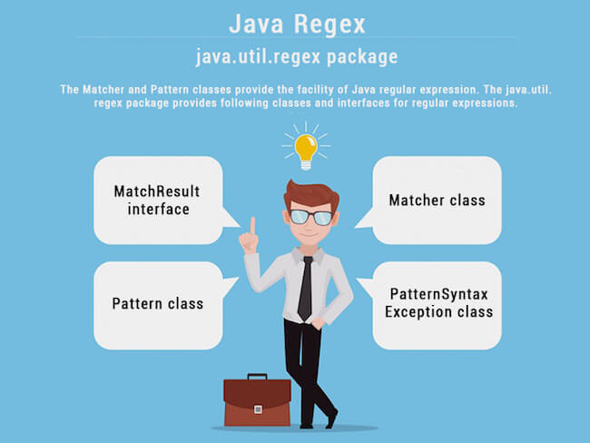

## Matcher class

It implements the **MatchResult** interface. It is a regex engine which is used to perform match operations on a character sequence.

|  |  |  |
| --- | --- | --- |
| **No.** | **Method** | **Description** |
| 1 | boolean matches() | test whether the regular expression matches the pattern. |
| 2 | boolean find() | finds the next expression that matches the pattern. |
| 3 | boolean find(int start) | finds the next expression that matches the pattern from the given start number. |
| 4 | String group() | returns the matched subsequence. |
| 5 | int start() | returns the starting index of the matched subsequence. |
| 6 | int end() | returns the ending index of the matched subsequence. |
| 7 | int groupCount() | returns the total number of the matched subsequence. |

## Pattern class

It is the compiled version of a regular expression. It is used to define a pattern for the regex engine.

|  |  |  |
| --- | --- | --- |
| **No.** | **Method** | **Description** |
| 1 | static Pattern compile(String regex) | compiles the given regex and returns the instance of the Pattern. |
| 2 | Matcher matcher(CharSequence input) | creates a matcher that matches the given input with the pattern. |
| 3 | static boolean matches(String regex, CharSequence input) | It works as the combination of compile and matcher methods. It compiles the regular expression and matches the given input with the pattern. |
| 4 | String[] split(CharSequence input) | splits the given input string around matches of given pattern. |
| 5 | String pattern() | returns the regex pattern. |

### **Example of Java Regular Expressions**

There are three ways to write the regex example in Java.

1. **import** java.util.regex.\*;
2. **public** **class** RegexExample1{
3. **public** **static** **void** main(String args[]){
4. //1st way
5. Pattern p = Pattern.compile(".s");//. represents single character
6. Matcher m = p.matcher("as");
7. **boolean** b = m.matches();
9. //2nd way
10. **boolean** b2=Pattern.compile(".s").matcher("as").matches();
12. //3rd way
13. **boolean** b3 = Pattern.matches(".s", "as");
15. System.out.println(b+" "+b2+" "+b3);
16. }}

**[Test it Now](https://www.javatpoint.com/opr/test.jsp?filename=RegexExample1" \t "_blank)**

#### **Output**

true true true

## Regular Expression . Example

The . (dot) represents a single character.

1. **import** java.util.regex.\*;
2. **class** RegexExample2{
3. **public** **static** **void** main(String args[]){
4. System.out.println(Pattern.matches(".s", "as"));//true (2nd char is s)
5. System.out.println(Pattern.matches(".s", "mk"));//false (2nd char is not s)
6. System.out.println(Pattern.matches(".s", "mst"));//false (has more than 2 char)
7. System.out.println(Pattern.matches(".s", "amms"));//false (has more than 2 char)
8. System.out.println(Pattern.matches("..s", "mas"));//true (3rd char is s)
9. }}

**[Test it Now](https://www.javatpoint.com/opr/test.jsp?filename=RegexExample2" \t "_blank)**

## Regex Character classes

|  |  |  |
| --- | --- | --- |
| **No.** | **Character Class** | **Description** |
| 1 | [abc] | a, b, or c (simple class) |
| 2 | [^abc] | Any character except a, b, or c (negation) |
| 3 | [a-zA-Z] | a through z or A through Z, inclusive (range) |
| 4 | [a-d[m-p]] | a through d, or m through p: [a-dm-p] (union) |
| 5 | [a-z&&[def]] | d, e, or f (intersection) |
| 6 | [a-z&&[^bc]] | a through z, except for b and c: [ad-z] (subtraction) |
| 7 | [a-z&&[^m-p]] | a through z, and not m through p: [a-lq-z](subtraction) |

### **Example of Java Regular Expressions**

1. **import** java.util.regex.\*;
2. **class** RegexExample3{
3. **public** **static** **void** main(String args[]){
4. System.out.println(Pattern.matches("[amn]", "abcd"));//false (not a or m or n)
5. System.out.println(Pattern.matches("[amn]", "a"));//true (among a or m or n)
6. System.out.println(Pattern.matches("[amn]", "ammmna"));//false (m and a comes more than once)
7. }}

**[Test it Now](https://www.javatpoint.com/opr/test.jsp?filename=RegexExample3" \t "_blank)**

## Regex Quantifiers

The quantifiers specify the number of occurrences of a character.

|  |  |
| --- | --- |
| **Regex** | **Description** |
| X? | X occurs once or not at all |
| X+ | X occurs once or more times |
| X\* | X occurs zero or more times |
| X{n} | X occurs n times only |
| X{n,} | X occurs n or more times |
| X{y,z} | X occurs at least y times but less than z times |

## Regular Expression Character classes and Quantifiers Example

1. **import** java.util.regex.\*;
2. **class** RegexExample4{
3. **public** **static** **void** main(String args[]){
4. System.out.println("? quantifier ....");
5. System.out.println(Pattern.matches("[amn]?", "a"));//true (a or m or n comes one time)
6. System.out.println(Pattern.matches("[amn]?", "aaa"));//false (a comes more than one time)
7. System.out.println(Pattern.matches("[amn]?", "aammmnn"));//false (a m and n comes more than one time)
8. System.out.println(Pattern.matches("[amn]?", "aazzta"));//false (a comes more than one time)
9. System.out.println(Pattern.matches("[amn]?", "am"));//false (a or m or n must come one time)
11. System.out.println("+ quantifier ....");
12. System.out.println(Pattern.matches("[amn]+", "a"));//true (a or m or n once or more times)
13. System.out.println(Pattern.matches("[amn]+", "aaa"));//true (a comes more than one time)
14. System.out.println(Pattern.matches("[amn]+", "aammmnn"));//true (a or m or n comes more than once)
15. System.out.println(Pattern.matches("[amn]+", "aazzta"));//false (z and t are not matching pattern)
17. System.out.println("\* quantifier ....");
18. System.out.println(Pattern.matches("[amn]\*", "ammmna"));//true (a or m or n may come zero or more times)
20. }}

**[Test it Now](https://www.javatpoint.com/opr/test.jsp?filename=RegexExample4" \t "_blank)**

## Regex Metacharacters

The regular expression metacharacters work as shortcodes.

|  |  |
| --- | --- |
| **Regex** | **Description** |
| . | Any character (may or may not match terminator) |
| \d | Any digits, short of [0-9] |
| \D | Any non-digit, short for [^0-9] |
| \s | Any whitespace character, short for [\t\n\x0B\f\r] |
| \S | Any non-whitespace character, short for [^\s] |
| \w | Any word character, short for [a-zA-Z\_0-9] |
| \W | Any non-word character, short for [^\w] |
| \b | A word boundary |
| \B | A non word boundary |

## Regular Expression Metacharacters Example

1. **import** java.util.regex.\*;
2. **class** RegexExample5{
3. **public** **static** **void** main(String args[]){
4. System.out.println("metacharacters d....");\\d means digit
6. System.out.println(Pattern.matches("\\d", "abc"));//false (non-digit)
7. System.out.println(Pattern.matches("\\d", "1"));//true (digit and comes once)
8. System.out.println(Pattern.matches("\\d", "4443"));//false (digit but comes more than once)
9. System.out.println(Pattern.matches("\\d", "323abc"));//false (digit and char)
11. System.out.println("metacharacters D....");\\D means non-digit
13. System.out.println(Pattern.matches("\\D", "abc"));//false (non-digit but comes more than once)
14. System.out.println(Pattern.matches("\\D", "1"));//false (digit)
15. System.out.println(Pattern.matches("\\D", "4443"));//false (digit)
16. System.out.println(Pattern.matches("\\D", "323abc"));//false (digit and char)
17. System.out.println(Pattern.matches("\\D", "m"));//true (non-digit and comes once)
19. System.out.println("metacharacters D with quantifier....");
20. System.out.println(Pattern.matches("\\D\*", "mak"));//true (non-digit and may come 0 or more times)
22. }}

**[Test it Now](https://www.javatpoint.com/opr/test.jsp?filename=RegexExample5" \t "_blank)**

## Regular Expression Question 1

1. /\*Create a regular expression that accepts alphanumeric characters only.
2. Its length must be six characters long only.\*/
4. **import** java.util.regex.\*;
5. **class** RegexExample6{
6. **public** **static** **void** main(String args[]){
7. System.out.println(Pattern.matches("[a-zA-Z0-9]{6}", "arun32"));//true
8. System.out.println(Pattern.matches("[a-zA-Z0-9]{6}", "kkvarun32"));//false (more than 6 char)
9. System.out.println(Pattern.matches("[a-zA-Z0-9]{6}", "JA2Uk2"));//true
10. System.out.println(Pattern.matches("[a-zA-Z0-9]{6}", "arun$2"));//false ($ is not matched)
11. }}

**[Test it Now](https://www.javatpoint.com/opr/test.jsp?filename=RegexExample6" \t "_blank)**

## Regular Expression Question 2

1. /\*Create a regular expression that accepts 10 digit numeric characters
2. starting with 7, 8 or 9 only.\*/
4. **import** java.util.regex.\*;
5. **class** RegexExample7{
6. **public** **static** **void** main(String args[]){
7. System.out.println("by character classes and quantifiers ...");
8. System.out.println(Pattern.matches("[789]{1}[0-9]{9}", "9953038949"));//true
9. System.out.println(Pattern.matches("[789][0-9]{9}", "9953038949"));//true
11. System.out.println(Pattern.matches("[789][0-9]{9}", "99530389490"));//false (11 characters)
12. System.out.println(Pattern.matches("[789][0-9]{9}", "6953038949"));//false (starts from 6)
13. System.out.println(Pattern.matches("[789][0-9]{9}", "8853038949"));//true
15. System.out.println("by metacharacters ...");
16. System.out.println(Pattern.matches("[789]{1}\\d{9}", "8853038949"));//true
17. System.out.println(Pattern.matches("[789]{1}\\d{9}", "3853038949"));//false (starts from 3)
19. }}

**[Test it Now](https://www.javatpoint.com/opr/test.jsp?filename=RegexExample7" \t "_blank)**

Output:

Enter regex pattern: java

Enter text: this is java, do you know java

I found the text java starting at index 8 and ending at index 12

I found the text java starting at index 26 and ending at index 30

# **Exception Handling in Java:**

The **Exception Handling in Java** is one of the powerful mechanism to handle the runtime errors so that the normal flow of the application can be maintained.

## What is Exception in Java?

**Dictionary Meaning:** Exception is an abnormal condition.

In Java, an exception is an event that disrupts the normal flow of the program. It is an object which is thrown at runtime.

4.2M

72

Snapchat Is Finally Getting a Desktop Version

### **Advantage of Exception Handling**

The core advantage of exception handling is **to maintain the normal flow of the application**. An exception normally disrupts the normal flow of the application; that is why we need to handle exceptions. Let's consider a scenario:

1. statement 1;
2. statement 2;
3. statement 3;
4. statement 4;
5. statement 5;//exception occurs
6. statement 6;
7. statement 7;
8. statement 8;
9. statement 9;
10. statement 10;

Suppose there are 10 statements in a Java program and an exception occurs at statement 5; the rest of the code will not be executed, i.e., statements 6 to 10 will not be executed. However, when we perform exception handling, the rest of the statements will be executed. That is why we use exception handling in [Java](https://www.javatpoint.com/java-tutorial).

**Exception handling** is one of the most important feature of java programming that allows us to handle the **runtime errors** caused by exceptions. In this guide, you will learn what is an exception, types of it, exception classes and how to handle exceptions in java with examples.

## What is an exception?

An Exception is an unwanted event that **interrupts the normal flow of the program**. When an exception occurs program execution gets terminated. In such cases we get a system generated error message.

The good thing about exceptions is that java developer can handle these exception in such a way so that the program doesn’t get terminated abruptly and the user get a meaningful error message.

**For example:** You are writing a program for division and both the numbers are entered by user. In the following example, user can enter any number, if user enters the second number (divisor) as 0 then the program will terminate and throw an exception because dividing a number by zero gives undefined result. To get the user input, we are using [**Scanner class**](https://beginnersbook.com/2022/08/java-scanner-class-with-examples/). Notice the output of the program.

import java.util.Scanner;

public class JavaExample {

public static void main(String[] args) {

int num1, num2;

Scanner scan = new Scanner(System.in);

System.out.print("Enter first number(dividend): ");

num1 = scan.nextInt();

System.out.print("Enter second number(divisor): ");

num2 = scan.nextInt();

int div = num1/num2;

System.out.println("Quotient: "+div);

}

}

**Output:**  
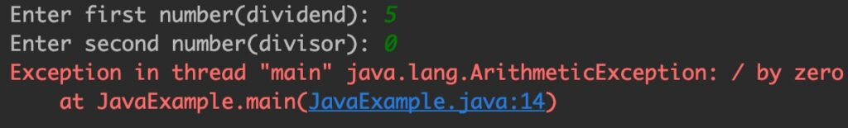

As you can see, the user input caused the program to throw Arithmetic exception, however this is not a good programming practice to leave such exceptions unhandled. Let’s handle this exception.

## Exception Handling in Java

Here, we are trying to handle the exception that is raised in the above program. You can see that the program ran fine and gave a meaningful error message which can be understood by the user.

**Note:** Do not worry about the try and catch blocks as we have covered these topics in detail in separate tutorials. For now just remember that the code that can throw exception needs to be inside try block and the catch block follows the try block, where the exception error message is set.

import java.util.Scanner;

public class JavaExample {

public static void main(String[] args) {

int num1, num2;

Scanner scan = new Scanner(System.in);

System.out.print("Enter first number(dividend): ");

num1 = scan.nextInt();

System.out.print("Enter second number(divisor): ");

num2 = scan.nextInt();

try {

int div = num1 / num2;

System.out.println("Quotient: "+div);

}catch(ArithmeticException e){

System.out.println("Do not enter divisor as zero.");

System.out.println("Error Message: "+e);

}

}

}

**Output:**  
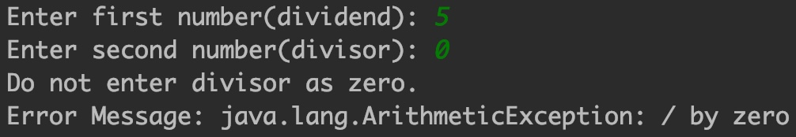  
If an exception occurs, which has not been handled by programmer then program execution gets terminated and a system generated error message is shown to the user.

These system generated messages are **not user friendly** so a user will not be able to understand what went wrong. In order to let them know the reason in simple language, we handle exceptions. We handle such exceptions and then prints a user friendly warning message to user, which lets them correct the error as most of the time **exception occurs due to bad data provided by user**.

### Why we handle the exceptions?

Exception handling ensures that the flow of the program doesn’t break when an exception occurs. For example, if a program has bunch of statements and an exception occurs mid way after executing certain statements then the statements, that occur after the statement that caused the exception will not execute and the program will terminate abruptly. By handling we make sure that all the statements execute and the flow of execution of program doesn’t break.

## Why an exception occurs?

There can be several reasons that can cause a program to throw exception. For example: Opening a non-existing file in your program, Network connection problem, bad input data provided by user etc. Let’s see few scenarios:  
**1. ArithmeticException:**  
We have already seen this exception in our example above. This exception occurs when we divide a number by zero. If we divide any number by zero.

int num = 25/0;//ArithmeticException

**2. NullPointerException:**  
When a variable contains null value and you are performing an operation on the variable. For example, if a string variable contains null and you are comparing with another string. Another example is when you are trying to print the length of the string that contains null.

String str = null;

//NullPointerException

System.out.println(str.length());

**3. NumberFormatException:**  
This exception occurs where there is a type mismatch. Let’s say you are trying to perform an arithmetic operator on a string variable.

String str = "beginnersbook.com";

//NumberFormatException

int num=Integer.parseInt(str);

**4. ArrayIndexOutOfBoundsException:**  
When you are trying to access the array index which is beyond the size of array. Here, we are trying to access the index 8 (9th element) but the size of the array is only 3. This exception occurs when you are accessing index which doesn’t exist.

int arr[]=new int[3];

//ArrayIndexOutOfBoundsException

arr[8]=100;

## Difference between error and exception

**Errors** indicate that something went wrong which is not in the scope of a programmer to handle. You cannot handle an error. Also, the error doesn’t occur due to bad data entered by user rather it indicates a system failure, disk crash or resource unavailability.

**Exceptions** are events that occurs during runtime due to bad data entered by user or an error in programming logic. A programmer can handle such conditions and take necessary corrective actions. Few examples:  
NullPointerException – When you try to use a reference that points to null.  
ArithmeticException – When bad data is provided by user, for example, when you try to divide a number by zero this exception occurs because dividing a number by zero is undefined.  
ArrayIndexOutOfBoundsException – When you try to access the elements of an array out of its bounds, for example array size is 5 (which means it has five elements) and you are trying to access the 10th element.

## Types of exceptions

There are two types of exceptions in Java:  
1) Checked exceptions  
2) Unchecked exceptions

## Hierarchy of Java Exception classes

The java.lang.Throwable class is the root class of Java Exception hierarchy inherited by two subclasses: Exception and Error. The hierarchy of Java Exception classes is given below:

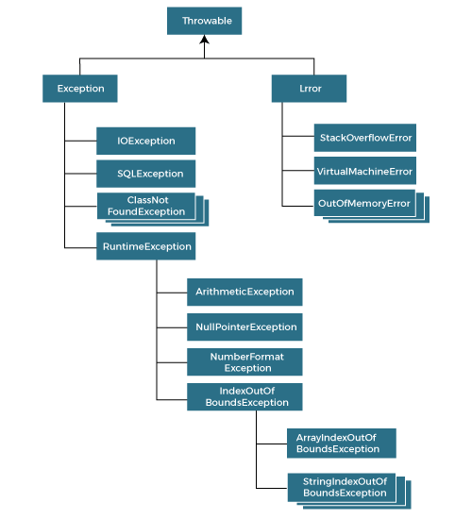

### 1) Checked exceptions

All exceptions other than Runtime Exceptions are known as Checked exceptions as the compiler checks them during compilation to see whether the programmer has handled them or not. If these exceptions are not handled/declared in the program, you will get compilation error. For example, SQLException, IOException, ClassNotFoundException etc.

### 2) Unchecked Exceptions

Runtime Exceptions are also known as Unchecked Exceptions. These exceptions are not checked at compile-time so compiler does not check whether the programmer has handled them or not but it’s the responsibility of the programmer to handle these exceptions and provide a safe exit.

For example, ArithmeticException, NullPointerException, ArrayIndexOutOfBoundsException etc. The examples that we seen above were unchecked exceptions.  
**Note:** Compiler doesn’t enforce you to catch such exceptions or ask you to declare it in the method using throws keyword.

## Frequently used terms in Exception handling

**try:** The code that can cause the exception, is placed inside try block. The try block detects whether the exception occurs or not, if exception occurs, it transfer the flow of program to the corresponding catch block or finally block. A try block is always followed by either a catch block or finally block.

**catch:** The catch block is where we write the logic to handle the exception, if it occurs. A catch block only executes if an exception is caught by the try block. A catch block is always accompanied by a try block.

**finally:** This block always executes whether an exception is occurred or not.

**throw:** It is used to explicitly throw an exception. It can be used to throw a checked or unchecked exception.

**throws:** It is used in method signature. It indicates that this method might throw one of the declared exceptions. While calling such methods, we need to handle the exceptions using try-catch block.

# Try Catch in Java – Exception handling

**Try catch block** is used for [**exception handling in Java**](https://beginnersbook.com/2013/04/java-exception-handling/). The code (or set of statements) that can throw an exception is placed inside **try block** and if the exception is raised, it is handled by the corresponding **catch block**. In this guide, we will see various examples to understand how to use try-catch for exception handling in java.

## Try block in Java

As mentioned in the beginning, try block contains set of statements where an exception can occur. A try block is always followed by a catch block or finally block, if exception occurs, the rest of the statements in the try block are skipped and the flow immediately jumps to the corresponding catch block.

**Note:** A try block must be followed by catch blocks or finally block or both.

### Syntax of try block with catch block

try{

//statements that may cause an exception

}catch(Exception e){

//statements that will execute when exception occurs

}

### Syntax of try block with finally block

try{

//statements that may cause an exception

}finally{

//statements that execute whether the exception occurs or not

}

### Syntax of try-catch-finally in Java

try{

//statements that may cause an exception

}catch(Exception e){

//statements that will execute if exception occurs

}finally{

//statements that execute whether the exception occurs or not

}

**Note:** It is upto the programmer to choose which statements needs to be placed inside try block. If programmer thinks that certain statements in a program can throw a exception, such statements can be enclosed inside try block and potential exceptions can be handled in catch blocks.

## Catch block in Java

A catch block is where you handle the exceptions, this block must immediately placed after a try block. **A single try block can have several catch blocks associated with it**. You can catch different exceptions in different catch blocks. When an exception occurs in try block, the corresponding catch block that handles that particular exception executes. For example if an arithmetic exception occurs in try block then the statements enclosed in catch block for arithmetic exception executes.

### Syntax of try catch in java

try

{

//statements that may cause an exception

}

catch (exception(type) e(object))‏

{

//error handling code

}

## Example: try catch in Java

If an exception occurs in try block then the control of execution is passed to the corresponding catch block. As discussed earlier, a single try block can have multiple catch blocks associated with it, you should place the catch blocks in such a way that the generic exception handler catch block is at the last(see in the example below).

The **generic exception handler** can handle all the exceptions but you should place is at the end, if you place it at the before all the catch blocks then it will display the generic message. You always want to give the user a meaningful message for each type of exception rather then a generic message.

class Example1 {

public static void main(String args[]) {

int num1, num2;

try {

  /\* We suspect that this block of statement can throw

\* exception so we handled it by placing these statements

\* inside try and handled the exception in catch block

\*/

num1 = 0;

num2 = 62 / num1;

System.out.println(num2);

System.out.println("Hey I'm at the end of try block");

}

  catch (ArithmeticException e) {

/\* This block will only execute if any Arithmetic exception

\* occurs in try block

\*/

System.out.println("You should not divide a number by zero");

}

catch (Exception e) {

/\* This is a generic Exception handler which means it can handle

\* all the exceptions. This will execute if the exception is not

\* handled by previous catch blocks.

\*/

System.out.println("Exception occurred");

}

System.out.println("I'm out of try-catch block in Java.");

}

}

Output:

You should not divide a number by zero

I'm out of try-catch block in Java.

## Multiple catch blocks in Java

The example we seen above is having multiple catch blocks, let’s see few rules about multiple catch blocks with the help of examples. To read this in detail, see [**catching multiple exceptions in java**](https://beginnersbook.com/2013/05/catch-multiple-exceptions/).

1. As I mentioned above, a single try block can have any number of catch blocks.

2. A generic catch block can handle all the exceptions. Whether it is ArrayIndexOutOfBoundsException or ArithmeticException or NullPointerException or any other type of exception, this handles all of them. To see the examples of NullPointerException and ArrayIndexOutOfBoundsException, refer this article: [**Exception Handling example programs**](https://beginnersbook.com/2013/04/exception-handling-examples/).

catch(Exception e){

  //This catch block catches all the exceptions

}

If you are wondering why we need other catch handlers when we have a generic that can handle all. This is because in generic exception handler you can display a message but you are not sure for which type of exception it may trigger so it will display the same message for all the exceptions and user may not be able to understand which exception occurred. Thats the reason you should place is at the end of all the specific exception catch blocks

3. If **no exception** occurs in try block then the **catch blocks are completely ignored**.

4. Corresponding catch blocks execute for that specific type of exception:  
catch(ArithmeticException e) is a catch block that can handle ArithmeticException  
catch(NullPointerException e) is a catch block that can handle NullPointerException

5. You can also throw exception, which is an advanced topic and I have covered it in separate tutorials: [**user defined exception**](https://beginnersbook.com/2013/04/user-defined-exception-in-java/), [**throws keyword**](https://beginnersbook.com/2013/12/throws-keyword-example-in-java/), [**throw vs throws**](https://beginnersbook.com/2013/04/difference-between-throw-and-throws-in-java/).  
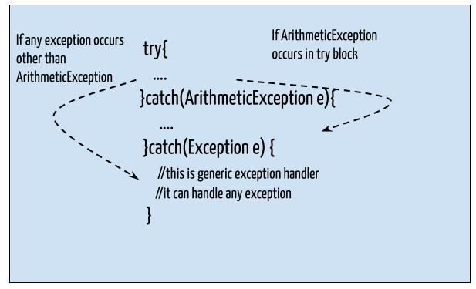

### Example of Multiple catch blocks

class Example2{

public static void main(String args[]){

try{

int a[]=new int[7];

a[4]=30/0;

System.out.println("First print statement in try block");

}

catch(ArithmeticException e){

System.out.println("Warning: ArithmeticException");

}

catch(ArrayIndexOutOfBoundsException e){

System.out.println("Warning: ArrayIndexOutOfBoundsException");

}

catch(Exception e){

System.out.println("Warning: Some Other exception");

}

System.out.println("Out of try-catch block...");

}

}

Output:

Warning: ArithmeticException

Out of try-catch block...

In the above example there are multiple catch blocks and these catch blocks executes sequentially when an exception occurs in try block. Which means if you put the last catch block ( catch(Exception e)) at the first place, just after try block then in case of any exception this block will execute as it can handle all exceptions. This catch block should be placed at the last to avoid such situations.

## Finally block

I have covered this in a separate tutorial here: [**java finally block**](https://beginnersbook.com/2013/04/java-finally-block/). For now you just need to know that **this block executes whether an exception occurs or not**. You should place those statements in finally blocks, that must execute whether exception occurs or not.

# How to Catch multiple exceptions

I have covered how to handle exceptions using try-catch blocks. In this guide, we will see how to handle multiple exceptions and how to write them in a correct order so that user gets a meaningful message for each type of exception.

## Catching multiple exceptions

Lets take an example to understand how to handle multiple exceptions.

class Example{

public static void main(String args[]){

try{

int arr[]=new int[7];

arr[4]=30/0;

System.out.println("Last Statement of try block");

}

catch(ArithmeticException e){

System.out.println("You should not divide a number by zero");

}

catch(ArrayIndexOutOfBoundsException e){

System.out.println("Accessing array elements outside of the limit");

}

catch(Exception e){

System.out.println("Some Other Exception");

}

System.out.println("Out of the try-catch block");

}

}

**Output:**

You should not divide a number by zero

Out of the try-catch block

In the above example, the first catch block got executed because the code we have written in try block throws ArithmeticException (because we divided the number by zero).

**Now lets change the code a little bit and see the change in output:**

class Example{

public static void main(String args[]){

try{

int arr[]=new int[7];

arr[10]=10/5;

System.out.println("Last Statement of try block");

}

catch(ArithmeticException e){

System.out.println("You should not divide a number by zero");

}

catch(ArrayIndexOutOfBoundsException e){

System.out.println("Accessing array elements outside of the limit");

}

catch(Exception e){

System.out.println("Some Other Exception");

}

System.out.println("Out of the try-catch block");

}

}

Output:

Accessing array elements outside of the limit

Out of the try-catch block

In this case, the second catch block got executed because the code throws ArrayIndexOutOfBoundsException. We are trying to access the 11th element of array in above program but the array size is only 7.

**What did we observe from the above two examples?**  
1. It is clear that when an exception occurs, the specific catch block (that declares that exception) executes. This is why in first example first block executed and in second example second catch.  
2. Although I have not shown you above, but if an exception occurs in above code which is not Arithmetic and ArrayIndexOutOfBounds then the last generic catch handler would execute.

**Lets change the code again and see the output:**

class Example{

public static void main(String args[]){

try{

int arr[]=new int[7];

arr[10]=10/5;

System.out.println("Last Statement of try block");

}

catch(Exception e){

System.out.println("Some Other Exception");

}

catch(ArithmeticException e){

System.out.println("You should not divide a number by zero");

}

catch(ArrayIndexOutOfBoundsException e){

System.out.println("Accessing array elements outside of the limit");

}

System.out.println("Out of the try-catch block");

}

}

**Output:**

Compile time error: Exception in thread "main" java.lang.Error:

Unresolved compilation problems: Unreachable catch block for ArithmeticException.

It is already handled by the catch block for Exception Unreachable catch block

for ArrayIndexOutOfBoundsException. It is already handled by the catch block for

Exception at Example.main(Example1.java:11)

**Why we got this error?**  
This is because we placed the generic exception catch block at the first place which means that none of the catch blocks placed after this block is reachable. You should always place this block at the end of all other specific exception catch blocks.

# Nested try catch block in Java – Exception handling

BY CHAITANYA SINGH

When a [**try catch block**](https://beginnersbook.com/2013/04/try-catch-in-java/) is present in another try block then it is called the nested try catch block. Each time a try block does not have a catch handler for a particular [**exception**](https://beginnersbook.com/2013/04/java-exception-handling/), then the catch blocks of parent try block are inspected for that exception, if match is found that that catch block executes.

If neither catch block nor parent catch block handles exception then the system generated message would be shown for the exception, similar to what we see when we don’t handle exception.

Lets see the syntax first then we will discuss this with an example.

## Syntax of Nested try Catch

....

//Main try block

try {

statement 1;

statement 2;

//try-catch block inside another try block

try {

statement 3;

statement 4;

//try-catch block inside nested try block

try {

statement 5;

statement 6;

}

catch(Exception e2) {

//Exception Message

}

}

catch(Exception e1) {

//Exception Message

}

}

//Catch of Main(parent) try block

catch(Exception e3) {

//Exception Message

}

....

## Nested Try Catch Example

Here we have deep (two level) nesting which means we have a try-catch block inside a nested try block. To make you understand better I have given the names to each try block in comments like try-block2, try-block3 etc.

This is how the structure is: try-block3 is inside try-block2 and try-block2 is inside main try-block, you can say that the main try-block is a grand parent of the try-block3. Refer the explanation which is given at the end of this code.

class NestingDemo{

public static void main(String args[]){

//main try-block

try{

//try-block2

try{

//try-block3

try{

int arr[]= {1,2,3,4};

/\* I'm trying to display the value of

\* an element which doesn't exist. The

\* code should throw an exception

\*/

System.out.println(arr[10]);

}catch(ArithmeticException e){

System.out.print("Arithmetic Exception");

System.out.println(" handled in try-block3");

}

}

catch(ArithmeticException e){

System.out.print("Arithmetic Exception");

System.out.println(" handled in try-block2");

}

}

catch(ArithmeticException e3){

System.out.print("Arithmetic Exception");

System.out.println(" handled in main try-block");

}

catch(ArrayIndexOutOfBoundsException e4){

System.out.print("ArrayIndexOutOfBoundsException");

System.out.println(" handled in main try-block");

}

catch(Exception e5){

System.out.print("Exception");

System.out.println(" handled in main try-block");

}

}

}

Output:

ArrayIndexOutOfBoundsException handled in main try-block

As you can see that the ArrayIndexOutOfBoundsException occurred in the grand child try-block3. Since try-block3 is not handling this exception, the control then gets transferred to the parent try-block2 and looked for the catch handlers in try-block2. Since the try-block2 is also not handling that exception, the control gets transferred to the main (grand parent) try-block where it found the appropriate catch block for exception. This is how the the nesting structure works.

## Example 2: Nested try block

class Nest{

public static void main(String args[]){

//Parent try block

try{

//Child try block1

try{

System.out.println("Inside block1");

int b =45/0;

System.out.println(b);

}

catch(ArithmeticException e1){

System.out.println("Exception: e1");

}

//Child try block2

try{

System.out.println("Inside block2");

int b =45/0;

System.out.println(b);

}

catch(ArrayIndexOutOfBoundsException e2){

System.out.println("Exception: e2");

}

System.out.println("Just other statement");

}

catch(ArithmeticException e3){

System.out.println("Arithmetic Exception");

System.out.println("Inside parent try catch block");

}

catch(ArrayIndexOutOfBoundsException e4){

System.out.println("ArrayIndexOutOfBoundsException");

System.out.println("Inside parent try catch block");

}

catch(Exception e5){

System.out.println("Exception");

System.out.println("Inside parent try catch block");

}

System.out.println("Next statement..");

}

}

**Output:**

Inside block1

Exception: e1

Inside block2

Arithmetic Exception

Inside parent try catch block

Next statement..

This is another example that shows how the nested try block works. You can see that there are two try-catch block inside main try block’s body. I’ve marked them as block 1 and block 2 in above example.  
**Block1:**I have divided an integer by zero and it caused an ArithmeticException, since the catch of block1 is handling ArithmeticException "Exception: e1" displayed.

**Block2:**In block2, ArithmeticException occurred but block 2 catch is only handling ArrayIndexOutOfBoundsException so in this case control jump to the Main try-catch(parent) body and checks for the ArithmeticException catch handler in parent catch blocks. Since catch of parent try block is handling this exception using generic Exception handler that handles all exceptions, the message “Inside parent try catch block” displayed as output.

**Parent try Catch block:** No exception occurred here so the “Next statement..” displayed.

The important point to note here is that whenever the child catch blocks are not handling any exception, the jumps to the parent catch blocks, if the exception is not handled there as well then the program will terminate abruptly showing system generated message.

# Java Finally block – Exception handling

BY CHAITANYA SINGH

In the previous tutorials I have covered [**try-catch block**](https://beginnersbook.com/2013/04/try-catch-in-java/) and [**nested try block**](https://beginnersbook.com/2013/04/nested-try-catch/). In this guide, we will see finally block which is used along with try-catch.  
A **finally block** contains all the crucial statements that must be executed whether exception occurs or not. The statements present in this block will always execute regardless of whether exception occurs in try block or not such as closing a connection, stream etc.

## Syntax of Finally block

try {

//Statements that may cause an exception

}

catch {

//Handling exception

}

finally {

//Statements to be executed

}

## A Simple Example of finally block

Here you can see that the exception occurred in try block which has been handled in catch block, after that finally block got executed.

class Example

{

public static void main(String args[]) {

try{

int num=121/0;

System.out.println(num);

}

catch(ArithmeticException e){

System.out.println("Number should not be divided by zero");

}

/\* Finally block will always execute

\* even if there is no exception in try block

\*/

finally{

System.out.println("This is finally block");

}

System.out.println("Out of try-catch-finally");

}

}

**Output:**

Number should not be divided by zero

This is finally block

Out of try-catch-finally

## Few Important points regarding finally block

1. A finally block must be associated with a try block, you cannot use finally without a try block. You should place those statements in this block that must be executed always.

2. Finally block is optional, as we have seen in previous tutorials that a try-catch block is sufficient for [**exception handling**](https://beginnersbook.com/2013/04/java-exception-handling/), however if you place a finally block then it will always run after the execution of try block.

3. In normal case when there is no exception in try block then the finally block is executed after try block. However if an exception occurs then the catch block is executed before finally block.

4. An exception in the finally block, behaves exactly like any other exception.

5. The statements present in the **finally block** execute even if the try block contains control transfer statements like return, break or continue.  
Lets see an example to see how finally works when return statement is present in try block:

### Another example of finally block and return statement

You can see that even though we have return statement in the method, the finally block still runs.

class JavaFinally

{

public static void main(String args[])

{

System.out.println(JavaFinally.myMethod());

}

public static int myMethod()

{

try {

return 112;

}

finally {

System.out.println("This is Finally block");

System.out.println("Finally block ran even after return statement");

}

}

}

**Output of above program:**

This is Finally block

Finally block ran even after return statement

112

To see more examples of finally and return refer: [**Java finally block and return statement**](https://beginnersbook.com/2013/05/java-finally-return/)  
.

## Cases when the finally block doesn’t execute

The circumstances that prevent execution of the code in a finally block are:  
– The death of a Thread  
– Using of the System. exit() method.  
– Due to an exception arising in the finally block.

## Finally and Close()

**close()** statement is used to close all the open streams in a program. Its a good practice to use close() inside finally block. Since finally block executes even if exception occurs so you can be sure that all input and output streams are closed properly regardless of whether the exception occurs or not.

For example:

....

try{

OutputStream osf = new FileOutputStream( "filename" );

OutputStream osb = new BufferedOutputStream(opf);

ObjectOutput op = new ObjectOutputStream(osb);

try{

output.writeObject(writableObject);

}

finally{

op.close();

}

}

catch(IOException e1){

System.out.println(e1);

}

...

## Finally block without catch

A try-finally block is possible without catch block. Which means a try block can be used with finally without having a catch block.

...

InputStream input = null;

try {

input = new FileInputStream("inputfile.txt");

}

finally {

if (input != null) {

try {

in.close();

}catch (IOException exp) {

System.out.println(exp);

}

}

}

...

## Finally block and System.exit()

**System.exit()** statement behaves differently than**return statement**. Unlike return statement whenever System.exit() gets called in try block then **Finally block** doesn’t execute. Here is a code snippet that demonstrate the same:

....

try {

//try block

System.out.println("Inside try block");

System.exit(0)

}

catch (Exception exp) {

System.out.println(exp);

}

finally {

System.out.println("Java finally block");

}

....

In the above example if the**System.exit(0)** gets called without any exception then finally won’t execute. However if any exception occurs while calling **System.exit(0)** then finally block will be executed.

## try-catch-finally block

* Either a try statement should be associated with a catch block or with finally.
* Since catch performs exception handling and finally performs the cleanup, the best approach is to use both of them.

**Syntax:**

try {

//statements that may cause an exception

}

catch (…)‏ {

//error handling code

}

finally {

//statements to be executed

}

### Examples of Try catch finally blocks

**Example 1:** The following example demonstrate the working of finally block when no exception occurs in try block

class Example1{

public static void main(String args[]){

try{

System.out.println("First statement of try block");

int num=45/3;

System.out.println(num);

}

catch(ArrayIndexOutOfBoundsException e){

System.out.println("ArrayIndexOutOfBoundsException");

}

finally{

System.out.println("finally block");

}

System.out.println("Out of try-catch-finally block");

}

}

**Output:**

First statement of try block

15

finally block

Out of try-catch-finally block

**Example 2:** This example shows the working of finally block when an exception occurs in try block but is not handled in the catch block:

class Example2{

public static void main(String args[]){

try{

System.out.println("First statement of try block");

int num=45/0;

System.out.println(num);

}

catch(ArrayIndexOutOfBoundsException e){

System.out.println("ArrayIndexOutOfBoundsException");

}

finally{

System.out.println("finally block");

}

System.out.println("Out of try-catch-finally block");

}

}

**Output:**

First statement of try block

finally block

Exception in thread "main" java.lang.ArithmeticException: / by zero

at beginnersbook.com.Example2.main(Details.java:6)

As you can see that the system generated exception message is shown but before that the finally block successfully executed.

**Example 3**: When exception occurs in try block and handled properly in catch block

class Example3{

public static void main(String args[]){

try{

System.out.println("First statement of try block");

int num=45/0;

System.out.println(num);

}

catch(ArithmeticException e){

System.out.println("ArithmeticException");

}

finally{

System.out.println("finally block");

}

System.out.println("Out of try-catch-finally block");

}

}

**Output:**

First statement of try block

ArithmeticException

finally block

Out of try-catch-finally block

[**❮ Previous**](https://beginnersbook.com/2013/04/nested-try-catch/)[**Next ❯**](https://beginnersbook.com/2013/04/throw-in-java/)

# How to throw exception in java with example

In Java we have already defined exception classes such as ArithmeticException, NullPointerException, ArrayIndexOutOfBounds exception etc. These exceptions are set to trigger on different-2 conditions. For example when we divide a number by zero, this triggers ArithmeticException, when we try to access the array element out of its bounds then we get ArrayIndexOutOfBoundsException.

We can define our own set of conditions or rules and throw an exception explicitly using throw keyword. For example, we can throw ArithmeticException when we divide number by 5, or any other numbers, what we need to do is just set the condition and throw any exception using throw keyword. Throw keyword can also be used for throwing custom exceptions, I have covered that in a separate tutorial, see [**Custom Exceptions in Java**](https://beginnersbook.com/2013/04/user-defined-exception-in-java/).

**Syntax of throw keyword:**

throw new exception\_class("error message");

For example:

throw new ArithmeticException("dividing a number by 5 is not allowed in this program");

## Example of throw keyword

Lets say we have a requirement where we we need to only register the students when their age is less than 12 and weight is less than 40, if any of the condition is not met then the user should get an ArithmeticException with the warning message “Student is not eligible for registration”. We have implemented the logic by placing the code in the method that checks student eligibility if the entered student age and weight doesn’t met the criteria then we throw the exception using throw keyword.

/\* In this program we are checking the Student age

\* if the student age<12 and weight <40 then our program

\* should return that the student is not eligible for registration.

\*/

public class ThrowExample {

static void checkEligibilty(int stuage, int stuweight){

if(stuage<12 && stuweight<40) {

throw new ArithmeticException("Student is not eligible for registration");

}

else {

System.out.println("Student Entry is Valid!!");

}

}

public static void main(String args[]){

System.out.println("Welcome to the Registration process!!");

checkEligibilty(10, 39);

System.out.println("Have a nice day..");

}

}

Output:

Welcome to the Registration process!!Exception in thread "main"

java.lang.ArithmeticException: Student is not eligible for registration

at beginnersbook.com.ThrowExample.checkEligibilty(ThrowExample.java:9)

at beginnersbook.com.ThrowExample.main(ThrowExample.java:18)

# Java Throws Keyword in Exception handling

The throws keyword is used to handle checked exceptions. As we learned in the previous article that exceptions are of two types: [**checked and unchecked**](https://beginnersbook.com/2013/04/java-checked-unchecked-exceptions-with-examples/). Checked exception (compile time) needs to be handled else the program won’t compile. On the other hand unchecked exception (Runtime) doesn’t get checked during compilation. **Throws keyword** is **used for handling checked exceptions**. You can declare multiple exceptions using throws keyword.

## The throws keyword vs try-catch in Java

You may be wondering why we need throws keyword when we can handle exceptions using try-catch block in Java. Well, thats a valid question. We already know we can [**handle exceptions**](https://beginnersbook.com/2013/04/java-exception-handling/) using [**try-catch block**](https://beginnersbook.com/2013/04/try-catch-in-java/).

The throws keyword does the same thing that try-catch does but there are some cases where you would prefer throws over try-catch. **For example:** Lets say we have a method myMethod() the statements inside this method can throw either ArithmeticException or NullPointerException, in this case you can use try-catch as shown below:

public void myMethod()

{

try {

// Statements that might throw an exception

}

catch (ArithmeticException e) {

// Exception handling statements

}

catch (NullPointerException e) {

// Exception handling statements

}

}

But suppose you have several such methods that can cause exceptions, in that case it would be tedious to write these try-catch for each method. The code will become unnecessary long and will be less-readable.

One way to overcome this problem is by using throws like this: declare the exceptions in the method signature using throws and handle the exceptions where you are calling this method by using try-catch.

Another advantage of using this approach is that you will be forced to handle the exception when you call this method, all the exceptions that are declared using throws, must be handled where you are calling this method else you will get compilation error.

public void myMethod() throws ArithmeticException, NullPointerException

{

// Statements that might throw an exception

}

public static void main(String args[]) {

try {

myMethod();

}

catch (ArithmeticException e) {

// Exception handling statements

}

catch (NullPointerException e) {

// Exception handling statements

}

}

## Example of throws Keyword

In this example the method myMethod() is throwing two **checked exceptions** so we have declared these exceptions in the method signature using **throws** Keyword. If we do not declare these exceptions then the program will throw a compilation error.

import java.io.\*;

class ThrowExample {

void myMethod(int num)throws IOException, ClassNotFoundException{

if(num==1)

throw new IOException("IOException Occurred");

else

throw new ClassNotFoundException("ClassNotFoundException");

}

}

public class Example1{

public static void main(String args[]){

try{

ThrowExample obj=new ThrowExample();

obj.myMethod(1);

}catch(Exception ex){

System.out.println(ex);

}

}

}

Output:

java.io.IOException: IOException Occurred

# Examples of throws Keyword in Java

In this guide, we will see few examples of throws keyword. I highly recommend you to read my detailed guide on [**throws keyword**](https://beginnersbook.com/2013/04/java-throws/) before going through these examples so that you have a better understand of the this concept.

Read these guides to learn exception handling from scratch:

* [**Exception handling in Java – complete guide**](https://beginnersbook.com/2013/04/java-exception-handling/)
* [**Exception handling examples**](https://beginnersbook.com/2013/04/exception-handling-examples/)

## Example 1: Exception propagation using throws keyword

In this example we are seeing an example of throws keyword in exception propagation. Here, an exception occurred in method1() which has been handled in the chain-calling method method3().

This example shows how exception propagation works. If the exception is not handled in the method then compiler checks whether the exception is handled in the calling method.

Here compiler didn’t find exception handling in method1(), so it checked in the calling method method2(), then it checked in the calling method method3(), where the exception is handled. The exception propagation concept is explained in detail [**here**](https://beginnersbook.com/2022/09/exception-propagation-in-java-with-examples/).

class Example1{

void method1() throws ArithmeticException{

throw new ArithmeticException("Calculation error");

}

void method2() throws ArithmeticException{

method1();

}

void method3(){

try{

method2();

}

catch(ArithmeticException e){

System.out.println("ArithmeticException handled");

}

}

public static void main(String args[]){

Example1 obj=new Example1();

obj.method3();

System.out.println("End Of Program");

}

}

**Output:**

ArithmeticException handled

End Of Program

## Example 2: throw and throws keyword example

In this example, we are using both [**throw keyword**](https://beginnersbook.com/2013/12/throw-keyword-example-in-java/) and throws keyword. We have declared the IOException using throws keyword and using the throw keyword to raise the exception in the myMethod().

import java.io.\*;

class Demo{

void myMethod()throws IOException{

//throw exception using throw keyword

throw new IOException("IO Exception occurred");

}

}

class JavaExample{

//declared IOException using throws keyword

public static void main(String args[])throws IOException{

Demo obj = new Demo();

obj.myMethod();

System.out.println("Rest of the program");

}

}

**Output:**  


## Example 3: When you don’t handle exception that is declared using throws

The ideal way to use throws is by declaring the exceptions in method signature and handle the exceptions using try-catch in calling method. Let’s see what happens when we declare the exception at both the places, in method signature as well as in calling method.

class ExceptionExample{

void method()throws ArithmeticException{

throw new ArithmeticException("ArithmeticException Occurred");

}

}

class Example1{

public static void main(String args[])throws ArithmeticException{

ExceptionExample obj=new ExceptionExample();

obj.method();

System.out.println("End Of Program");

}

}

**Output:**

Exception in thread "main" java.lang.ArithmeticException:

ArithmeticException Occurred

at ExceptionExample.method(Example1.java:4)

at Example1.main(Example1.java:10)

# User defined exception in java

In java we have already defined, exception classes such as ArithmeticException, NullPointerException etc. These exceptions are already set to trigger on pre-defined conditions such as when you divide a number by zero it triggers ArithmeticException, In the last tutorial we learnt how to throw these exceptions explicitly based on your conditions using [**throw keyword**](https://beginnersbook.com/2013/04/throw-in-java/).

In java we can create our own exception class and throw that exception using throw keyword. These exceptions are known as **user-defined** or **custom** exceptions. In this tutorial we will see how to create your own custom exception and throw it on a particular condition.

To understand this tutorial you should have the basic knowledge of [**try-catch block**](https://beginnersbook.com/2013/04/try-catch-in-java/) and [**throw in java**](https://beginnersbook.com/2013/04/throw-in-java/).

## Example of User defined exception in Java

/\* This is my Exception class, I have named it MyException

\* you can give any name, just remember that it should

\* extend Exception class

\*/

class MyException extends Exception{

String str1;

/\* Constructor of custom exception class

\* here I am copying the message that we are passing while

\* throwing the exception to a string and then displaying

\* that string along with the message.

\*/

MyException(String str2) {

str1=str2;

}

public String toString(){

return ("MyException Occurred: "+str1) ;

}

}

class Example1{

public static void main(String args[]){

try{

System.out.println("Starting of try block");

// I'm throwing the custom exception using throw

throw new MyException("This is My error Message");

}

catch(MyException exp){

System.out.println("Catch Block") ;

System.out.println(exp) ;

}

}

}

**Output:**

Starting of try block

Catch Block

MyException Occurred: This is My error Message

**Explanation:**  
You can see that while throwing custom exception I gave a string in parenthesis ( throw new MyException("This is My error Message");). That’s why we have a [**parameterized constructor**](https://beginnersbook.com/2014/01/parameterized-constructor-in-java-example/) (with a String parameter) in my custom exception class.

**Notes:**  
1. User-defined exception must extend Exception class.  
2. The exception is thrown using throw keyword.

## Another Example of Custom Exception

In this example we are throwing an exception from a method. In this case we should use throws clause in the method signature otherwise you will get compilation error saying that “unhandled exception in method”. To understand how throws clause works, refer this guide: [**throws keyword in java**](https://beginnersbook.com/2013/04/java-throws/).

class InvalidProductException extends Exception

{

public InvalidProductException(String s)

{

// Call constructor of parent Exception

super(s);

}

}

public class Example1

{

void productCheck(int weight) throws InvalidProductException{

if(weight<100){

throw new InvalidProductException("Product Invalid");

}

}

public static void main(String args[])

{

Example1 obj = new Example1();

try

{

obj.productCheck(60);

}

catch (InvalidProductException ex)

{

System.out.println("Caught the exception");

System.out.println(ex.getMessage());

}

}

}

**Output:**

Caught the exception

Product Invalid

# Java Nested and Inner Class

In Java, you can define a class within another class. Such class is known as nested class. For example,

class OuterClass {

// ...

class NestedClass {

// ...

}

}

There are two types of nested classes you can create in Java.

* Non-static nested class (inner class)
* Static nested class

**Recommended reading**:

* [Java Access Modifiers](https://www.programiz.com/java-programming/access-modifiers)
* [Java Static Keyword](https://www.programiz.com/java-programming/static-keyword)

Let's first look at non-static nested classes.

## Non-Static Nested Class (Inner Class)

A non-static nested class is a class within another class. It has access to members of the enclosing class (outer class). It is commonly known as inner class.

Since the inner class exists within the outer class, you must instantiate the outer class first, in order to instantiate the inner class.

Here's an example of how you can declare inner classes in Java.

### Example 1: Inner class

class CPU {

double price;

// nested class

class Processor{

// members of nested class

double cores;

String manufacturer;

double getCache(){

return 4.3;

}

}

// nested protected class

protected class RAM{

// members of protected nested class

double memory;

String manufacturer;

double getClockSpeed(){

return 5.5;

}

}

}

public class Main {

public static void main(String[] args) {

// create object of Outer class CPU

CPU cpu = new CPU();

// create an object of inner class Processor using outer class

CPU.Processor processor = cpu.new Processor();

// create an object of inner class RAM using outer class CPU

CPU.RAM ram = cpu.new RAM();

System.out.println("Processor Cache = " + processor.getCache());

System.out.println("Ram Clock speed = " + ram.getClockSpeed());

}

}

[Run Code](https://www.programiz.com/java-programming/online-compiler)

**Output**:

Processor Cache = 4.3

Ram Clock speed = 5.5

In the above program, there are two nested classes: Processor and RAM inside the outer class: CPU. We can declare the inner class as protected. Hence, we have declared the RAM class as protected.

Inside the Main class,

* we first created an instance of an outer class CPU named cpu.
* Using the instance of the outer class, we then created objects of inner classes:
* CPU.Processor processor = cpu.new Processor;

CPU.RAM ram = cpu.new RAM();

**Note**: We use the dot (.) operator to create an instance of the inner class using the outer class.

### Accessing Members of Outer Class within Inner Class

We can access the members of the outer class by using this keyword. If you want to learn about this keyword, visit [Java this keyword](https://docs.oracle.com/javase/tutorial/java/javaOO/thiskey.html).

### Example 2: Accessing Members

class Car {

String carName;

String carType;

// assign values using constructor

public Car(String name, String type) {

this.carName = name;

this.carType = type;

}

// private method

private String getCarName() {

return this.carName;

}

// inner class

class Engine {

String engineType;

void setEngine() {

// Accessing the carType property of Car

if(Car.this.carType.equals("4WD")){

// Invoking method getCarName() of Car

if(Car.this.getCarName().equals("Crysler")) {

this.engineType = "Smaller";

} else {

this.engineType = "Bigger";

}

}else{

this.engineType = "Bigger";

}

}

String getEngineType(){

return this.engineType;

}

}

}

public class Main {

public static void main(String[] args) {

// create an object of the outer class Car

Car car1 = new Car("Mazda", "8WD");

// create an object of inner class using the outer class

Car.Engine engine = car1.new Engine();

engine.setEngine();

System.out.println("Engine Type for 8WD= " + engine.getEngineType());

Car car2 = new Car("Crysler", "4WD");

Car.Engine c2engine = car2.new Engine();

c2engine.setEngine();

System.out.println("Engine Type for 4WD = " + c2engine.getEngineType());

}

}

[Run Code](https://www.programiz.com/java-programming/online-compiler)

**Output**:

Engine Type for 8WD= Bigger

Engine Type for 4WD = Smaller

In the above program, we have the inner class named Engine inside the outer class Car. Here, notice the line,

if(Car.this.carType.equals("4WD")) {...}

We are using this keyword to access the carType variable of the outer class. You may have noticed that instead of using this.carType we have used Car.this.carType.

It is because if we had not mentioned the name of the outer class Car, then this keyword will represent the member inside the inner class.

Similarly, we are also accessing the method of the outer class from the inner class.

if (Car.this.getCarName().equals("Crysler") {...}

It is important to note that, although the getCarName() is a private method, we are able to access it from the inner class.

## Static Nested Class

In Java, we can also define a static class inside another class. Such class is known as static nested class. Static nested classes are not called static inner classes.

Unlike inner class, a static nested class cannot access the member variables of the outer class. It is because the **static nested class** doesn't require you to create an instance of the outer class.

OuterClass.NestedClass obj = new OuterClass.NestedClass();

Here, we are creating an object of the **static nested class** by simply using the class name of the outer class. Hence, the outer class cannot be referenced using OuterClass.this.

### Example 3: Static Inner Class

class MotherBoard {

// static nested class

static class USB{

int usb2 = 2;

int usb3 = 1;

int getTotalPorts(){

return usb2 + usb3;

}

}

}

public class Main {

public static void main(String[] args) {

// create an object of the static nested class

// using the name of the outer class

MotherBoard.USB usb = new MotherBoard.USB();

System.out.println("Total Ports = " + usb.getTotalPorts());

}

}

[Run Code](https://www.programiz.com/java-programming/online-compiler)

**Output**:

Total Ports = 3

In the above program, we have created a static class named USB inside the class MotherBoard. Notice the line,

MotherBoard.USB usb = new MotherBoard.USB();

Here, we are creating an object of USB using the name of the outer class.

Now, let's see what would happen if you try to access the members of the outer class:

### Example 4: Accessing members of Outer class inside Static Inner Class

class MotherBoard {

String model;

public MotherBoard(String model) {

this.model = model;

}

// static nested class

static class USB{

int usb2 = 2;

int usb3 = 1;

int getTotalPorts(){

// accessing the variable model of the outer classs

if(MotherBoard.this.model.equals("MSI")) {

return 4;

}

else {

return usb2 + usb3;

}

}

}

}

public class Main {

public static void main(String[] args) {

// create an object of the static nested class

MotherBoard.USB usb = new MotherBoard.USB();

System.out.println("Total Ports = " + usb.getTotalPorts());

}

}

[Run Code](https://www.programiz.com/java-programming/online-compiler)

When we try to run the program, we will get an error:

error: non-static variable this cannot be referenced from a static context

This is because we are not using the object of the outer class to create an object of the inner class. Hence, there is no reference to the outer class Motherboard stored in Motherboard.this.

### Key Points to Remember

* Java treats the inner class as a regular member of a class. They are just like methods and variables declared inside a class.
* Since inner classes are members of the outer class, you can apply any access modifiers like private, protected to your inner class which is not possible in normal classes.
* Since the nested class is a member of its enclosing outer class, you can use the dot (.) notation to access the nested class and its members.
* Using the nested class will make your code more readable and provide better encapsulation.
* Non-static nested classes (inner classes) have access to other members of the outer/enclosing class, even if they are declared privateprivate.

**Multithreading in [Java](https://www.javatpoint.com/java-tutorial)**

is a process of executing multiple threads simultaneously.

A thread is a lightweight sub-process, the smallest unit of processing. Multiprocessing and multithreading, both are used to achieve multitasking.

However, we use multithreading than multiprocessing because threads use a shared memory area. They don't allocate separate memory area so saves memory, and context-switching between the threads takes less time than process.

Java Multithreading is mostly used in games, animation, etc.

47.7M

1.1K

Features of Java - Javatpoint

### **Advantages of Java Multithreading**

1) It **doesn't block the user** because threads are independent and you can perform multiple operations at the same time.

2) You **can perform many operations together, so it saves time**.

3) Threads are **independent**, so it doesn't affect other threads if an exception occurs in a single thread.

## Multitasking

Multitasking is a process of executing multiple tasks simultaneously. We use multitasking to utilize the CPU. Multitasking can be achieved in two ways:

* Process-based Multitasking (Multiprocessing)
* Thread-based Multitasking (Multithreading)

### **1) Process-based Multitasking (Multiprocessing)**

* Each process has an address in memory. In other words, each process allocates a separate memory area.
* A process is heavyweight.
* Cost of communication between the process is high.
* Switching from one process to another requires some time for saving and loading [registers](https://www.javatpoint.com/register-memory)

, memory maps, updating lists, etc.

### **2) Thread-based Multitasking (Multithreading)**

* Threads share the same address space.
* A thread is lightweight.
* Cost of communication between the thread is low.

#### **Note: At least one process is required for each thread.**

## What is Thread in java

A thread is a lightweight subprocess, the smallest unit of processing. It is a separate path of execution.

Threads are independent. If there occurs exception in one thread, it doesn't affect other threads. It uses a shared memory area.

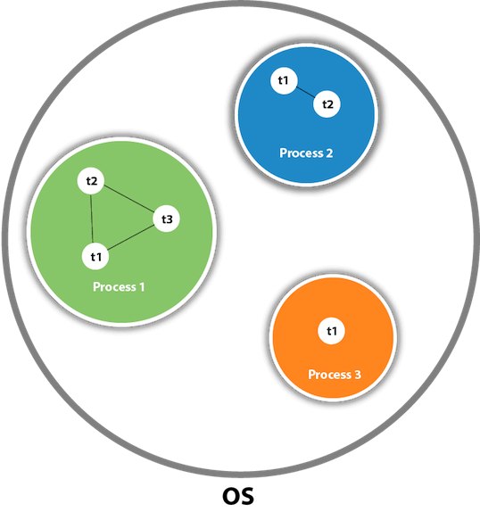

As shown in the above figure, a thread is executed inside the process. There is context-switching between the threads. There can be multiple processes inside the [OS](https://www.javatpoint.com/os-tutorial)

, and one process can have multiple threads.

#### **Note: At a time one thread is executed only.**

## Java Thread class

Java provides **Thread class** to achieve thread programming. Thread class provides [constructors](https://www.javatpoint.com/java-constructor)

and methods to create and perform operations on a thread. Thread class extends [Object class](https://www.javatpoint.com/object-class)

and implements Runnable interface.

**Thread Life Cycle in Java**

The Lifecycle of a thread:

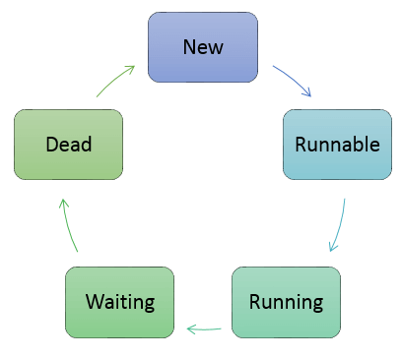

Thread Life Cycle in Java

There are various stages of life cycle of thread as shown in above diagram:

1. New
2. Runnable
3. Running
4. Waiting
5. Dead
6. **New:** In this phase, the thread is created using class “Thread class”.It remains in this state till the program **starts** the thread. It is also known as born thread.
7. **Runnable:** In this page, the instance of the thread is invoked with a start method. The thread control is given to scheduler to finish the execution. It depends on the scheduler, whether to run the thread.
8. **Running:** When the thread starts executing, then the state is changed to “running” state. The scheduler selects one thread from the thread pool, and it starts executing in the application.
9. **Waiting:** This is the state when a thread has to wait. As there multiple threads are running in the application, there is a need for synchronization between threads. Hence, one thread has to wait, till the other thread gets executed. Therefore, this state is referred as waiting state.
10. **Dead:** This is the state when the thread is terminated. The thread is in running state and as soon as it completed processing it is in “dead state”.

# **Java Threads | How to create a thread in Java**

There are two ways to create a thread:

1. By extending Thread class
2. By implementing Runnable interface.

### **Thread class:**

Thread class provide constructors and methods to create and perform operations on a thread.Thread class extends Object class and implements Runnable interface.

### **Commonly used Constructors of Thread class:**

* Thread()
* Thread(String name)
* Thread(Runnable r)
* Thread(Runnable r,String name)

### **Commonly used methods of Thread class:**

1. **public void run():** is used to perform action for a thread.
2. **public void start():** starts the execution of the thread.JVM calls the run() method on the thread.
3. **public void sleep(long miliseconds):** Causes the currently executing thread to sleep (temporarily cease execution) for the specified number of milliseconds.
4. **public void join():** waits for a thread to die.
5. **public void join(long miliseconds):** waits for a thread to die for the specified miliseconds.
6. **public int getPriority():** returns the priority of the thread.
7. **public int setPriority(int priority):** changes the priority of the thread.
8. **public String getName():** returns the name of the thread.
9. **public void setName(String name):** changes the name of the thread.
10. **public Thread currentThread():** returns the reference of currently executing thread.
11. **public int getId():** returns the id of the thread.
12. **public Thread.State getState():** returns the state of the thread.
13. **public boolean isAlive():** tests if the thread is alive.
14. **public void yield():** causes the currently executing thread object to temporarily pause and allow other threads to execute.
15. **public void suspend():** is used to suspend the thread(depricated).
16. **public void resume():** is used to resume the suspended thread(depricated).
17. **public void stop():** is used to stop the thread(depricated).
18. **public boolean isDaemon():** tests if the thread is a daemon thread.
19. **public void setDaemon(boolean b):** marks the thread as daemon or user thread.
20. **public void interrupt():** interrupts the thread.
21. **public boolean isInterrupted():** tests if the thread has been interrupted.
22. **public static boolean interrupted():** tests if the current thread has been interrupted.

### **Runnable interface:**

The Runnable interface should be implemented by any class whose instances are intended to be executed by a thread. Runnable interface have only one method named run().

1. **public void run():** is used to perform action for a thread.

### **Starting a thread:**

The **start() method** of Thread class is used to start a newly created thread. It performs the following tasks:

34.8M

697

How to find Nth Highest Salary in SQL

* A new thread starts(with new callstack).
* The thread moves from New state to the Runnable state.
* When the thread gets a chance to execute, its target run() method will run.

### **1) Java Thread Example by extending Thread class**

**FileName:** Multi.java

1. **class** Multi **extends** Thread{
2. **public** **void** run(){
3. System.out.println("thread is running...");
4. }
5. **public** **void** run(int id){
6. System.out.println("thread is running id...");
7. }
8. **public** **static** **void** main(String args[]){
9. Multi t1=**new** Multi();
10. t1.start();
11. }
12. }

**Output:**

thread is running...

### **2) Java Thread Example by implementing Runnable interface**

**FileName:** Multi3.java

1. **class** Multi3 **implements** Runnable{
2. **public** **void** run(){
3. System.out.println("thread is running...");
4. }
6. **public** **static** **void** main(String args[]){
7. Multi3 m1=**new** Multi3();
8. Thread t1 =**new** Thread(m1);   // Using the constructor Thread(Runnable r)
9. t1.start();
10. }
11. }

**Output:**

thread is running...

If you are not extending the Thread class, your class object would not be treated as a thread object. So you need to explicitly create the Thread class object. We are passing the object of your class that implements Runnable so that your class run() method may execute.

### **3) Using the Thread Class: Thread(String Name)**

We can directly use the Thread class to spawn new threads using the constructors defined above.

**FileName:** MyThread1.java

1. **public** **class** MyThread1
2. {
3. // Main method
4. **public** **static** **void** main(String argvs[])
5. {
6. // creating an object of the Thread class using the constructor Thread(String name)
7. Thread t= **new** Thread("My first thread");
9. // the start() method moves the thread to the active state
10. t.start();
11. // getting the thread name by invoking the getName() method
12. String str = t.getName();
13. System.out.println(str);
14. }
15. }

**Output:**

My first thread

### **4) Using the Thread Class: Thread(Runnable r, String name)**

Observe the following program.

**FileName:** MyThread2.java

1. **public** **class** MyThread2 **implements** Runnable
2. {
3. **public** **void** run()
4. {
5. System.out.println("Now the thread is running ...");
6. }
8. // main method
9. **public** **static** **void** main(String argvs[])
10. {
11. // creating an object of the class MyThread2
12. Runnable r1 = **new** MyThread2();
14. // creating an object of the class Thread using Thread(Runnable r, String name)
15. Thread th1 = **new** Thread(r1, "My new thread");
17. // the start() method moves the thread to the active state
18. th1.start();
20. // getting the thread name by invoking the getName() method
21. String str = th1.getName();
22. System.out.println(str);
23. }
24. }

**Output:**

My new thread

Now the thread is running ...

# **Thread Scheduler in Java**

A component of Java that decides which thread to run or execute and which thread to wait is called a **thread scheduler in Java**. In Java, a thread is only chosen by a thread scheduler if it is in the runnable state. However, if there is more than one thread in the runnable state, it is up to the thread scheduler to pick one of the threads and ignore the other ones. There are some criteria that decide which thread will execute first. There are two factors for scheduling a thread i.e. **Priority** and **Time of arrival**.

**Priority:** Priority of each thread lies between 1 to 10. If a thread has a higher priority, it means that thread has got a better chance of getting picked up by the thread scheduler.

**Time of Arrival:** Suppose two threads of the same priority enter the runnable state, then priority cannot be the factor to pick a thread from these two threads. In such a case, **arrival time** of thread is considered by the thread scheduler. A thread that arrived first gets the preference over the other threads.

48M

885

Difference between JDK, JRE, and JVM

### **First Come First Serve Scheduling:**

In this scheduling algorithm, the scheduler picks the threads thar arrive first in the runnable queue. Observe the following table:

|  |  |
| --- | --- |
| **Threads** | **Time of Arrival** |
| t1 | 0 |
| t2 | 1 |
| t3 | 2 |
| t4 | 3 |

In the above table, we can see that Thread t1 has arrived first, then Thread t2, then t3, and at last t4, and the order in which the threads will be processed is according to the time of arrival of threads.

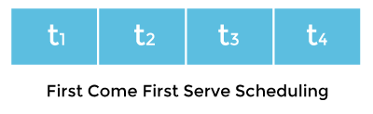

Hence, Thread t1 will be processed first, and Thread t4 will be processed last.

### **Time-slicing scheduling:**

Usually, the First Come First Serve algorithm is non-preemptive, which is bad as it may lead to infinite blocking (also known as starvation). To avoid that, some time-slices are provided to the threads so that after some time, the running thread has to give up the CPU. Thus, the other waiting threads also get time to run their job.

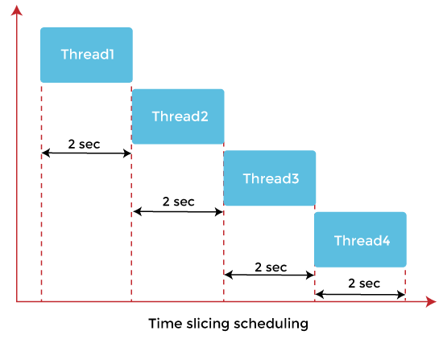

In the above diagram, each thread is given a time slice of 2 seconds. Thus, after 2 seconds, the first thread leaves the CPU, and the CPU is then captured by Thread2. The same process repeats for the other threads too.

### **Preemptive-Priority Scheduling:**

The name of the scheduling algorithm denotes that the algorithm is related to the priority of the threads.

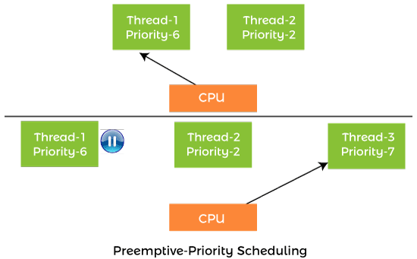

Suppose there are multiple threads available in the runnable state. The thread scheduler picks that thread that has the highest priority. Since the algorithm is also preemptive, therefore, time slices are also provided to the threads to avoid starvation. Thus, after some time, even if the highest priority thread has not completed its job, it has to release the CPU because of preemption.

# **Thread.sleep() in Java with Examples**

The Java Thread class provides the two variant of the sleep() method. First one accepts only an arguments, whereas the other variant accepts two arguments. The method sleep() is being used to halt the working of a thread for a given amount of time. The time up to which the thread remains in the sleeping state is known as the sleeping time of the thread. After the sleeping time is over, the thread starts its execution from where it has left.

### **The sleep() Method Syntax:**

Following are the syntax of the sleep() method.

1. **public** **static** **void** sleep(**long** mls) **throws** InterruptedException
2. **public** **static** **void** sleep(**long** mls, **int** n) **throws** InterruptedException

The method sleep() with the one parameter is the native method, and the implementation of the native method is accomplished in another programming language. The other methods having the two parameters are not the native method. That is, its implementation is accomplished in Java. We can access the sleep() methods with the help of the Thread class, as the signature of the sleep() methods contain the static keyword. The native, as well as the non-native method, throw a checked Exception. Therefore, either try-catch block or the throws keyword can work here.

The Thread.sleep() method can be used with any thread. It means any other thread or the main thread can invoke the sleep() method.

### **Parameters:**

The following are the parameters used in the sleep() method.

**mls:** The time in milliseconds is represented by the parameter mls. The duration for which the thread will sleep is given by the method sleep().

**n:** It shows the additional time up to which the programmer or developer wants the thread to be in the sleeping state. The range of n is from 0 to 999999.

The method does not return anything.

### **Important Points to Remember About the Sleep() Method**

Whenever the Thread.sleep() methods execute, it always halts the execution of the current thread.

Whenever another thread does interruption while the current thread is already in the sleep mode, then the InterruptedException is thrown.

If the system that is executing the threads is busy, then the actual sleeping time of the thread is generally more as compared to the time passed in arguments. However, if the system executing the sleep() method has less load, then the actual sleeping time of the thread is almost equal to the time passed in the argument.

### **Example of the sleep() method in Java : on the custom thread**

The following example shows how one can use the sleep() method on the custom thread.

**FileName:** TestSleepMethod1.java

1. **class** TestSleepMethod1 **extends** Thread{
2. **public** **void** run(){
3. **for**(**int** i=1;i<5;i++){
4. // the thread will sleep for the 500 milli seconds
5. **try**{
6. Thread.sleep(500);
7. }**catch**(InterruptedException e){
8. System.out.println(e);
9. }
10. System.out.println(i);
11. }
12. }
13. **public** **static** **void** main(String args[]){
14. TestSleepMethod1 t1=**new** TestSleepMethod1();
15. TestSleepMethod1 t2=**new** TestSleepMethod1();
17. t1.start();
18. t2.start();
19. }
20. }

**Output:**

1

1

2

2

3

3

4

4

As you know well that at a time only one thread is executed. If you sleep a thread for the specified time, the thread scheduler picks up another thread and so on.

### **Example of the sleep() Method in Java : on the main thread**

**FileName:** TestSleepMethod2.java

1. // important import statements
2. **import** java.lang.Thread;
3. **import** java.io.\*;

6. **public** **class** TestSleepMethod2
7. {
8. // main method
9. **public** **static** **void** main(String argvs[])
10. {
12. **try** {
13. **for** (**int** j = 0; j < 5; j++)
14. {
16. // The main thread sleeps for the 1000 milliseconds, which is 1 sec
17. // whenever the loop runs
18. Thread.sleep(1000);
20. // displaying the value of the variable
21. System.out.println(j);
22. }
23. }
24. **catch** (Exception expn)
25. {
26. // catching the exception
27. System.out.println(expn);
28. }
29. }
30. }

**Output:**

0

1

2

3

4

### **Example of the sleep() Method in Java: When the sleeping time is -ive**

The following example throws the exception IllegalArguementException when the time for sleeping is negative.

**FileName:** TestSleepMethod3.java

1. // important import statements
2. **import** java.lang.Thread;
3. **import** java.io.\*;
5. **public** **class** TestSleepMethod3
6. {
7. // main method
8. **public** **static** **void** main(String argvs[])
9. {
10. // we can also use throws keyword followed by
11. // exception name for throwing the exception
12. **try**
13. {
14. **for** (**int** j = 0; j < 5; j++)
15. {
17. // it throws the exception IllegalArgumentException
18. // as the time is -ive which is -100
19. Thread.sleep(-100);
21. // displaying the variable's value
22. System.out.println(j);
23. }
24. }
25. **catch** (Exception expn)
26. {
28. // the exception iscaught here
29. System.out.println(expn);
30. }
31. }
32. }

**Output:**

java.lang.IllegalArgumentException: timeout value is negative

# **Can we start a thread twice**

No. After starting a thread, it can never be started again. If you does so, an IllegalThreadStateException is thrown. In such case, thread will run once but for second time, it will throw exception.

Let's understand it by the example given below:

1. **public** **class** TestThreadTwice1 **extends** Thread{
2. **public** **void** run(){
3. System.out.println("running...");
4. }
5. **public** **static** **void** main(String args[]){
6. TestThreadTwice1 t1=**new** TestThreadTwice1();
7. t1.start();
8. t1.start();
9. }
10. }

[**Test it Now**](https://www.javatpoint.com/opr/test.jsp?filename=TestThreadTwice1)

**Output:**

running

Exception in thread "main" java.lang.IllegalThreadStateException

**Java Thread Synchronization**

In multithreading, there is the asynchronous behavior of the programs. If one thread is writing some data and another thread which is reading data at the same time, might create inconsistency in the application.

When there is a need to access the shared resources by two or more threads, then synchronization approach is utilized.

Java has provided synchronized methods to implement synchronized behavior.

In this approach, once the thread reaches inside the synchronized block, then no other thread can call that method on the same object. All threads have to wait till that thread finishes the synchronized block and comes out of that.

In this way, the synchronization helps in a multithreaded application. One thread has to wait till other thread finishes its execution only then the other threads are allowed for execution.

It can be written in the following form:

Synchronized(object)

{

//Block of statements to be synchronized

}

**Java Multithreading Example**

In this multithreading Java example, we will take two threads and fetch the names of the thread.

**Example1:**

GuruThread1.java

package demotest;

public class GuruThread1 implements Runnable{

/\*\*

\* @param args

\*/

public static void main(String[] args) {

Thread guruThread1 = new Thread("Guru1");

Thread guruThread2 = new Thread("Guru2");

guruThread1.start();

guruThread2.start();

System.out.println("Thread names are following:");

System.out.println(guruThread1.getName());

System.out.println(guruThread2.getName());

}

@Override

public void run() {

}

}

**Explanation of the code:**

* **Code Line 3:** We have taken a class “GuruThread1” which implements Runnable (it should be implemented by any class whose instances are intended to be executed by the thread.)
* **Code Line 8:**This is the main method of the class
* **Code Line 9:** Here we are instantiating the Thread class and creating an instance named as “guruThread1” and creating a thread.
* **Code Line 10:** Here we are instantiating the Thread class and creating an instance named a “guruThread2” and creating a thread.
* **Code Line 11:** We are starting the thread i.e. guruThread1.
* **Code Line 12:** We are starting the thread i.e. guruThread2.
* **Code Line 13:** Outputting the text as “Thread names are following:”
* **Code Line 14:** Getting the name of thread 1 using method getName() of the thread class.
* **Code Line 15:** Getting the name of thread 2 using method getName() of the thread class.

When you execute the above code, you get the following output:

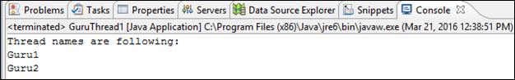

**Output:**

Thread names are being outputted here as

* Guru1
* Guru2

**Example 2:**

In this multithreading in Java example, we will learn about overriding methods run() and start() method of a runnable interface and create two threads of that class and run them accordingly.

Also, we are taking two classes,

* One which will implement the runnable interface and
* Another one which will have the main method and execute accordingly.

package demotest;

public class GuruThread2 {

public static void main(String[] args) {

// TODO Auto-generated method stub

GuruThread3 threadguru1 = new GuruThread3("guru1");

threadguru1.start();

GuruThread3 threadguru2 = new GuruThread3("guru2");

threadguru2.start();

}

}

class GuruThread3 implements Runnable {

Thread guruthread;

private String guruname;

GuruThread3(String name) {

guruname = name;

}

@Override

public void run() {

System.out.println("Thread running" + guruname);

for (int i = 0; i < 4; i++) {

System.out.println(i);

System.out.println(guruname);

try {

Thread.sleep(1000);

} catch (InterruptedException e) {

System.out.println("Thread has been interrupted");

}

}

}

public void start() {

System.out.println("Thread started");

if (guruthread == null) {

guruthread = new Thread(this, guruname);

guruthread.start();

}

}

}

**Explanation of the code:**

* **Code Line 2:** Here we are taking a class “GuruThread2” which will have the main method in it.
* **Code Line 4:** Here we are taking a main method of the class.
* **Code Line 6-7:** Here we are creating an instance of class GuruThread3 (which is created in below lines of the code) as “threadguru1” and we are starting the thread.
* **Code Line 8-9:** Here we are creating another instance of class GuruThread3 (which is created in below lines of the code) as “threadguru2” and we are starting the thread.
* **Code Line 11:** Here we are creating a class “GuruThread3” which is implementing the runnable interface (it should be implemented by any class whose instances are intended to be executed by the thread.)
* **Code Line 13-14:** we are taking two class variables from which one is of the type thread class and other of the string class.
* **Code Line 15-18:** we are overriding the GuruThread3 constructor, which takes one argument as string type (which is threads name) that gets assigned to class variable guruname and hence the name of the thread is stored.
* **Code Line 20:** Here we are overriding the run() method of the runnable interface.
* **Code Line 21:** We are outputting the thread name using println statement.
* **Code Line 22-31:** Here we are using a for loop with counter initialized to 0, and it should not be less than 4 (we can take any number hence here loop will run 4 times) and incrementing the counter. We are printing the thread name and also making the thread sleep for 1000 milliseconds within a try-catch block as sleep method raised checked exception.
* **Code Line 33:** Here we are overriding start method of the runnable interface.
* **Code Line 35:** We are outputting the text “Thread started”.
* **Code Line 36-40:** Here we are taking an if condition to check whether class variable guruthread has value in it or no. If its null then we are creating an instance using thread class which takes the name as a parameter (value for which was assigned in the constructor). After which the thread is started using start() method.

When you execute the above code you get the following output:

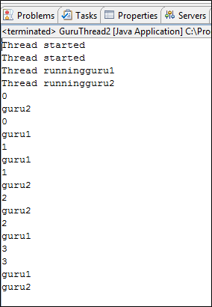

**Output**:

There are two threads hence, we get two times message “Thread started”.

We get the names of the thread as we have outputted them.

It goes into for loop where we are printing the counter and thread name and counter starts with 0.

The loop executes three times and in between the thread is slept for 1000 milliseconds.

Hence, first, we get guru1 then guru2 then again guru2 because the thread sleeps here for 1000 milliseconds and then next guru1 and again guru1, thread sleeps for 1000 milliseconds, so we get guru2 and then guru1.

# Java File Class

The File class of the java.io package is used to perform various operations on files and directories.

There is another package named java.nio that can be used to work with files. However, in this tutorial, we will focus on the java.io package.

## File and Directory

A file is a named location that can be used to store related information. For example,

**main.java** is a Java file that contains information about the Java program.

A directory is a collection of files and subdirectories. A directory inside a directory is known as subdirectory.

## Create a Java File Object

To create an object of File, we need to import the java.io.File package first. Once we import the package, here is how we can create objects of file.

// creates an object of File using the path

File file = new File(String pathName);

Here, we have created a file object named file. The object can be used to work with files and directories.

**Note**: In Java, creating a file object does not mean creating a file. Instead, a file object is an abstract representation of the file or directory pathname (specified in the parenthesis).

## Java File Operation Methods

|  |  |  |
| --- | --- | --- |
| Operation | Method | Package |
| To create file | createNewFile() | java.io.File |
| To read file | read() | java.io.FileReader |
| To write file | write() | java.io.FileWriter |
| To delete file | delete() | java.io.File |

### Java create files

To create a new file, we can use the createNewFile() method. It returns

* true if a new file is created.
* false if the file already exists in the specified location.

### Example: Create a new File

// importing the File class

import java.io.File;

class Main {

public static void main(String[] args) {

// create a file object for the current location

File file = new File("newFile.txt");

try {

// trying to create a file based on the object

boolean value = file.createNewFile();

if (value) {

System.out.println("The new file is created.");

}

else {

System.out.println("The file already exists.");

}

}

catch(Exception e) {

e.getStackTrace();

}

}

}

In the above example, we have created a file object named file. The file object is linked with the specified file path.

File file = new File("newFile.txt");

Here, we have used the file object to create the new file with the specified path.  
  
**If newFile.txt doesn't exist in the current location**, the file is created and this message is shown.

The new file is created.

**However, if newFile.txt already exists**, we will see this message.

The file already exists.

### Java read files

To read data from the file, we can use subclasses of either [InputStream](https://www.programiz.com/java-programming/inputstream) or [Reader](https://www.programiz.com/java-programming/reader).

### Example: Read a file using FileReader

Suppose we have a file named **input.txt** with the following content.

This is a line of text inside the file.

Now let's try to read the file using Java FileReader.

// importing the FileReader class

import java.io.FileReader;

class Main {

public static void main(String[] args) {

char[] array = new char[100];

try {

// Creates a reader using the FileReader

FileReader input = new FileReader("input.txt");

// Reads characters

input.read(array);

System.out.println("Data in the file:");

System.out.println(array);

// Closes the reader

input.close();

}

catch(Exception e) {

e.getStackTrace();

}

}

}

**Output**

Data in the file:

This is a line of text inside the file.

In the above example, we have used created an object of FileReader named input. It is now linked with the **input.txt** file.

FileReader input = new FileReader("input.txt");

To read the data from the **input.txt** file, we have used the read() method of FileReader.

### Java write to files

To write data to the file, we can use subclasses of either [OutputStream](https://www.programiz.com/java-programming/outputstream) or [Writer](https://www.programiz.com/java-programming/writer).

### Example: Write to file using FileWriter

// importing the FileWriter class

import java.io.FileWriter;

class Main {

public static void main(String args[]) {

String data = "This is the data in the output file";

try {

// Creates a Writer using FileWriter

FileWriter output = new FileWriter("output.txt");

// Writes string to the file

output.write(data);

System.out.println("Data is written to the file.");

// Closes the writer

output.close();

}

catch (Exception e) {

e.getStackTrace();

}

}

}

**Output**

Data is written to the file.

In the above example, we have created a writer using the FileWriter class. The writer is linked with the **output.txt** file.

FileWriter output = new FileWriter("output.txt");

To write data to the file, we have used the write() method.

Here when we run the program, the **output.txt** file is filled with the following content.

This is the data in the output file.

### Java delete files

We can use the delete() method of the File class to delete the specified file or directory. It returns

* true if the file is deleted.
* false if the file does not exist.

**Note**: We can only delete empty directories.

### Example: Delete a file

import java.io.File;

class Main {

public static void main(String[] args) {

// creates a file object

File file = new File("file.txt");

// deletes the file

boolean value = file.delete();

if(value) {

System.out.println("The File is deleted.");

}

else {

System.out.println("The File is not deleted.");

}

}

}

**Output**

The File is deleted.

In the above example, we have created an object of File named file. The file now holds the information about the specified file.

File file = new File("file.txt");

Here we have used the delete() method to delete the file specified by the object.

**Java Wrapper Class**

In this tutorial, we will learn about the Java Wrapper class with the help of examples.

The wrapper classes in Java are used to convert primitive types (int, char, float, etc) into corresponding objects.

Each of the 8 primitive types has corresponding wrapper classes.

|  |  |
| --- | --- |
| Primitive Type | Wrapper Class |
| byte | Byte |
| boolean | Boolean |
| char | Character |
| double | Double |
| float | Float |
| int | Integer |
| long | Long |
| short | Short |

**Convert Primitive Type to Wrapper Objects**

We can also use the valueOf() method to convert primitive types into corresponding objects.

**Example 1: Primitive Types to Wrapper Objects**

class Main {

public static void main(String[] args) {

// create primitive types

int a = 5;

double b = 5.65;

//converts into wrapper objects

Integer aObj = Integer.valueOf(a);

Double bObj = Double.valueOf(b);

if(aObj instanceof Integer) {

System.out.println("An object of Integer is created.");

}

if(bObj instanceof Double) {

System.out.println("An object of Double is created.");

}

}

}

[Run Code](https://www.programiz.com/java-programming/online-compiler)

**Output**

An object of Integer is created.

An object of Double is created.

In the above example, we have used the valueOf() method to convert the primitive types into objects.

Here, we have used the instanceof operator to check whether the generated objects are of Integer or Double type or not.

However, the Java compiler can directly convert the primitive types into corresponding objects. For example,

int a = 5;

// converts into object

Integer aObj = a;

double b = 5.6;

// converts into object

Double bObj = b;

This process is known as **auto-boxing**. To learn more, visit [Java autoboxing and unboxing](https://www.programiz.com/java-programming/autoboxing-unboxing).

**Note**: We can also convert primitive types into wrapper objects using Wrapper class constructors. But the use of constructors is discarded after Java 9.

**Wrapper Objects into Primitive Types**

To convert objects into the primitive types, we can use the corresponding value methods (intValue(), doubleValue(), etc) present in each wrapper class.

**Example 2: Wrapper Objects into Primitive Types**

class Main {

public static void main(String[] args) {

// creates objects of wrapper class

Integer aObj = Integer.valueOf(23);

Double bObj = Double.valueOf(5.55);

// converts into primitive types

int a = aObj.intValue();

double b = bObj.doubleValue();

System.out.println("The value of a: " + a);

System.out.println("The value of b: " + b);

}

}

[Run Code](https://www.programiz.com/java-programming/online-compiler)

**Output**

The value of a: 23

The value of b: 5.55

In the above example, we have used the intValue() and doubleValue() method to convert the Integer and Double objects into corresponding primitive types.

However, the Java compiler can automatically convert objects into corresponding primitive types. For example,

Integer aObj = Integer.valueOf(2);

// converts into int type

int a = aObj;

Double bObj = Double.valueOf(5.55);

// converts into double type

double b = bObj;

This process is known as **unboxing**. To learn more, visit [Java autoboxing and unboxing](https://www.programiz.com/java-programming/autoboxing-unboxing).

**Advantages of Wrapper Classes**

* In Java, sometimes we might need to use objects instead of primitive data types. For example, while working with collections.
* // error
* ArrayList<int> list = new ArrayList<>();
* // runs perfectly

ArrayList<Integer> list = new ArrayList<>();

In such cases, wrapper classes help us to use primitive data types as objects.

* We can store the null value in wrapper objects. For example,
* // generates an error
* int a = null;
* // runs perfectly
* Integer a = null;

**Note**: Primitive types are more efficient than corresponding objects. Hence, when efficiency is the requirement, it is always recommended primitive types.

**Java Arrays**

In this tutorial, we will learn to work with arrays in Java. We will learn to declare, initialize, and access array elements with the help of examples.

An array is a collection of similar types of data.

For example, if we want to store the names of 100 people then we can create an array of the string type that can store 100 names.

String[] array = new String[100];

Here, the above array cannot store more than 100 names. The number of values in a Java array is always fixed.

**How to declare an array in Java?**

In Java, here is how we can declare an array.

dataType[] arrayName;

* dataType - it can be [primitive data types](https://www.programiz.com/java-programming/variables-primitive-data-types#data-types) like int, char, double, byte, etc. or [Java objects](https://www.programiz.com/java-programming/class-objects)
* arrayName - it is an [identifier](https://www.programiz.com/java-programming/keywords-identifiers#identifiers)

For example,

double[] data;

Here, data is an array that can hold values of type double.

**But, how many elements can array this hold?**

Good question! To define the number of elements that an array can hold, we have to allocate memory for the array in Java. For example,

// declare an array

double[] data;

// allocate memory

data = new double[10];

Here, the array can store **10** elements. We can also say that the **size or length** of the array is 10.

In Java, we can declare and allocate the memory of an array in one single statement. For example,

double[] data = new double[10];

**How to Initialize Arrays in Java?**

In Java, we can initialize arrays during declaration. For example,

//declare and initialize and array

int[] age = {12, 4, 5, 2, 5};

Here, we have created an array named age and initialized it with the values inside the curly brackets.

Note that we have not provided the size of the array. In this case, the Java compiler automatically specifies the size by counting the number of elements in the array (i.e. 5).

In the Java array, each memory location is associated with a number. The number is known as an array index. We can also initialize arrays in Java, using the index number. For example,

// declare an array

int[] age = new int[5];

// initialize array

age[0] = 12;

age[1] = 4;

age[2] = 5;

..

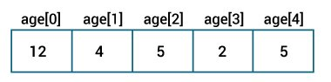Java Arrays initialization

**Note**:

* Array indices always start from 0. That is, the first element of an array is at index 0.
* If the size of an array is n, then the last element of the array will be at index n-1.

**How to Access Elements of an Array in Java?**

We can access the element of an array using the index number. Here is the syntax for accessing elements of an array,

// access array elements

array[index]

Let's see an example of accessing array elements using index numbers.

**Example: Access Array Elements**

class Main {

public static void main(String[] args) {

// create an array

int[] age = {12, 4, 5, 2, 5};

// access each array elements

System.out.println("Accessing Elements of Array:");

System.out.println("First Element: " + age[0]);

System.out.println("Second Element: " + age[1]);

System.out.println("Third Element: " + age[2]);

System.out.println("Fourth Element: " + age[3]);

System.out.println("Fifth Element: " + age[4]);

}

}

[Run Code](https://www.programiz.com/java-programming/online-compiler)

**Output**

Accessing Elements of Array:

First Element: 12

Second Element: 4

Third Element: 5

Fourth Element: 2

Fifth Element: 5

In the above example, notice that we are using the index number to access each element of the array.

We can use loops to access all the elements of the array at once.

**Looping Through Array Elements**

In Java, we can also loop through each element of the array. For example,

**Example: Using For Loop**

class Main {

public static void main(String[] args) {

// create an array

int[] age = {12, 4, 5};

// loop through the array

// using for loop

System.out.println("Using for Loop:");

for(int i = 0; i < age.length; i++) {

System.out.println(age[i]);

}

}

}

[Run Code](https://www.programiz.com/java-programming/online-compiler)

**Output**

Using for Loop:

12

4

5

In the above example, we are using the [for Loop in Java](https://www.programiz.com/java-programming/for-loop) to iterate through each element of the array. Notice the expression inside the loop,

age.length

Here, we are using the length property of the array to get the size of the array.

We can also use the [for-each loop](https://www.programiz.com/java-programming/enhanced-for-loop) to iterate through the elements of an array. For example,

**Example: Using the for-each Loop**

class Main {

public static void main(String[] args) {

// create an array

int[] age = {12, 4, 5};

// loop through the array

// using for loop

System.out.println("Using for-each Loop:");

for(int a : age) {

System.out.println(a);

}

}

}

[Run Code](https://www.programiz.com/java-programming/online-compiler)

**Output**

Using for-each Loop:

12

4

5

**Example: Compute Sum and Average of Array Elements**

class Main {

public static void main(String[] args) {

int[] numbers = {2, -9, 0, 5, 12, -25, 22, 9, 8, 12};

int sum = 0;

Double average;

// access all elements using for each loop

// add each element in sum

for (int number: numbers) {

sum += number;

}

// get the total number of elements

int arrayLength = numbers.length;

// calculate the average

// convert the average from int to double

average = ((double)sum / (double)arrayLength);

System.out.println("Sum = " + sum);

System.out.println("Average = " + average);

}

}

[Run Code](https://www.programiz.com/java-programming/online-compiler)

**Output**:

Sum = 36

Average = 3.6

In the above example, we have created an array of named numbers. We have used the for...each loop to access each element of the array.

Inside the loop, we are calculating the sum of each element. Notice the line,

int arrayLength = number.length;

Here, we are using the [length attribute](http://stackoverflow.com/questions/8755812/array-length-in-java) of the array to calculate the size of the array. We then calculate the average using:

average = ((double)sum / (double)arrayLength);

As you can see, we are converting the int value into double. This is called type casting in Java. To learn more about typecasting, visit [Java Type Casting](https://www.programiz.com/java-programming/typecasting).

**Multidimensional Arrays**

Arrays we have mentioned till now are called one-dimensional arrays. However, we can declare multidimensional arrays in Java.

A multidimensional array is an array of arrays. That is, each element of a multidimensional array is an array itself. For example,

double[][] matrix = {{1.2, 4.3, 4.0},

{4.1, -1.1}

};

Here, we have created a multidimensional array named matrix. It is a 2-dimensional array. To learn more, visit the [Java multidimensional array](https://www.programiz.com/java-programming/multidimensional-array).

# Java Multidimensional Arrays

In this tutorial, we will learn about the Java multidimensional array using 2-dimensional arrays and 3-dimensional arrays with the help of examples.

Before we learn about the multidimensional array, make sure you know about [Java array](https://www.programiz.com/java-programming/arrays).

A multidimensional array is an array of arrays. Each element of a multidimensional array is an array itself. For example,

int[][] a = new int[3][4];

Here, we have created a multidimensional array named a. It is a 2-dimensional array, that can hold a maximum of 12 elements,

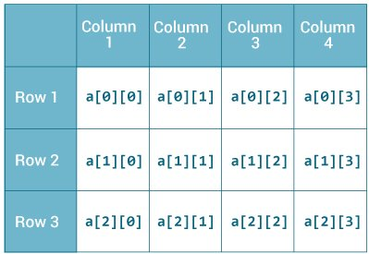2-dimensional Array

Remember, Java uses zero-based indexing, that is, indexing of arrays in Java starts with 0 and not 1.

Let's take another example of the multidimensional array. This time we will be creating a 3-dimensional array. For example,

String[][][] data = new String[3][4][2];

Here, data is a 3d array that can hold a maximum of 24 (3\*4\*2) elements of type String.

## How to initialize a 2d array in Java?

Here is how we can initialize a 2-dimensional array in Java.

int[][] a = {

{1, 2, 3},

{4, 5, 6, 9},

{7},

};

As we can see, each element of the multidimensional array is an array itself. And also, unlike C/C++, each row of the multidimensional array in Java can be of different lengths.

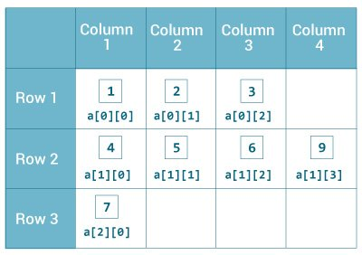Initialization of 2-dimensional Array

### Example: 2-dimensional Array

class MultidimensionalArray {

public static void main(String[] args) {

// create a 2d array

int[][] a = {

{1, 2, 3},

{4, 5, 6, 9},

{7},

};

// calculate the length of each row

System.out.println("Length of row 1: " + a[0].length);

System.out.println("Length of row 2: " + a[1].length);

System.out.println("Length of row 3: " + a[2].length);

}

}

[Run Code](https://www.programiz.com/java-programming/online-compiler)

**Output**:

Length of row 1: 3

Length of row 2: 4

Length of row 3: 1

In the above example, we are creating a multidimensional array named a. Since each component of a multidimensional array is also an array (a[0], a[1] and a[2] are also arrays).

Here, we are using the length attribute to calculate the length of each row.

### Example: Print all elements of 2d array Using Loop

class MultidimensionalArray {

public static void main(String[] args) {

int[][] a = {

{1, -2, 3},

{-4, -5, 6, 9},

{7},

};

for (int i = 0; i < a.length; ++i) {

for(int j = 0; j < a[i].length; ++j) {

System.out.println(a[i][j]);

}

}

}

}

[Run Code](https://www.programiz.com/java-programming/online-compiler)

**Output**:

1

-2

3

-4

-5

6

9

7

We can also use the [for...each loop](https://www.programiz.com/java-programming/enhanced-for-loop) to access elements of the multidimensional array. For example,

class MultidimensionalArray {

public static void main(String[] args) {

// create a 2d array

int[][] a = {

{1, -2, 3},

{-4, -5, 6, 9},

{7},

};

// first for...each loop access the individual array

// inside the 2d array

for (int[] innerArray: a) {

// second for...each loop access each element inside the row

for(int data: innerArray) {

System.out.println(data);

}

}

}

}

[Run Code](https://www.programiz.com/java-programming/online-compiler)

**Output**:

1

-2

3

-4

-5

6

9

7

In the above example, we are have created a 2d array named a. We then used for loop and for...each loop to access each element of the array.

## How to initialize a 3d array in Java?

Let's see how we can use a 3d array in Java. We can initialize a 3d array similar to the 2d array. For example,

// test is a 3d array

int[][][] test = {

{

{1, -2, 3},

{2, 3, 4}

},

{

{-4, -5, 6, 9},

{1},

{2, 3}

}

};

Basically, a 3d array is an array of 2d arrays. The rows of a 3d array can also vary in length just like in a 2d array.

### Example: 3-dimensional Array

class ThreeArray {

public static void main(String[] args) {

// create a 3d array

int[][][] test = {

{

{1, -2, 3},

{2, 3, 4}

},

{

{-4, -5, 6, 9},

{1},

{2, 3}

}

};

// for..each loop to iterate through elements of 3d array

for (int[][] array2D: test) {

for (int[] array1D: array2D) {

for(int item: array1D) {

System.out.println(item);

}

}

}

}

}

[Run Code](https://www.programiz.com/java-programming/online-compiler)

**Output**:

1

-2

3

2

3

4

-4

-5

6

9

1

2

3

**Java Comments**

In this tutorial, you will learn about Java comments, why we use them, and how to use comments in right way.

In computer programming, comments are a portion of the program that are completely ignored by Java compilers. They are mainly used to help programmers to understand the code. For example,

// declare and initialize two variables

int a =1;

int b = 3;

// print the output

System.out.println("This is output");

Here, we have used the following comments,

* declare and initialize two variables
* print the output

**Types of Comments in Java**

In Java, there are two types of comments:

* single-line comment
* multi-line comment

**Single-line Comment**

A single-line comment starts and ends in the same line. To write a single-line comment, we can use the // symbol. For example,

// "Hello, World!" program example

class Main {

public static void main(String[] args) {

// prints "Hello, World!"

System.out.println("Hello, World!");

}

}

[Run Code](https://www.programiz.com/java-programming/online-compiler)

**Output**:

Hello, World!

Here, we have used two single-line comments:

* "Hello, World!" program example
* prints "Hello World!"

The Java compiler ignores everything from // to the end of line. Hence, it is also known as **End of Line** comment.

**Multi-line Comment**

When we want to write comments in multiple lines, we can use the multi-line comment. To write multi-line comments, we can use the /\*....\*/ symbol. For example,

/\* This is an example of multi-line comment.

\* The program prints "Hello, World!" to the standard output.

\*/

class HelloWorld {

public static void main(String[] args) {

System.out.println("Hello, World!");

}

}

[Run Code](https://www.programiz.com/java-programming/online-compiler)

**Output**:

Hello, World!

Here, we have used the multi-line comment:

/\* This is an example of multi-line comment.

\* The program prints "Hello, World!" to the standard output.

\*/

This type of comment is also known as **Traditional Comment**. In this type of comment, the Java compiler ignores everything from /\* to \*/.

**Use Comments the Right Way**

One thing you should always consider that comments shouldn't be the substitute for a way to explain poorly written code in English. You should always write well structured and self explaining code. And, then use comments.

Some believe that code should be self-describing and comments should be rarely used. However, in my personal opinion, there is nothing wrong with using comments. We can use comments to explain complex algorithms, regex or scenarios where we have to choose one technique among different technique to solve problems.

**Note**: In most cases, always use comments to explain '**why**' rather than '**how**' and you are good to go.

**1. Overview**

In this tutorial, You'll learn **ArrayList with Real-Time examples**. If you are new to java programming, you'll get a question "**What are the real-life examples of the ArrayList in Java?**". Initial days when I was in engineering the second year, my professor was teaching [ArrayList](https://java-w3schools.blogspot.com/2017/09/javautilarraylist-class-in-java-with.html) in java.  
  
I have learned about it. **ArrayList** is a dynamic array to store the elements and also it grows the size automatically if it reaching its threshold value. But when we should be using the ArrayList in realtime applications.

Remember, for now, **In the software world there is no application deployed in production without ArrayList. Now think about the usage of ArrayList. ArrayList can be used in many more scenarios in realtime.**  
  
We will be seeing a few real-time examples of ArrayList in Java.

**2. Collecting database records into ArrayList**

JDBC is used to connect to the database and perform the operations on the tables. **Every application needs to save user data and activities into the database**. Once a Select query is executed, a ResultSet instance is returned. This ResultSet will contain all records.  
  
For Example, the Amazon website has many customer's records in its database. If they want to retrieve the customers from the database and show it on a web screen. In this case, ArrayList will be used to add customer records from ResultSet.  
  
Let us take a look at the below code.

**Customer class:**

package com.java.w3schools.blog.arraylist;

import java.io.Serializable;

import java.util.Date;

public class Customer implements Serializable {

private String fullName;

private String email;

private String password;

private String mobileNumber;

private Date dateOfBirth;

public String getFullName() {

return fullName;

}

public void setFullName(String fullName) {

this.fullName = fullName;

}

public String getEmail() {

return email;

}

public void setEmail(String email) {

this.email = email;

}

public String getPassword() {

return password;

}

public void setPassword(String password) {

this.password = password;

}

public String getMobileNumber() {

return mobileNumber;

}

public void setMobileNumber(String mobileNumber) {

this.mobileNumber = mobileNumber;

}

public Date getDateOfBirth() {

return dateOfBirth;

}

public void setDateOfBirth(Date dateOfBirth) {

this.dateOfBirth = dateOfBirth;

}

}

**Loading into ArrayList:**

import java.sql.Connection;

import java.sql.DriverManager;

import java.sql.ResultSet;

import java.sql.Statement;

public class SelectDataDemo {

    public static void main(String[] args) {

        Connection connection = null;

        Statement selectStmt = null;

List customerList = new ArrayList;

        try

        {

            Class.forName("com.mysql.jdbc.Driver");

            connection = DriverManager.getConnection("jdbc:mysql://localhost:8080/AMAZONDB", "scoot", "tiger");

            selectStmt = connection.createStatement();

            ResultSet rs = selectStmt.executeQuery("SELECT FULL\_NAME, EMAIL, PASSWORD, DOB, MOBILE\_NUMBER FROM CUSTOMER ");

            while(rs.next())

            {

  Customer customer = new Customer();

               customer.setFullName(rs.getString(1));

               customer.setEmail(rs.getString(2));

               customer.setPassword(rs.getString(3));

               customer.setDateOfBirth(new java.util.Date(rs.getDate(4).getTime()));

  customer.setMobileNumber(rs.getString(5));

  customerList.add(customer)

            }

        }

        catch (Exception e) {

            e.printStackTrace();

        }finally {

            try {

                selectStmt.close();

                insertStmt.close();

                connection.close();

            } catch (Exception e) {

                e.printStackTrace();

            }

        }

System.out.println("Customer records count : "+customerList.size());

    }

}

This is the best case to use the ***ArrayList*** to load the records. Every application must be having this kind of use case.

# Collections in Java

The **Java Collections Framework** is a collection of interfaces and classes, which helps in storing and processing the data efficiently

## Collections Framework hierarchy

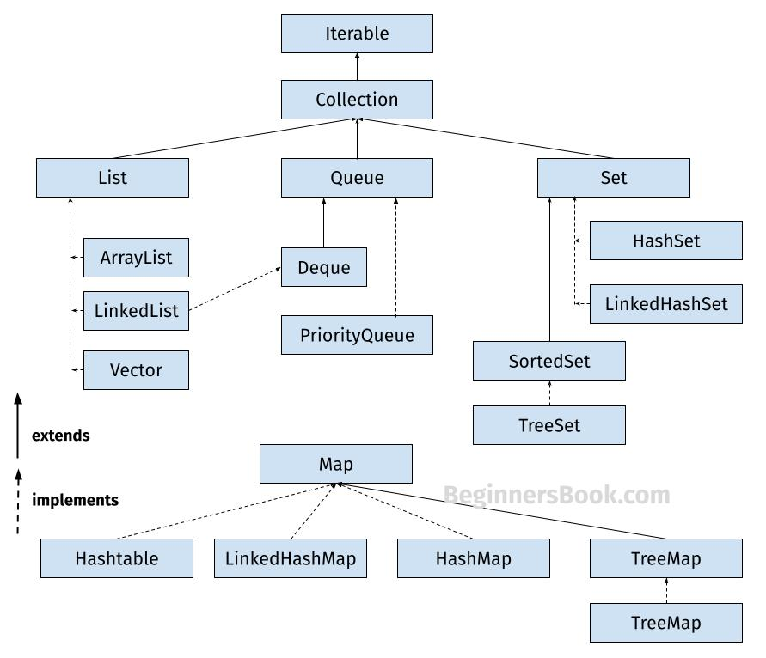

**1. List**

A List is an ordered Collection (sometimes called a sequence). Lists may contain duplicate elements. Elements can be inserted or accessed by their position in the list, using a zero-based index. The classes that implements List interface are:

* ArrayList
* LinkedList
* Vector
* Stack

**1.1 ArrayList**

ArrayList is a popular alternative of [arrays in Java](https://beginnersbook.com/2013/05/java-arrays/). It is based on an Array **data structure**. ArrayList is a resizable-array implementation of the List interface. It implements all optional list operations.

import java.util.\*;

class JavaExample{

public static void main(String args[]){

//creating ArrayList of string type

ArrayList<String> arrList=new ArrayList<>();

//adding few elements

arrList.add("Cricket"); //list: ["Cricket"]

arrList.add("Hockey"); //list: ["Cricket", "Hockey"]

//inserting element at first position, index 0

//represents first element because ArrayList is based

//on zero based indexing system

arrList.add(0, "BasketBall"); //list: ["BasketBall", "Cricket", "Hockey"]

System.out.println("ArrayList Elements: ");

//Traversing ArrayList using enhanced for loop

for(String str:arrList)

System.out.println(str);

}

}

**Output:**  
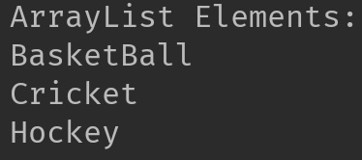

.

**1.2 LinkedList**

LinkedList is a linear data structure. However LinkedList elements are not stored in contiguous locations like arrays, they are linked with each other using pointers. Each element of the LinkedList has the reference(address/pointer) to the next element of the LinkedList.  
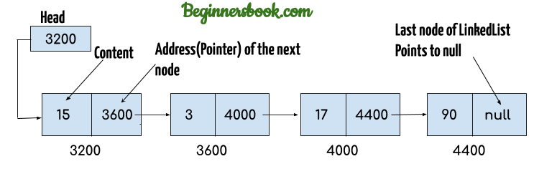

import java.util.\*;

public class JavaExample{

public static void main(String args[]){

LinkedList<String> linkList=new LinkedList<>();

linkList.add("Apple"); //["Apple"]

linkList.add("Orange"); //["Apple", "Orange"]

//inserting element at first position

linkList.add(0, "Banana"); ////["Banana", "Apple", "Orange"]

System.out.println("LinkedList elements: ");

//iterating LinkedList using iterator

Iterator<String> it=linkList.iterator();

while(it.hasNext()){

System.out.println(it.next());

}

}

}

**Output:**  
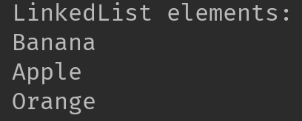

**1.3 Vector**

Here is the list of all the tutorials published on the Vector.

import java.util.\*;

public class JavaExample{

public static void main(String args[]){

Vector<String> v=new Vector<>();

v.add("item1"); //["item1"]

v.add("item2"); //["item1", "item2"]

v.add("item3"); //["item1", "item2", "item3"]

//removing an element

v.remove("item2"); //["item1", "item3"]

System.out.println("Vector Elements: ");

//iterating Vector using iterator

Iterator<String> it=v.iterator();

while(it.hasNext()){

System.out.println(it.next());

}

}

}

**Output:**  
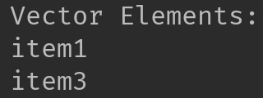  
Refer [this article](https://beginnersbook.com/2013/12/vector-in-java/) for more **guides on Vector**.

**1.4 Stack**

Stack class extends Vector class, which means it is a subclass of Vector. Stack works on the concept of Last In First Out (LIFO). The elements are inserted using push() method at the end of the stack, the pop() method removes the element which was inserted last in the Stack.

import java.util.\*;

public class JavaExample{

public static void main(String args[]){

Stack<String> stack = new Stack<>();

//push() method adds the element in the stack

//and pop() method removes the element from the stack

stack.push("Chaitanya"); //["Chaitanya"]

stack.push("Ajeet"); //["Chaitanya", Ajeet]

stack.push("Hari"); //["Chaitanya", "Ajeet", "Hari"]

stack.pop(); //removes the last element

stack.push("Steve"); //["Chaitanya", "Ajeet", "Steve"]

stack.push("Carl"); //["Chaitanya", "Ajeet", "Steve", "Carl"]

stack.pop(); //removes the last element

System.out.println("Stack elements: ");

for(String str: stack){

System.out.println(str);

}

}

}

**Output:**  
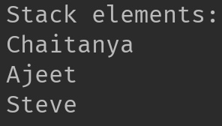

**2. Set**

A Set is a Collection that cannot contain duplicate elements. There are three main implementations of Set interface: HashSet, TreeSet, and LinkedHashSet.

**2.1 HashSet**

[HashSet](https://beginnersbook.com/2013/12/hashset-class-in-java-with-example/) which stores its elements in a hash table, is the best-performing implementation. HashSet allows only unique elements. It doesn’t maintain the insertion order which means element inserted last can appear at first when traversing the HashSet.

import java.util.\*;

public class JavaExample{

public static void main(String args[]){

HashSet<String> set=new HashSet<>();

set.add("Paul");

set.add("Ram");

set.add("Aaron");

set.add("Leo");

set.add("Becky");

Iterator<String> it=set.iterator();

while(it.hasNext()){

System.out.println(it.next());

}

}

}

**Output:**

Aaron

Leo

Paul

Ram

Becky

**2.2 LinkedHashSet**

Unlike HashSet, the [LinkedHashSet](https://beginnersbook.com/2013/12/linkedhashset-class-in-java-with-example/) maintains insertion order.

import java.util.\*;

public class JavaExample{

public static void main(String args[]){

LinkedHashSet<String> set=new LinkedHashSet<>();

set.add("Paul");

set.add("Ram");

set.add("Aaron");

set.add("Leo");

set.add("Becky");

Iterator<String> it=set.iterator();

while(it.hasNext()){

System.out.println(it.next());

}

}

}

**Output:**

Paul

Ram

Aaron

Leo

Becky

**2.3 TreeSet**

[TreeSet](https://beginnersbook.com/2013/12/treeset-class-in-java-with-example/) stores elements in a red-black tree. It is substantially slower than HashSet. TreeSet class implements SortedSet interface, which allows TreeSet to order its elements based on their values, which means TreeSet elements are sorted in ascending order.

import java.util.\*;

public class JavaExample{

public static void main(String args[]){

TreeSet<String> set=new TreeSet<>();

set.add("Paul");

set.add("Ram");

set.add("Aaron");

set.add("Leo");

set.add("Becky");

Iterator<String> it=set.iterator();

while(it.hasNext()){

System.out.println(it.next());

}

}

}

**Output:**

Aaron

Becky

Leo

Paul

Ram

**3. Map**

A Map is an object that maps keys to values. A map cannot contain duplicate keys. There are three main implementations of Map interfaces: HashMap, TreeMap, and LinkedHashMap.

**3.1 HashMap**

**HashMap:** HashMap is like HashSet, it doesn’t maintain insertion order and doesn’t sort the elements in any order.

public class JavaExample{

public static void main(String args[]){

HashMap<Integer, String> hmap = new HashMap<>();

//key and value pairs

hmap.put(101, "Chaitanya");

hmap.put(105, "Derick");

hmap.put(111, "Logan");

hmap.put(120, "Paul");

//print HashMap elements

Set set = hmap.entrySet();

Iterator iterator = set.iterator();

while(iterator.hasNext()) {

Map.Entry m = (Map.Entry)iterator.next();

System.out.print("key is: "+ m.getKey() + " & Value is: ");

System.out.println(m.getValue());

}

}

}

**Output:**  
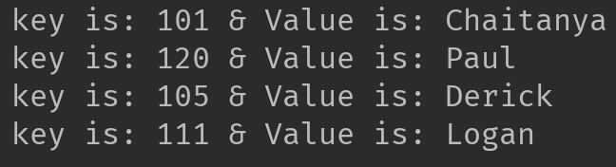

**3.2 TreeMap**

**TreeMap:** It stores its elements in a red-black tree. The elements of TreeMap are sorted in ascending order. It is substantially slower than HashMap.This is the same example that we have seen above in HashMap. Here, elements are sorted based on keys.

import java.util.\*;

public class JavaExample{

public static void main(String args[]){

TreeMap<Integer, String> hmap = new TreeMap<>();

//key and value pairs

hmap.put(101, "Chaitanya");

hmap.put(105, "Derick");

hmap.put(111, "Logan");

hmap.put(120, "Paul");

//print HashMap elements

Set set = hmap.entrySet();

Iterator iterator = set.iterator();

while(iterator.hasNext()) {

Map.Entry m = (Map.Entry)iterator.next();

System.out.print("key is: "+ m.getKey() + " & Value is: ");

System.out.println(m.getValue());

}

}

}

**Output:**  
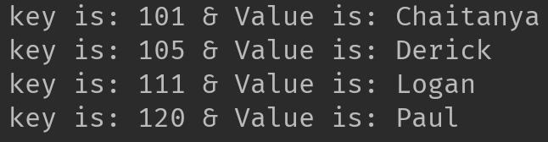

**3.3 LinkedHashMap**

**LinkedHashMap:** It maintains insertion order. Refer [this guide](https://beginnersbook.com/2013/12/linkedhashmap-in-java/), to learn LinkedHashMap in detail. As you can see: In the following example, the key & value pairs maintained the insertion order.

import java.util.\*;

public class JavaExample{

public static void main(String args[]){

LinkedHashMap<Integer, String> hmap = new LinkedHashMap<>();

//key and value pairs

hmap.put(100, "Chaitanya");

hmap.put(120, "Paul");

hmap.put(105, "Derick");

hmap.put(111, "Logan");

//print LinkedHashMap elements

Set set = hmap.entrySet();

Iterator iterator = set.iterator();

while(iterator.hasNext()) {

Map.Entry m = (Map.Entry)iterator.next();

System.out.print("key is: "+ m.getKey() + " & Value is: ");

System.out.println(m.getValue());

}

}

}

**Output:**

key is: 100 & Value is: Chaitanya

key is: 120 & Value is: Paul

key is: 105 & Value is: Derick

key is: 111 & Value is: Logan

**ArrayList in Java With Examples**

**Arraylist** class implements List interface and it is based on an Array data structure. It is widely used because of the functionality and flexibility it offers. **ArrayList in Java**, is a resizable-array implementation of the List interface

**Array vs arraylist in java**

The main **difference between array and arraylist** is that arraylist can grow and shrink dynamically while an array cannot.

An array has a **fixed length** so if it is full you cannot add any more elements to it. Similarly, if number of elements are removed from ArrayList, the memory consumption remains same as it doesn’t shrink.

On the other hand, **ArrayList can dynamically grow and shrink** after addition and removal of elements. ArrayList class has several useful methods that can make our task easy.

**ArrayList in Java**

* ArrayList can grow and shrink automatically based on the addition and removal of elements.
* ArrayList can contain duplicate elements
* ArrayList maintains the insertion order, which means the elements appear in the same order in which they are inserted.
* ArrayList is non synchronized. However you can make it [synchronized](https://beginnersbook.com/2013/12/how-to-synchronize-arraylist-in-java-with-example/).

**Hierarchy of ArrayList class in Java**

ArrayList class implements List interface and List interface extends Collection interface.  
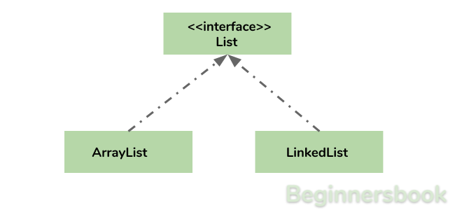

**Arraylist in Java declaration**

This is how you can declare an ArrayList of String type:

ArrayList<String> list=new ArrayList<>();

This is how you can declare an ArrayList of Integer type:

ArrayList<Integer> list=new ArrayList<>();

**Adding elements to Arraylist in java**

**Adding Element in ArrayList at specified position:**  
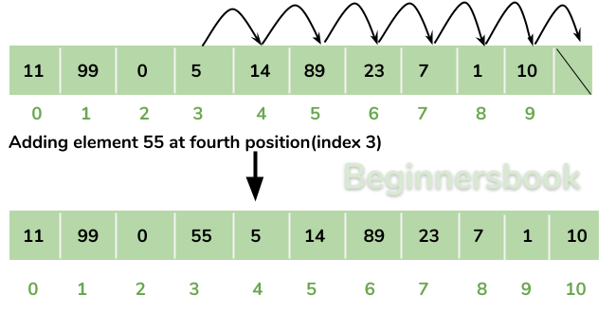  
You can add elements to an ArrayList by using [add() method](https://beginnersbook.com/2013/12/java-arraylist-add-method-example/). This method has couple of variations, which you can use based on the requirement.

**For example:** If you want to add the element at the end of the List then you can simply call the add() method like this:

arrList.add("Steve"); //This will add "Steve" at the end of List

To add the element at the specified location in ArrayList, you can specify the index in the add() method like this:

arrList.add(3, "Steve"); //This will add "Steve" at the fourth position

Lets write the complete code:

import java.util.\*;

class JavaExample{

public static void main(String args[]){

ArrayList<String> arrList=new ArrayList<String>();

arrList.add("Steve");

arrList.add("Tim");

arrList.add("Lucy");

arrList.add("Pat");

arrList.add("Angela");

arrList.add("Tom");

//displaying elements

System.out.println(arrList);

//Adding "Steve" at the fourth position

arrList.add(3, "Steve");

//displaying elements

System.out.println(arrList);

}

}

**Output:**

[Steve, Tim, Lucy, Pat, Angela, Tom]

[Steve, Tim, Lucy, Steve, Pat, Angela, Tom]

**Note:** Since the index starts with 0, index 3 would represent fourth position not 3.

**Change an element in ArrayList**

You can use the **set method** to change an element in ArrayList. You need to provide the **index** and **new element**, this method then updates the element present at the **given index** with the **new given element**.

In the following example, we have given the index as 0 and new element as “Lucy” in the set() method. The method updated the element present at the index 0 (“Jim”) with the new String element “Lucy”.

import java.util.ArrayList;

public class JavaExample {

public static void main(String[] args) {

ArrayList<String> names = new ArrayList<String>();

names.add("Jim");

names.add("Jack");

names.add("Ajeet");

names.add("Chaitanya");

names.set(0, "Lucy");

System.out.println(names);

}

}

**Output:**  
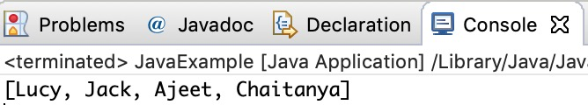

**How to remove element from Arraylist in Java?**

**Removing Element from ArrayList:**  
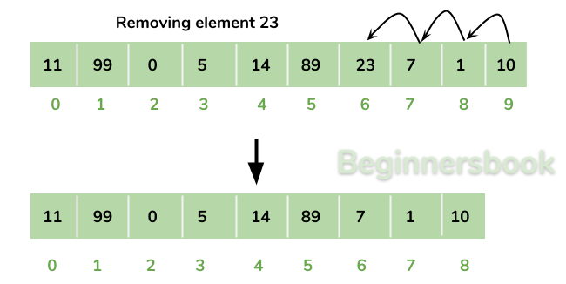  
You can use **remove() method** to remove elements from an ArrayList. Similar to add() method, this method also has couple of variations.

**For example:**

import java.util.\*;

class JavaExample{

public static void main(String args[]){

ArrayList<String> alist=new ArrayList<String>();

alist.add("Steve");

alist.add("Tim");

alist.add("Lucy");

alist.add("Pat");

alist.add("Angela");

alist.add("Tom");

//displaying elements

System.out.println(alist);

//Removing "Steve" and "Angela"

alist.remove("Steve");

alist.remove("Angela");

//displaying elements

System.out.println(alist);

//Removing 3rd element

alist.remove(2);

//displaying elements

System.out.println(alist);

}

}

**Output:**

[Steve, Tim, Lucy, Pat, Angela, Tom]

[Tim, Lucy, Pat, Tom]

[Tim, Lucy, Tom]

**Iterating ArrayList**

Here, we are using enhanced for loop to iterate ArrayList elements. This one of the best ways to iterate an ArrayList of string type.

import java.util.\*;

class JavaExample{

public static void main(String args[]){

ArrayList<String> alist=new ArrayList<String>();

alist.add("Gregor Clegane");

alist.add("Khal Drogo");

alist.add("Cersei Lannister");

alist.add("Sandor Clegane");

alist.add("Tyrion Lannister");

//iterating ArrayList

for(String str:alist)

System.out.println(str);

}

}

**Output:**

Gregor Clegane

Khal Drogo

Cersei Lannister

Sandor Clegane

Tyrion Lannister

**ArrayList Size**

We can use size() method of ArrayList to find the **number of elements in an ArrayList**.

import java.util.ArrayList;

public class JavaExample {

public static void main(String[] args) {

ArrayList<Integer> numbers = new ArrayList<Integer>();

numbers.add(1);

numbers.add(7);

numbers.add(5);

numbers.add(6);

System.out.println("Number of elements in ArrayList: "+numbers.size());

}

}

**Output:**  
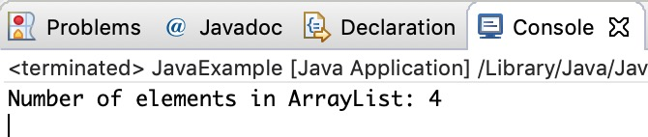

**Sort ArrayList**

You can use the **sort() method** of the **Collections utility class**to [sort an ArrayList](https://beginnersbook.com/2013/12/how-to-sort-arraylist-in-java/). This class is is a part of **java.util** package. In the following example we are sorting a list of String type **alphabetically.** This method also works on **numeric lists** (such as Integer type ArrayList).

import java.util.ArrayList;

import java.util.Collections;

public class JavaExample {

public static void main(String[] args) {

ArrayList<String> fruits = new ArrayList<String>();

fruits.add("Orange");

fruits.add("Apple");

fruits.add("Banana");

fruits.add("Pineapple");

Collections.sort(fruits);

for (String str : fruits) {

System.out.println(str);

}

}

}

**Output:**  
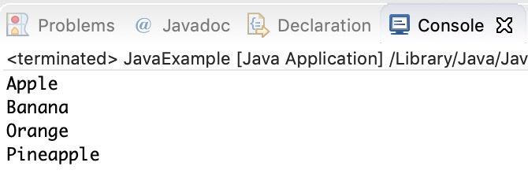

**ArrayList Example in Java**

This example demonstrates, how to **create**, **initialize**, **add** and **remove** elements from ArrayList. In this example we have an ArrayList of “String” type. We are adding 5 String element in the ArrayList using the method add(String E). This method adds the element at the end of the ArrayList.

We are then **adding** two more elements in the ArrayList using method add(int index, String E). This method adds the specified element at the specified index, index 0 indicates first position, 1 indicates second position and so on.

We are then **removing** the elements “Chaitanya” and “Harry” from the ArrayList. We again removed the second element of the ArrayList using method remove(int index).

import java.util.\*;

public class JavaExample {

public static void main(String args[]) {

/\* Creating ArrayList of type "String" which means

\* we can only add "String" elements

\*/

ArrayList<String> obj = new ArrayList<String>();

/\*This is how we add elements to an ArrayList\*/

obj.add("Ajeet");

obj.add("Harry");

obj.add("Chaitanya");

obj.add("Steve");

obj.add("Anuj");

// Displaying elements

System.out.println("Original ArrayList:");

for(String str:obj)

System.out.println(str);

/\* Add element at the given index

\* obj.add(0, "Rahul") - Adding element "Rahul" at first position

\* obj.add(1, "Justin") - Adding element "Justin" at second position

\*/

obj.add(0, "Rahul");

obj.add(1, "Justin");

// Displaying elements

System.out.println("ArrayList after add operation:");

for(String str:obj)

System.out.println(str);

//Remove elements from ArrayList like this

obj.remove("Chaitanya"); //Removes "Chaitanya" from ArrayList

obj.remove("Harry"); //Removes "Harry" from ArrayList

// Displaying elements

System.out.println("ArrayList after remove operation:");

for(String str:obj)

System.out.println(str);

//Remove element from the specified index

obj.remove(1); //Removes Second element from the List

// Displaying elements

System.out.println("Final ArrayList:");

for(String str:obj)

System.out.println(str);

}

}

**Output:**

Original ArrayList:

Ajeet

Harry

Chaitanya

Steve

Anuj

ArrayList after add operation:

Rahul

Justin

Ajeet

Harry

Chaitanya

Steve

Anuj

ArrayList after remove operation:

Rahul

Justin

Ajeet

Steve

Anuj

Final ArrayList:

Rahul

Ajeet

Steve

Anuj

**All methods of Arraylist in Java**

In the above examples, we have used methods such as add() and remove(). However there are number of other useful methods available in ArrayList class.

1) [**add**](https://beginnersbook.com/2013/12/java-arraylist-add-method-example/)**( Object o)**: This method adds an object o at the end of the arraylist.

obj.add("hello");

This statement would add a string hello in the arraylist at last position.

2) [**add**](https://beginnersbook.com/2013/12/java-arraylist-addint-index-e-element-example/)**(int index, Object o)**: It adds the object o at the specified index in the ArrayList.

obj.add(2, "bye");

It will add the string “bye” at the 2nd index (third element as array list starts with index 0) of array list.

3) [**remove**](https://beginnersbook.com/2013/12/java-arraylist-removeobject-method-example/)**(Object o)**: Removes the object o from the ArrayList.

obj.remove("Chaitanya");

This statement will remove the string “Chaitanya” from the ArrayList.

4) [**remove**](https://beginnersbook.com/2013/12/java-arraylist-remove-method-example/)**(int index)**: Removes element from a given index.

obj.remove(3);

It would remove the element of index 3 (4th element of the list – List starts with o).

5) [**set**](https://beginnersbook.com/2013/12/java-arraylist-set-method-example/)**(int index, Object o)**: Used for updating an element. It replaces the element present at the specified index with the object o.

obj.set(2, "Tom");

It would replace the 3rd element (index =2 is 3rd element) with the value Tom.

6)**int indexOf(Object o)**: Gives the index of the object o. If the element is not found in the list then this method returns the value -1.

int pos = obj.indexOf("Tom");

This would give the index (position) of the string Tom in the list.

7) **Object**[**get**](https://beginnersbook.com/2013/12/java-arraylist-get-method-example/)**(int index)**: It returns the object of list which is present at the specified index.

String str= obj.get(2);

This would return the string stored at 3rd position (index 2) and would be assigned to the string “str”. We are using string variable to store the get() result because the list is of string type. If the list is of int type then we can use int variable to store the returned element.

8) [**int size()**](https://beginnersbook.com/2013/12/how-to-find-length-of-arraylist-in-java/): It returns the size of the ArrayList (Number of elements of the list).

int numberofitems = obj.size();

9) **boolean**[**contains**](https://beginnersbook.com/2013/12/java-arraylist-contains-method-example/)**(Object o)**: It checks whether the given object o is present in the array list. If the element is found it returns true else it returns false.

obj.contains("Steve");

It would return true if the string “Steve” is present in the list else we would get false.

10) [**clear**](https://beginnersbook.com/2013/12/how-to-empty-an-arraylist-in-java/)**():** It is used for removing all the elements of the array list in one go. The below code will remove all the elements of ArrayList whose object is obj.

obj.clear();

# LinkedList in Java with Example

Similar to arrays in Java, **LinkedList is a linear data structure**. However LinkedList elements are not stored in contiguous locations like arrays, they are linked with each other using pointers. Each element of the LinkedList has the reference(address/pointer) to the next element of the LinkedList.

## LinkedList representation

Each element in the LinkedList is called the **Node**. Each Node of the LinkedList contains two items: 1) Content of the element 2) Pointer/Address/Reference to the Next Node in the LinkedList.

**This is how a LinkedList looks:**  


**Note:**  
1. **Head** of the LinkedList only contains the Address of the **First element** of the List.  
2. The Last element of the LinkedList contains **null** in the pointer part of the node because it is the end of the List so it doesn’t point to anything as shown in the above diagram.  
3. The diagram which is shown above represents a **singly linked list**. There is another complex type variation of LinkedList which is called **doubly linked list**, node of a doubly linked list contains three parts: 1) Pointer to the previous node of the linked list 2) content of the element 3) pointer to the next node of the linked list.

## Why do we need a Linked List?

You must be aware of the arrays which is also a linear data structure but **arrays have certain limitations such as:**

3) **Inserting an element in an array is performance wise expensive** as we have to shift several elements to make a space for the new element. For example:  
Let’s say we have an array that has following elements: 10, 12, 15, 20, 4, 5, 100, now if we want to insert a new element 99 after the element that has value 12 then we have to shift all the elements after 12 to their right to make space for new element.

Similarly **deleting an element** from the array is also a performance wise expensive operation because all the elements after the deleted element have to be shifted left.

**These limitations are handled in the Linked List by providing following features:**

3. Insert and delete operations in the Linked list are not performance wise expensive because adding and deleting an element from the linked list does’t require element shifting, only the pointer of the previous and the next node requires change.

## Hierarchy of LinkedList class in Java

## Java Linked List example of adding elements

In the following example we are using add(), addFirst() and addLast() methods to add the elements at the desired locations in the LinkedList, there are several such useful methods in the LinkedList class which I have mentioned at the end of this article.

package com.beginnersbook;

import java.util.\*;

public class JavaExample{

public static void main(String args[]){

LinkedList<String> list=new LinkedList<String>();

//Adding elements to the Linked list

list.add("Steve");

list.add("Carl");

list.add("Raj");

//Adding an element to the first position

list.addFirst("Negan");

//Adding an element to the last position

list.addLast("Rick");

//Adding an element to the 3rd position

list.add(2, "Glenn");

//Iterating LinkedList

Iterator<String> iterator=list.iterator();

while(iterator.hasNext()){

System.out.println(iterator.next());

}

}

}

**Output:**  
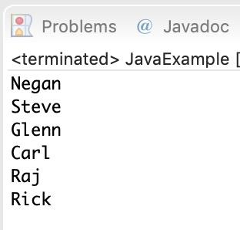

## Java example of removing elements from the LinkedList

In the following example we are checking out the few popular **remove methods** in the LinkedList that are used to remove elements from certain positions in the LinkedList

package com.beginnersbook;

import java.util.\*;

public class JavaExample{

public static void main(String args[]){

LinkedList<String> list=new LinkedList<String>();

//Adding elements to the Linked list

list.add("Steve");

list.add("Carl");

list.add("Raj");

list.add("Negan");

list.add("Rick");

//Removing First element

//Same as list.remove(0);

list.removeFirst();

//Removing Last element

list.removeLast();

//Iterating LinkedList

Iterator<String> iterator=list.iterator();

while(iterator.hasNext()){

System.out.print(iterator.next()+" ");

}

//removing 2nd element, index starts with 0

list.remove(1);

System.out.print("\nAfter removing second element: ");

//Iterating LinkedList again

Iterator<String> iterator2=list.iterator();

while(iterator2.hasNext()){

System.out.print(iterator2.next()+" ");

}

}

}

**Output:**  
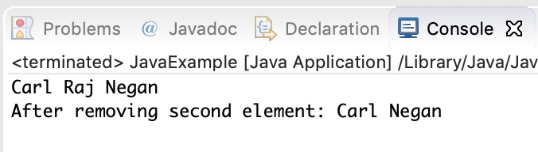

## Example of LinkedList in Java

import java.util.\*;

public class LinkedListExample {

public static void main(String args[]) {

/\* Linked List Declaration \*/

LinkedList<String> linkedlist = new LinkedList<String>();

/\*add(String Element) is used for adding

\* the elements to the linked list\*/

linkedlist.add("Item1");

linkedlist.add("Item5");

linkedlist.add("Item3");

linkedlist.add("Item6");

linkedlist.add("Item2");

/\*Display Linked List Content\*/

System.out.println("Linked List Content: " +linkedlist);

/\*Add First and Last Element\*/

linkedlist.addFirst("First Item");

linkedlist.addLast("Last Item");

System.out.println("LinkedList Content after addition: " +linkedlist);

/\*This is how to get and set Values\*/

Object firstvar = linkedlist.get(0);

System.out.println("First element: " +firstvar);

linkedlist.set(0, "Changed first item");

Object firstvar2 = linkedlist.get(0);

System.out.println("First element after update by set method: " +firstvar2);

/\*Remove first and last element\*/

linkedlist.removeFirst();

linkedlist.removeLast();

System.out.println("LinkedList after deletion of first and last element: " +linkedlist);

/\* Add to a Position and remove from a position\*/

linkedlist.add(0, "Newly added item");

linkedlist.remove(2);

System.out.println("Final Content: " +linkedlist);

}

}

Output:

Linked List Content: [Item1, Item5, Item3, Item6, Item2]

LinkedList Content after addition: [First Item, Item1, Item5, Item3, Item6, Item2, Last Item]

First element: First Item

First element after update by set method: Changed first item

LinkedList after deletion of first and last element: [Item1, Item5, Item3, Item6, Item2]

Final Content: [Newly added item, Item1, Item3, Item6, Item2]

## Methods of LinkedList class:

Here I have mentioned the brief description of the LinkedList methods, I have covered each one of these methods in separate tutorials, links are provided at the end of this article.

For all the examples in the below methods, consider llistobj as a reference for LinkedList<String>.

LinkedList<String> llistobj  = new LinkedList<String>();

1) **boolean add(Object item)**: It adds the item at the end of the list.

llistobj.add("Hello");

It would add the string “Hello” at the end of the linked list.

2) **void add(int index, Object item)**: It adds an item at the given index of the the list.

llistobj.add(2, "bye");

This will add the string “bye” at the 3rd position( 2 index is 3rd position as index starts with 0).

3) **boolean addAll(Collection c)**: It adds all the elements of the specified collection c to the list. It throws NullPointerException if the specified collection is null. Consider the below example –

LinkedList<String> llistobj = new LinkedList<String>();

ArrayList<String> arraylist= new ArrayList<String>();

arraylist.add("String1");

arraylist.add("String2");

llistobj.addAll(arraylist);

This piece of code would add all the elements of ArrayList to the LinkedList.

4) **boolean addAll(int index, Collection c)**: It adds all the elements of collection c to the list starting from a give index in the list. It throws NullPointerException if the collection c is null and IndexOutOfBoundsException when the specified index is out of the range.

llistobj.add(5, arraylist);

It would add all the elements of the ArrayList to the LinkedList starting from position 6 (index 5).

5) **void addFirst(Object item)**: It adds the item (or element) at the first position in the list.

llistobj.addFirst("text");

It would add the string “text” at the beginning of the list.

6) **void addLast(Object item)**: It inserts the specified item at the end of the list.

llistobj.addLast("Chaitanya");

This statement will add a string “Chaitanya” at the end position of the linked list.

7) **void clear()**: It removes all the elements of a list.

llistobj.clear();

8) **Object clone()**: It returns the copy of the list.

For e.g. My linkedList has four items: text1, text2, text3 and text4.

Object str= llistobj.clone();

System.out.println(str);

Output: The output of above code would be:

[text1, text2, text3, text4]

9) **boolean contains(Object item)**: It checks whether the given item is present in the list or not. If the item is present then it returns true else false.

boolean var = llistobj.contains("TestString");

It will check whether the string “TestString” exist in the list or not.

10) **Object get(int index)**: It returns the item of the specified index from the list.

Object var = llistobj.get(2);

It will fetch the 3rd item from the list.

11) **Object getFirst()**: It fetches the first item from the list.

Object var = llistobj.getFirst();

12) **Object getLast()**: It fetches the last item from the list.

Object var= llistobj.getLast();

13) **int indexOf(Object item)**: It returns the index of the specified item.

llistobj.indexOf("bye");

14) **int lastIndexOf(Object item)**: It returns the index of last occurrence of the specified element.

int pos = llistobj.lastIndexOf("hello);

integer variable pos will be having the index of last occurrence of string “hello”.

15) **Object poll()**: It returns and removes the first item of the list.

Object o = llistobj.poll();

16) **Object pollFirst()**: same as poll() method. Removes the first item of the list.

Object o = llistobj.pollFirst();

17) **Object pollLast()**: It returns and removes the last element of the list.

Object o = llistobj.pollLast();

18) **Object remove()**: It removes the first element of the list.

llistobj.remove();

19) **Object remove(int index)**: It removes the item from the list which is present at the specified index.

llistobj.remove(4);

It will remove the 5th element from the list.

20) **Object remove(Object obj)**: It removes the specified object from the list.

llistobj.remove("Test Item");

21) **Object removeFirst()**: It removes the first item from the list.

llistobj.removeFirst();

22) **Object removeLast()**: It removes the last item of the list.

llistobj.removeLast();

23) **Object removeFirstOccurrence(Object item)**: It removes the first occurrence of the specified item.

llistobj.removeFirstOccurrence("text");

It will remove the first occurrence of the string “text” from the list.

24) **Object removeLastOccurrence(Object item)**: It removes the last occurrence of the given element.

llistobj.removeLastOccurrence("String1);

It will remove the last occurrence of string “String1”.

25) **Object set(int index, Object item)**: It updates the item of specified index with the give value.

llistobj.set(2, "Test");

It will update the 3rd element with the string “Test”.

26)**int size()**: It returns the number of elements of the list.

llistobj.size();

# How to loop LinkedList in Java

In the last tutorial we discussed LinkedList and it’s methods with example. Here we will see how to loop/iterate a LinkedList. There are four ways in which a LinkedList can be iterated –

1. For loop
2. Advanced For loop
3. Iterator
4. While Loop

#### Example:

In this example we have a LinkedList of String Type and we are looping through it using all the four mentioned methods.

package beginnersbook.com;

import java.util.\*;

public class LinkedListExample {

public static void main(String args[]) {

/\*LinkedList declaration\*/

LinkedList<String> linkedlist=new LinkedList<String>();

linkedlist.add("Apple");

linkedlist.add("Orange");

linkedlist.add("Mango");

/\*for loop\*/

System.out.println("\*\*For loop\*\*");

for(int num=0; num<linkedlist.size(); num++)

{

System.out.println(linkedlist.get(num));

}

/\*Advanced for loop\*/

System.out.println("\*\*Advanced For loop\*\*");

for(String str: linkedlist)

{

System.out.println(str);

}

/\*Using Iterator\*/

System.out.println("\*\*Iterator\*\*");

Iterator i = linkedlist.iterator();

while (i.hasNext()) {

System.out.println(i.next());

}

/\* Using While Loop\*/

System.out.println("\*\*While Loop\*\*");

int num = 0;

while (linkedlist.size() > num) {

System.out.println(linkedlist.get(num));

num++;

}

}

}

Output:

\*\*For loop\*\*

Apple

Orange

Mango

\*\*Advanced For loop\*\*

Apple

Orange

Mango

\*\*Iterator\*\*

Apple

Orange

Mango

\*\*While Loop\*\*

Apple

Orange

Mango

# Vector in Java

Vector implements List Interface. Like ArrayList it also maintains insertion order but it is rarely used in non-thread environment as it is synchronized and due to which it gives poor performance in searching, adding, delete and update of its elements.

#### Three ways to create vector class object:

**Method 1:**

Vector vec = new Vector();

It creates an empty Vector with the default initial capacity of 10. It means the Vector will be re-sized when the 11th elements needs to be inserted into the Vector. Note: By default vector doubles its size. i.e. In this case the Vector size would remain 10 till 10 insertions and once we try to insert the 11th element It would become 20 (double of default capacity 10).

**Method 2:**  
Syntax: Vector object= new Vector(int initialCapacity)

Vector vec = new Vector(3);

It will create a Vector of initial capacity of 3.

**Method 3:**  
Syntax:

Vector object= new vector(int initialcapacity, capacityIncrement)

Example:

Vector vec= new Vector(4, 6)

Here we have provided two arguments. The initial capacity is 4 and capacityIncrement is 6. It means upon insertion of 5th element the size would be 10 (4+6) and on 11th insertion it would be 16(10+6).

## Complete Example of Vector in Java:

import java.util.\*;

public class VectorExample {

public static void main(String args[]) {

/\* Vector of initial capacity(size) of 2 \*/

Vector<String> vec = new Vector<String>(2);

/\* Adding elements to a vector\*/

vec.addElement("Apple");

vec.addElement("Orange");

vec.addElement("Mango");

vec.addElement("Fig");

/\* check size and capacityIncrement\*/

System.out.println("Size is: "+vec.size());

System.out.println("Default capacity increment is: "+vec.capacity());

vec.addElement("fruit1");

vec.addElement("fruit2");

vec.addElement("fruit3");

/\*size and capacityIncrement after two insertions\*/

System.out.println("Size after addition: "+vec.size());

System.out.println("Capacity after increment is: "+vec.capacity());

/\*Display Vector elements\*/

Enumeration en = vec.elements();

System.out.println("\nElements are:");

while(en.hasMoreElements())

System.out.print(en.nextElement() + " ");

}

}

Output:

Size is: 4

Default capacity increment is: 4

Size after addition: 7

Capacity after increment is: 8

Elements are:

Apple Orange Mango Fig fruit1 fruit2 fruit3

# HashSet in Java With Examples

This class implements the Set interface, backed by a hash table (actually a HashMap instance).

**Points to Note about HashSet:**

1. HashSet **internally uses Hashtable** data structure.
2. HashSet **doesn’t maintain any order**, the elements would be returned in any random order.
3. HashSet **doesn’t allow duplicates**. If you try to add a duplicate element in HashSet, the old value would be overwritten.
4. HashSet **allows null values**, however if you insert more than one nulls, it would override the previous null value.
5. HashSet is **non-synchronized**. However it can be synchronized explicitly like this: Set s = Collections.synchronizedSet(new HashSet(...));

## A Simple Example of HashSet in Java

Let’s see a simple HashSet example, where we are adding few string elements to HashSet and then iterating the HashSet to print the elements.

import java.util.HashSet;

public class JavaExample {

public static void main(String args[]) {

// HashSet declaration

HashSet<String> hSet = new HashSet<>();

// Adding elements to the HashSet

hSet.add("Cricket");

hSet.add("Hockey");

hSet.add("Basketball");

System.out.println("HashSet Elements: ");

// Iterating HashSet

for(String s: hSet){

System.out.println(s);

}

}

}

**Output:**

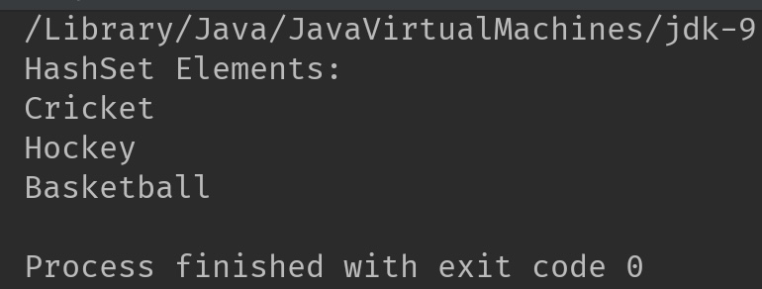

## HashSet class Hierarchy

HashSet class extends AbstractSet class. The AbstractSet class implements Set interface, which extends Collection interface. This hierarchy can be represented as follows:

HashSet -> AbstractSet -> Set -> Collection -> Iterable

## HashSet Declaration

HashSet class belongs to java.util package. The declaration of HashSet in Java is:

public class HashSet<E> extends AbstractSet<E> implements Set<E>, Cloneable, Serializable

## Initial Capacity and Load Factor:

**Initial capacity** represents the initial data buckets allocated to HashSet, this automatically increases when HashSet gets full.

**Load factor** measures the load of HashSet, it represents how much the HashSet is full. A load factor of .60 means that when HashSet is 60% full, the capacity of HashSet is automatically increased.

Number of element in HashSet

Load Factor Of HashSet = ----------------------------

Size of the HashSet

## Constructors of Java HashSet Class

|  |  |
| --- | --- |
| Constructor | Description |
| HashSet() | It builds an empty HashSet with initial capacity of 16 and load factor of .75. Example: HashSet<String> hSet = HashSet<>(); |
| HashSet(int initialCapacity) | It builds an empty HashSet with the specified initial capacity. The default load factor remains .75. |
| HashSet(int initialCapacity, float loadFactor) | It builds an empty HashSet with the specified initial capacity and load factor. |
| HashSet(Collection) | This doesn’t create an empty HashSet. It creates the HashSet with the elements copied from the passed Collection. |

## Java HashSet Examples

Let’s see few examples of HashSet in Java.

### 1. Adding duplicate elements

HashSet overrides duplicate values.

import java.util.HashSet;

public class HashSetExample {

public static void main(String args[]) {

// HashSet declaration

HashSet<String> hset =

new HashSet<String>();

// Adding elements to the HashSet

hset.add("Apple");

hset.add("Mango");

hset.add("Grapes");

hset.add("Orange");

hset.add("Fig");

//Addition of duplicate elements

hset.add("Apple");

hset.add("Mango");

//Addition of null values

hset.add(null);

hset.add(null);

//Displaying HashSet elements

System.out.println(hset);

}

}

**Output:**

[null, Mango, Grapes, Apple, Orange, Fig]

As you can see there all the duplicate values are not present in the output including the duplicate null value.

### 2. Removing elements

import java.util.HashSet;

public class JavaExample {

public static void main(String args[]) {

// HashSet declaration

HashSet<String> hSet = new HashSet<>();

// Adding elements to the HashSet

hSet.add("AA");

hSet.add("BB");

hSet.add("CC");

hSet.add("DD");

hSet.add("EE");

//removing elements

hSet.remove("EE");

hSet.remove("CC");

System.out.println("HashSet Elements: ");

// Iterating HashSet

for(String s: hSet){

System.out.println(s);

}

}

}

**Output:**

HashSet Elements:

AA

BB

DD

### 3. Adding elements from other Collection

Here, we are adding [ArrayList](https://beginnersbook.com/2013/12/java-arraylist/) elements to HashSet

import java.util.\*;

public class JavaExample {

public static void main(String args[]) {

//ArrayList declaration and and adding elements

ArrayList<String> arrList=new ArrayList<>();

arrList.add("AA");

arrList.add("BB");

arrList.add("CC");

//copying ArrayList elements to HashSet

HashSet<String> hSet=new HashSet(arrList);

//adding another element to HashSet after copy

hSet.add("DD");

System.out.println("HashSet elements: ");

Iterator<String> it= hSet.iterator();

while(it.hasNext())

{

System.out.println(it.next());

}

}

}

**Output:**

HashSet elements:

AA

BB

CC

DD

## HashSet Methods:

1. **boolean add(Element  e)**: It adds the element e to the list.
2. **void clear()**: It removes all the elements from the list.
3. **Object clone()**: This method returns a shallow copy of the HashSet.
4. **boolean contains(Object o)**: It checks whether the specified Object o is present in the list or not. If the object has been found it returns true else false.
5. **boolean isEmpty()**: Returns true if there is no element present in the Set.
6. **int size()**: It gives the number of elements of a Set.
7. **boolean(Object o)**: It removes the specified Object o from the Set.

# How to Iterate over a Set/HashSet

BY CHAITANYA SINGH

There are following two ways to iterate through HashSet:  
1) Using Iterator  
2) Without using Iterator

#### Example 1: Using Iterator

import java.util.HashSet;

import java.util.Iterator;

class IterateHashSet{

public static void main(String[] args) {

// Create a HashSet

HashSet<String> hset = new HashSet<String>();

//add elements to HashSet

hset.add("Chaitanya");

hset.add("Rahul");

hset.add("Tim");

hset.add("Rick");

hset.add("Harry");

Iterator<String> it = hset.iterator();

while(it.hasNext()){

System.out.println(it.next());

}

}

}

**Output:**

Chaitanya

Rick

Harry

Rahul

Tim

### Example 2: Iterate without using Iterator

import java.util.HashSet;

import java.util.Set;

class IterateHashSet{

public static void main(String[] args) {

// Create a HashSet

Set<String> hset = new HashSet<String>();

//add elements to HashSet

hset.add("Chaitanya");

hset.add("Rahul");

hset.add("Tim");

hset.add("Rick");

hset.add("Harry");

for (String temp : hset) {

System.out.println(temp);

}

}

}

**Output:**

Chaitanya

Rick

Harry

Rahul

Tim

# How to convert a HashSet to a TreeSet

#### Description

Program to convert a HashSet to a TreeSet

#### Program

Here is the complete code for HashSet to TreeSet conversion. We have a HashSet of Strings and we are creating a TreeSet of strings by copying all the elements of HashSet to TreeSet.

import java.util.HashSet;

import java.util.TreeSet;

import java.util.Set;

class ConvertHashSettoTreeSet{

public static void main(String[] args) {

// Create a HashSet

HashSet<String> hset = new HashSet<String>();

//add elements to HashSet

hset.add("Element1");

hset.add("Element2");

hset.add("Element3");

hset.add("Element4");

// Displaying HashSet elements

System.out.println("HashSet contains: "+ hset);

// Creating a TreeSet of HashSet elements

TreeSet<String> tset = new TreeSet<String>(hset);

// Displaying TreeSet elements

System.out.println("TreeSet contains: ");

for(String temp : tset){

System.out.println(temp);

}

}

}

**Output:**

HashSet contains: [Element1, Element2, Element3, Element4]

TreeSet contains:

Element1

Element2

Element3

Element4

# Convert HashSet to a List/ArrayList

learning how to convert a HashSet to a List (ArrayList).

#### Program

Here we have a HashSet of String elements and we are creating an ArrayList of Strings by copying all the elements of HashSet to ArrayList. Following is the complete code:

import java.util.HashSet;

import java.util.List;

import java.util.ArrayList;

class ConvertHashSetToArrayList{

public static void main(String[] args) {

// Create a HashSet

HashSet<String> hset = new HashSet<String>();

//add elements to HashSet

hset.add("Steve");

hset.add("Matt");

hset.add("Govinda");

hset.add("John");

hset.add("Tommy");

// Displaying HashSet elements

System.out.println("HashSet contains: "+ hset);

// Creating a List of HashSet elements

List<String> list = new ArrayList<String>(hset);

// Displaying ArrayList elements

System.out.println("ArrayList contains: "+ list);

}

}

**Output:**

HashSet contains: [Tommy, Matt, Steve, Govinda, John]

ArrayList contains: [Tommy, Matt, Steve, Govinda, John]

# LinkedHashSet Class in Java with Example

Earlier we have shared tutorials on [HashSet](https://beginnersbook.com/2013/12/hashset-class-in-java-with-example/) and [TreeSet](https://beginnersbook.com/2013/12/treeset-class-in-java-with-example/). [LinkedHashSet](https://docs.oracle.com/javase/6/docs/api/java/util/LinkedHashSet.html) is also an implementation of Set interface, it is similar to the HashSet and TreeSet except the below mentioned differences:

1. HashSet doesn’t maintain any kind of order of its elements.
2. TreeSet sorts the elements in ascending order.
3. LinkedHashSet maintains the insertion order. Elements gets sorted in the same sequence in which they have been added to the Set.

## Example of LinkedHashSet:

import java.util.LinkedHashSet;

public class LinkedHashSetExample {

public static void main(String args[]) {

// LinkedHashSet of String Type

LinkedHashSet<String> lhset = new LinkedHashSet<String>();

// Adding elements to the LinkedHashSet

lhset.add("Z");

lhset.add("PQ");

lhset.add("N");

lhset.add("O");

lhset.add("KK");

lhset.add("FGH");

System.out.println(lhset);

// LinkedHashSet of Integer Type

LinkedHashSet<Integer> lhset2 = new LinkedHashSet<Integer>();

// Adding elements

lhset2.add(99);

lhset2.add(7);

lhset2.add(0);

lhset2.add(67);

lhset2.add(89);

lhset2.add(66);

System.out.println(lhset2);

}

}

**Output:**

[Z, PQ, N, O, KK, FGH]

[99, 7, 0, 67, 89, 66]

Observe the output: Both types of LinkedHashSet have preserved the insertion order.

# TreeSet Class in Java with example

TreeSet is similar to [HashSet](https://beginnersbook.com/2013/12/hashset-class-in-java-with-example/) except that it sorts the elements in the ascending order while HashSet doesn’t maintain any order. TreeSet allows null element but like HashSet it doesn’t allow. Like most of the other collection classes this class is also not synchronized, however it can be synchronized explicitly like this: SortedSet s = Collections.synchronizedSortedSet(new TreeSet(...));

## TreeSet Example:

In this example we have two TreeSet (TreeSet<String> & TreeSet<Integer>). We have added the values to both of them randomly however the result we got is sorted in ascending order.

import java.util.TreeSet;

public class TreeSetExample {

public static void main(String args[]) {

// TreeSet of String Type

TreeSet<String> tset = new TreeSet<String>();

// Adding elements to TreeSet<String>

tset.add("ABC");

tset.add("String");

tset.add("Test");

tset.add("Pen");

tset.add("Ink");

tset.add("Jack");

//Displaying TreeSet

System.out.println(tset);

// TreeSet of Integer Type

TreeSet<Integer> tset2 = new TreeSet<Integer>();

// Adding elements to TreeSet<Integer>

tset2.add(88);

tset2.add(7);

tset2.add(101);

tset2.add(0);

tset2.add(3);

tset2.add(222);

System.out.println(tset2);

}

}

Output: You can see both the TreeSet have been sorted in ascending order implicitly.

[ABC, Ink, Jack, Pen, String, Test]

[0, 3, 7, 88, 101, 222]

# **Java Map Interface**

A map contains values on the basis of key, i.e. key and value pair. Each key and value pair is known as an entry. A Map contains unique keys.

A Map is useful if you have to search, update or delete elements on the basis of a key.

## Java Map Hierarchy

There are two interfaces for implementing Map in java: Map and SortedMap, and three classes: HashMap, LinkedHashMap, and TreeMap. The hierarchy of Java Map is given below:

Java Map Hierarchy

A Map doesn't allow duplicate keys, but you can have duplicate values. HashMap and LinkedHashMap allow null keys and values, but TreeMap doesn't allow any null key or value.

Play Videox[](https://campaign.adpushup.com/get-started/?utm_source=banner&utm_campaign=growth_hack)

A Map can't be traversed, so you need to convert it into Set using keySet() or entrySet() method.

## Map.Entry Interface

Entry is the subinterface of Map. So we will be accessed it by Map.Entry name. It returns a collection-view of the map, whose elements are of this class. It provides methods to get key and value.

### **Methods of Map.Entry interface**

|  |  |
| --- | --- |
| **Method** | **Description** |
| K getKey() | It is used to obtain a key. |
| V getValue() | It is used to obtain value. |
| int hashCode() | It is used to obtain hashCode. |
| V setValue(V value) | It is used to replace the value corresponding to this entry with the specified value. |
| boolean equals(Object o) | It is used to compare the specified object with the other existing objects. |
| static <K extends Comparable<? super K>,V> Comparator<Map.Entry<K,V>> comparingByKey() | It returns a comparator that compare the objects in natural order on key. |
| static <K,V> Comparator<Map.Entry<K,V>> comparingByKey(Comparator<? super K> cmp) | It returns a comparator that compare the objects by key using the given Comparator. |
| static <K,V extends Comparable<? super V>> Comparator<Map.Entry<K,V>> comparingByValue() | It returns a comparator that compare the objects in natural order on value. |
| static <K,V> Comparator<Map.Entry<K,V>> comparingByValue(Comparator<? super V> cmp) | It returns a comparator that compare the objects by value using the given Comparator. |

### **Java Map Example: Non-Generic (Old Style)**

1. //Non-generic
2. **import** java.util.\*;
3. **public** **class** MapExample1 {
4. **public** **static** **void** main(String[] args) {
5. Map map=**new** HashMap();
6. //Adding elements to map
7. map.put(1,"Amit");
8. map.put(5,"Rahul");
9. map.put(2,"Jai");
10. map.put(6,"Amit");
11. //Traversing Map
12. Set set=map.entrySet();//Converting to Set so that we can traverse
13. Iterator itr=set.iterator();
14. **while**(itr.hasNext()){
15. //Converting to Map.Entry so that we can get key and value separately
16. Map.Entry entry=(Map.Entry)itr.next();
17. System.out.println(entry.getKey()+" "+entry.getValue());
18. }
19. }
20. }

Output:

1 Amit

2 Jai

5 Rahul

6 Amit

### **Java Map Example: Generic (New Style)**

1. **import** java.util.\*;
2. **class** MapExample2{
3. **public** **static** **void** main(String args[]){
4. Map<Integer,String> map=**new** HashMap<Integer,String>();
5. map.put(100,"Amit");
6. map.put(101,"Vijay");
7. map.put(102,"Rahul");
8. //Elements can traverse in any order
9. **for**(Map.Entry m:map.entrySet()){
10. System.out.println(m.getKey()+" "+m.getValue());
11. }
12. }
13. }

Output:

102 Rahul

100 Amit

101 Vijay

Java HashMap

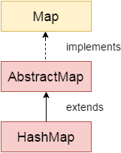

Java **HashMap** class implements the Map interface which allows us *to store key and value pair*, where keys should be unique. If you try to insert the duplicate key, it will replace the element of the corresponding key. It is easy to perform operations using the key index like updation, deletion, etc. HashMap class is found in the java.util package.

HashMap in Java is like the legacy Hashtable class, but it is not synchronized. It allows us to store the null elements as well, but there should be only one null key. Since Java 5, it is denoted as HashMap<K,V>, where K stands for key and V for value. It inherits the AbstractMap class and implements the Map interface.

Points to remember

* Java HashMap contains values based on the key.
* Java HashMap contains only unique keys.
* Java HashMap may have one null key and multiple null values.
* Java HashMap is non synchronized.
* Java HashMap maintains no order.
* The initial default capacity of Java HashMap class is 16 with a load factor of 0.75.

### **Java HashMap Example**

Let's see a simple example of HashMap to store key and value pair.

1. **import** java.util.\*;
2. **public** **class** HashMapExample1{
3. **public** **static** **void** main(String args[]){
4. HashMap<Integer,String> map=**new** HashMap<Integer,String>();//Creating HashMap
5. map.put(1,"Mango");  //Put elements in Map
6. map.put(2,"Apple");
7. map.put(3,"Banana");
8. map.put(4,"Grapes");
10. System.out.println("Iterating Hashmap...");
11. **for**(Map.Entry m : map.entrySet()){
12. System.out.println(m.getKey()+" "+m.getValue());
13. }
14. }
15. }

[Test it Now](https://www.javatpoint.com/opr/test.jsp?filename=HashMapExample1)

Iterating Hashmap...

1 Mango

2 Apple

3 Banana

4 Grapes

In this example, we are storing Integer as the key and String as the value, so we are using HashMap<Integer,String> as the type. The put() method inserts the elements in the map.

To get the key and value elements, we should call the getKey() and getValue() methods. The Map.Entry interface contains the getKey() and getValue() methods. But, we should call the entrySet() method of Map interface to get the instance of Map.Entry.

### **No Duplicate Key on HashMap**

You cannot store duplicate keys in HashMap. However, if you try to store duplicate key with another value, it will replace the value.

1. **import** java.util.\*;
2. **public** **class** HashMapExample2{
3. **public** **static** **void** main(String args[]){
4. HashMap<Integer,String> map=**new** HashMap<Integer,String>();//Creating HashMap
5. map.put(1,"Mango");  //Put elements in Map
6. map.put(2,"Apple");
7. map.put(3,"Banana");
8. map.put(1,"Grapes"); //trying duplicate key
10. System.out.println("Iterating Hashmap...");
11. **for**(Map.Entry m : map.entrySet()){
12. System.out.println(m.getKey()+" "+m.getValue());
13. }
14. }
15. }

[Test it Now](https://www.javatpoint.com/opr/test.jsp?filename=HashMapExample2)

Iterating Hashmap...

1 Grapes

2 Apple

3 Banana

### **Java HashMap example to add() elements**

Here, we see different ways to insert elements.

1. **import** java.util.\*;
2. **class** HashMap1{
3. **public** **static** **void** main(String args[]){
4. HashMap<Integer,String> hm=**new** HashMap<Integer,String>();
5. System.out.println("Initial list of elements: "+hm);
6. hm.put(100,"Amit");
7. hm.put(101,"Vijay");
8. hm.put(102,"Rahul");
10. System.out.println("After invoking put() method ");
11. **for**(Map.Entry m:hm.entrySet()){
12. System.out.println(m.getKey()+" "+m.getValue());
13. }
15. hm.putIfAbsent(103, "Gaurav");
16. System.out.println("After invoking putIfAbsent() method ");
17. **for**(Map.Entry m:hm.entrySet()){
18. System.out.println(m.getKey()+" "+m.getValue());
19. }
20. HashMap<Integer,String> map=**new** HashMap<Integer,String>();
21. map.put(104,"Ravi");
22. map.putAll(hm);
23. System.out.println("After invoking putAll() method ");
24. **for**(Map.Entry m:map.entrySet()){
25. System.out.println(m.getKey()+" "+m.getValue());
26. }
27. }
28. }

Initial list of elements: {}

After invoking put() method

100 Amit

101 Vijay

102 Rahul

After invoking putIfAbsent() method

100 Amit

101 Vijay

102 Rahul

103 Gaurav

After invoking putAll() method

100 Amit

101 Vijay

102 Rahul

103 Gaurav

104 Ravi

### **Java HashMap example to remove() elements**

Here, we see different ways to remove elements.

1. **import** java.util.\*;
2. **public** **class** HashMap2 {
3. **public** **static** **void** main(String args[]) {
4. HashMap<Integer,String> map=**new** HashMap<Integer,String>();
5. map.put(100,"Amit");
6. map.put(101,"Vijay");
7. map.put(102,"Rahul");
8. map.put(103, "Gaurav");
9. System.out.println("Initial list of elements: "+map);
10. //key-based removal
11. map.remove(100);
12. System.out.println("Updated list of elements: "+map);
13. //value-based removal
14. map.remove(101);
15. System.out.println("Updated list of elements: "+map);
16. //key-value pair based removal
17. map.remove(102, "Rahul");
18. System.out.println("Updated list of elements: "+map);
19. }
20. }

Output:

Initial list of elements: {100=Amit, 101=Vijay, 102=Rahul, 103=Gaurav}

Updated list of elements: {101=Vijay, 102=Rahul, 103=Gaurav}

Updated list of elements: {102=Rahul, 103=Gaurav}

Updated list of elements: {103=Gaurav}

### **Java HashMap example to replace() elements**

Here, we see different ways to replace elements.

1. **import** java.util.\*;
2. **class** HashMap3{
3. **public** **static** **void** main(String args[]){
4. HashMap<Integer,String> hm=**new** HashMap<Integer,String>();
5. hm.put(100,"Amit");
6. hm.put(101,"Vijay");
7. hm.put(102,"Rahul");
8. System.out.println("Initial list of elements:");
9. **for**(Map.Entry m:hm.entrySet())
10. {
11. System.out.println(m.getKey()+" "+m.getValue());
12. }
13. System.out.println("Updated list of elements:");
14. hm.replace(102, "Gaurav");
15. **for**(Map.Entry m:hm.entrySet())
16. {
17. System.out.println(m.getKey()+" "+m.getValue());
18. }
19. System.out.println("Updated list of elements:");
20. hm.replace(101, "Vijay", "Ravi");
21. **for**(Map.Entry m:hm.entrySet())
22. {
23. System.out.println(m.getKey()+" "+m.getValue());
24. }
25. System.out.println("Updated list of elements:");
26. hm.replaceAll((k,v) -> "Ajay");
27. **for**(Map.Entry m:hm.entrySet())
28. {
29. System.out.println(m.getKey()+" "+m.getValue());
30. }
31. }
32. }

Initial list of elements:

100 Amit

101 Vijay

102 Rahul

Updated list of elements:

100 Amit

101 Vijay

102 Gaurav

Updated list of elements:

100 Amit

101 Ravi

102 Gaurav

Updated list of elements:

100 Ajay

101 Ajay

102 Ajay

### **Difference between HashSet and HashMap**

HashSet contains only values whereas HashMap contains an entry(key and value).

### **Java HashMap Example: Book**

1. **import** java.util.\*;
2. **class** Book {
3. **int** id;
4. String name,author,publisher;
5. **int** quantity;
6. **public** Book(**int** id, String name, String author, String publisher, **int** quantity) {
7. **this**.id = id;
8. **this**.name = name;
9. **this**.author = author;
10. **this**.publisher = publisher;
11. **this**.quantity = quantity;
12. }
13. }
14. **public** **class** MapExample {
15. **public** **static** **void** main(String[] args) {
16. //Creating map of Books
17. Map<Integer,Book> map=**new** HashMap<Integer,Book>();
18. //Creating Books
19. Book b1=**new** Book(101,"Let us C","Yashwant Kanetkar","BPB",8);
20. Book b2=**new** Book(102,"Data Communications & Networking","Forouzan","Mc Graw Hill",4);
21. Book b3=**new** Book(103,"Operating System","Galvin","Wiley",6);
22. //Adding Books to map
23. map.put(1,b1);
24. map.put(2,b2);
25. map.put(3,b3);
27. //Traversing map
28. **for**(Map.Entry<Integer, Book> entry:map.entrySet()){
29. **int** key=entry.getKey();
30. Book b=entry.getValue();
31. System.out.println(key+" Details:");
32. System.out.println(b.id+" "+b.name+" "+b.author+" "+b.publisher+" "+b.quantity);
33. }
34. }
35. }

[Test it Now](https://www.javatpoint.com/opr/test.jsp?filename=MapExample)

Output:

1 Details:

101 Let us C Yashwant Kanetkar BPB 8

2 Details:

102 Data Communications and Networking Forouzan Mc Graw Hill 4

3 Details:

103 Operating System Galvin Wiley 6

Working of HashMap in Java

What is Hashing

It is the process of converting an object into an integer value. The integer value helps in indexing and faster searches.

What is HashMap

HashMap is a part of the Java collection framework. It uses a technique called Hashing. It implements the map interface. It stores the data in the pair of Key and Value. HashMap contains an array of the nodes, and the node is represented as a class. It uses an array and LinkedList data structure internally for storing Key and Value. There are four fields in HashMap.

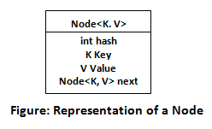

Before understanding the internal working of HashMap, you must be aware of hashCode() and equals() method.

* **equals():** It checks the equality of two objects. It compares the Key, whether they are equal or not. It is a method of the Object class. It can be overridden. If you override the equals() method, then it is mandatory to override the hashCode() method.
* **hashCode():** This is the method of the object class. It returns the memory reference of the object in integer form. The value received from the method is used as the bucket number. The bucket number is the address of the element inside the map. Hash code of null Key is 0.
* **Buckets:** Array of the node is called buckets. Each node has a data structure like a LinkedList. More than one node can share the same bucket. It may be different in capacity.

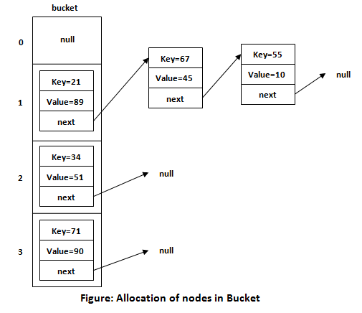

Insert Key, Value pair in HashMap

We use put() method to insert the Key and Value pair in the HashMap. The default size of HashMap is 16 (0 to 15).

Play Videox[](https://campaign.adpushup.com/get-started/?utm_source=banner&utm_campaign=growth_hack)

Example

In the following example, we want to insert three (Key, Value) pair in the HashMap.

1. HashMap<String, Integer> map = **new** HashMap<>();
2. map.put("Aman", 19);
3. map.put("Sunny", 29);
4. map.put("Ritesh", 39);

Let's see at which index the Key, value pair will be saved into HashMap. When we call the put() method, then it calculates the hash code of the Key "Aman." Suppose the hash code of "Aman" is 2657860. To store the Key in memory, we have to calculate the index.

Calculating Index

Index minimizes the size of the array. The Formula for calculating the index is:

1. Index = hashcode(Key) & (n-1)

Where n is the size of the array. Hence the index value for "Aman" is:

1. Index = 2657860 & (16-1) = 4

The value 4 is the computed index value where the Key and value will store in HashMap.

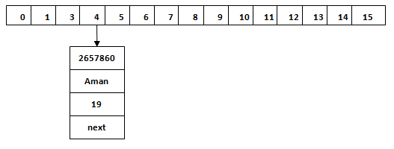

Hash Collision

This is the case when the calculated index value is the same for two or more Keys. Let's calculate the hash code for another Key "Sunny." Suppose the hash code for "Sunny" is 63281940. To store the Key in the memory, we have to calculate index by using the index formula.

1. Index=63281940 & (16-1) = 4

The value 4 is the computed index value where the Key will be stored in HashMap. In this case, equals() method check that both Keys are equal or not. If Keys are same, replace the value with the current value. Otherwise, connect this node object to the existing node object through the LinkedList. Hence both Keys will be stored at index 4.

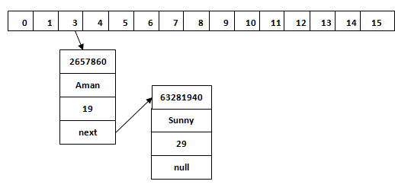

Similarly, we will store the Key "Ritesh." Suppose hash code for the Key is 2349873. The index value will be 1. Hence this Key will be stored at index 1.

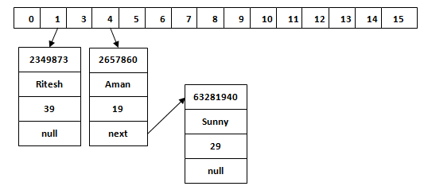

get() method in HashMap

get() method is used to get the value by its Key. It will not fetch the value if you don't know the Key. When get(K Key) method is called, it calculates the hash code of the Key.

Suppose we have to fetch the Key "Aman." The following method will be called.

1. map.get(**new** Key("Aman"));

It generates the hash code as 2657860. Now calculate the index value of 2657860 by using index formula. The index value will be 4, as we have calculated above. get() method search for the index value 4. It compares the first element Key with the given Key. If both keys are equal, then it returns the value else check for the next element in the node if it exists. In our scenario, it is found as the first element of the node and return the value 19.

Let's fetch another Key "Sunny."

The hash code of the Key "Sunny" is 63281940. The calculated index value of 63281940 is 4, as we have calculated for put() method. Go to index 4 of the array and compare the first element's Key with the given Key. It also compares Keys. In our scenario, the given Key is the second element, and the next of the node is null. It compares the second element Key with the specified Key and returns the value 29. It returns null if the next of the node is null.

Java LinkedHashMap class

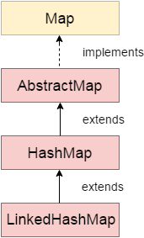

Java LinkedHashMap class is Hashtable and Linked list implementation of the Map interface, with predictable iteration order. It inherits HashMap class and implements the Map interface.

Points to remember

* Java LinkedHashMap contains values based on the key.
* Java LinkedHashMap contains unique elements.
* Java LinkedHashMap may have one null key and multiple null values.
* Java LinkedHashMap is non synchronized.
* Java LinkedHashMap maintains insertion order.
* The initial default capacity of Java HashMap class is 16 with a load factor of 0.75.

LinkedHashMap class declaration

Let's see the declaration for java.util.LinkedHashMap class.

1. **public** **class** LinkedHashMap<K,V> **extends** HashMap<K,V> **implements** Map<K,V>

LinkedHashMap class Parameters

Let's see the Parameters for java.util.LinkedHashMap class.

* **K**: It is the type of keys maintained by this map.
* **V**: It is the type of mapped values.

Java LinkedHashMap Example

1. **import** java.util.\*;
2. **class** LinkedHashMap1{
3. **public** **static** **void** main(String args[]){
5. LinkedHashMap<Integer,String> hm=**new** LinkedHashMap<Integer,String>();
7. hm.put(100,"Amit");
8. hm.put(101,"Vijay");
9. hm.put(102,"Rahul");
11. **for**(Map.Entry m:hm.entrySet()){
12. System.out.println(m.getKey()+" "+m.getValue());
13. }
14. }
15. }

Output:100 Amit

101 Vijay

102 Rahul

Java LinkedHashMap Example: Key-Value pair

1. **import** java.util.\*;
2. **class** LinkedHashMap2{
3. **public** **static** **void** main(String args[]){
4. LinkedHashMap<Integer, String> map = **new** LinkedHashMap<Integer, String>();
5. map.put(100,"Amit");
6. map.put(101,"Vijay");
7. map.put(102,"Rahul");
8. //Fetching key
9. System.out.println("Keys: "+map.keySet());
10. //Fetching value
11. System.out.println("Values: "+map.values());
12. //Fetching key-value pair
13. System.out.println("Key-Value pairs: "+map.entrySet());
14. }
15. }

Keys: [100, 101, 102]

Values: [Amit, Vijay, Rahul]

Key-Value pairs: [100=Amit, 101=Vijay, 102=Rahul]

Java LinkedHashMap Example:remove()

1. **import** java.util.\*;
2. **public** **class** LinkedHashMap3 {
3. **public** **static** **void** main(String args[]) {
4. Map<Integer,String> map=**new** LinkedHashMap<Integer,String>();
5. map.put(101,"Amit");
6. map.put(102,"Vijay");
7. map.put(103,"Rahul");
8. System.out.println("Before invoking remove() method: "+map);
9. map.remove(102);
10. System.out.println("After invoking remove() method: "+map);
11. }
12. }

Output:

Play Videox[](https://campaign.adpushup.com/get-started/?utm_source=banner&utm_campaign=growth_hack)

Before invoking remove() method: {101=Amit, 102=Vijay, 103=Rahul}

After invoking remove() method: {101=Amit, 103=Rahul}

Java LinkedHashMap Example: Book

1. **import** java.util.\*;
2. **class** Book {
3. **int** id;
4. String name,author,publisher;
5. **int** quantity;
6. **public** Book(**int** id, String name, String author, String publisher, **int** quantity) {
7. **this**.id = id;
8. **this**.name = name;
9. **this**.author = author;
10. **this**.publisher = publisher;
11. **this**.quantity = quantity;
12. }
13. }
14. **public** **class** MapExample {
15. **public** **static** **void** main(String[] args) {
16. //Creating map of Books
17. Map<Integer,Book> map=**new** LinkedHashMap<Integer,Book>();
18. //Creating Books
19. Book b1=**new** Book(101,"Let us C","Yashwant Kanetkar","BPB",8);
20. Book b2=**new** Book(102,"Data Communications & Networking","Forouzan","Mc Graw Hill",4);
21. Book b3=**new** Book(103,"Operating System","Galvin","Wiley",6);
22. //Adding Books to map
23. map.put(2,b2);
24. map.put(1,b1);
25. map.put(3,b3);
27. //Traversing map
28. **for**(Map.Entry<Integer, Book> entry:map.entrySet()){
29. **int** key=entry.getKey();
30. Book b=entry.getValue();
31. System.out.println(key+" Details:");
32. System.out.println(b.id+" "+b.name+" "+b.author+" "+b.publisher+" "+b.quantity);
33. }
34. }
35. }

Output:

2 Details:

102 Data Communications & Networking Forouzan Mc Graw Hill 4

1 Details:

101 Let us C Yashwant Kanetkar BPB 8

3 Details:

103 Operating System Galvin Wiley 6

Java TreeMap class

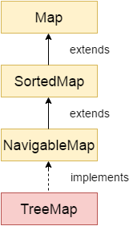

Java TreeMap class is a red-black tree based implementation. It provides an efficient means of storing key-value pairs in sorted order.

The important points about Java TreeMap class are:

* Java TreeMap contains values based on the key. It implements the NavigableMap interface and extends AbstractMap class.
* Java TreeMap contains only unique elements.
* Java TreeMap cannot have a null key but can have multiple null values.
* Java TreeMap is non synchronized.
* Java TreeMap maintains ascending order.

TreeMap class declaration

Let's see the declaration for java.util.TreeMap class.

1. **public** **class** TreeMap<K,V> **extends** AbstractMap<K,V> **implements** NavigableMap<K,V>, Cloneable, Serializable

TreeMap class Parameters

Let's see the Parameters for java.util.TreeMap class.

Play Video[](https://campaign.adpushup.com/get-started/?utm_source=banner&utm_campaign=growth_hack)

* **K**: It is the type of keys maintained by this map.
* **V**: It is the type of mapped values.

Java TreeMap Example

1. **import** java.util.\*;
2. **class** TreeMap1{
3. **public** **static** **void** main(String args[]){
4. TreeMap<Integer,String> map=**new** TreeMap<Integer,String>();
5. map.put(100,"Amit");
6. map.put(102,"Ravi");
7. map.put(101,"Vijay");
8. map.put(103,"Rahul");
10. **for**(Map.Entry m:map.entrySet()){
11. System.out.println(m.getKey()+" "+m.getValue());
12. }
13. }
14. }

Output:100 Amit

101 Vijay

102 Ravi

103 Rahul

Java TreeMap Example: remove()

1. **import** java.util.\*;
2. **public** **class** TreeMap2 {
3. **public** **static** **void** main(String args[]) {
4. TreeMap<Integer,String> map=**new** TreeMap<Integer,String>();
5. map.put(100,"Amit");
6. map.put(102,"Ravi");
7. map.put(101,"Vijay");
8. map.put(103,"Rahul");
9. System.out.println("Before invoking remove() method");
10. **for**(Map.Entry m:map.entrySet())
11. {
12. System.out.println(m.getKey()+" "+m.getValue());
13. }
14. map.remove(102);
15. System.out.println("After invoking remove() method");
16. **for**(Map.Entry m:map.entrySet())
17. {
18. System.out.println(m.getKey()+" "+m.getValue());
19. }
20. }
21. }

Output:

Before invoking remove() method

100 Amit

101 Vijay

102 Ravi

103 Rahul

After invoking remove() method

100 Amit

101 Vijay

103 Rahul

Java TreeMap Example: NavigableMap

1. **import** java.util.\*;
2. **class** TreeMap3{
3. **public** **static** **void** main(String args[]){
4. NavigableMap<Integer,String> map=**new** TreeMap<Integer,String>();
5. map.put(100,"Amit");
6. map.put(102,"Ravi");
7. map.put(101,"Vijay");
8. map.put(103,"Rahul");
9. //Maintains descending order
10. System.out.println("descendingMap: "+map.descendingMap());
11. //Returns key-value pairs whose keys are less than or equal to the specified key.
12. System.out.println("headMap: "+map.headMap(102,**true**));
13. //Returns key-value pairs whose keys are greater than or equal to the specified key.
14. System.out.println("tailMap: "+map.tailMap(102,**true**));
15. //Returns key-value pairs exists in between the specified key.
16. System.out.println("subMap: "+map.subMap(100, **false**, 102, **true**));
17. }
18. }

descendingMap: {103=Rahul, 102=Ravi, 101=Vijay, 100=Amit}

headMap: {100=Amit, 101=Vijay, 102=Ravi}

tailMap: {102=Ravi, 103=Rahul}

subMap: {101=Vijay, 102=Ravi}

Java TreeMap Example: SortedMap

1. **import** java.util.\*;
2. **class** TreeMap4{
3. **public** **static** **void** main(String args[]){
4. SortedMap<Integer,String> map=**new** TreeMap<Integer,String>();
5. map.put(100,"Amit");
6. map.put(102,"Ravi");
7. map.put(101,"Vijay");
8. map.put(103,"Rahul");
9. //Returns key-value pairs whose keys are less than the specified key.
10. System.out.println("headMap: "+map.headMap(102));
11. //Returns key-value pairs whose keys are greater than or equal to the specified key.
12. System.out.println("tailMap: "+map.tailMap(102));
13. //Returns key-value pairs exists in between the specified key.
14. System.out.println("subMap: "+map.subMap(100, 102));
15. }
16. }

headMap: {100=Amit, 101=Vijay}

tailMap: {102=Ravi, 103=Rahul}

subMap: {100=Amit, 101=Vijay}

What is difference between HashMap and TreeMap?

|  |  |
| --- | --- |
| **HashMap** | **TreeMap** |
| 1) HashMap can contain one null key. | TreeMap cannot contain any null key. |
| 2) HashMap maintains no order. | TreeMap maintains ascending order. |

Java TreeMap Example: Book

1. **import** java.util.\*;
2. **class** Book {
3. **int** id;
4. String name,author,publisher;
5. **int** quantity;
6. **public** Book(**int** id, String name, String author, String publisher, **int** quantity) {
7. **this**.id = id;
8. **this**.name = name;
9. **this**.author = author;
10. **this**.publisher = publisher;
11. **this**.quantity = quantity;
12. }
13. }
14. **public** **class** MapExample {
15. **public** **static** **void** main(String[] args) {
16. //Creating map of Books
17. Map<Integer,Book> map=**new** TreeMap<Integer,Book>();
18. //Creating Books
19. Book b1=**new** Book(101,"Let us C","Yashwant Kanetkar","BPB",8);
20. Book b2=**new** Book(102,"Data Communications & Networking","Forouzan","Mc Graw Hill",4);
21. Book b3=**new** Book(103,"Operating System","Galvin","Wiley",6);
22. //Adding Books to map
23. map.put(2,b2);
24. map.put(1,b1);
25. map.put(3,b3);
27. //Traversing map
28. **for**(Map.Entry<Integer, Book> entry:map.entrySet()){
29. **int** key=entry.getKey();
30. Book b=entry.getValue();
31. System.out.println(key+" Details:");
32. System.out.println(b.id+" "+b.name+" "+b.author+" "+b.publisher+" "+b.quantity);
33. }
34. }
35. }

Output:

1 Details:

101 Let us C Yashwant Kanetkar BPB 8

2 Details:

102 Data Communications & Networking Forouzan Mc Graw Hill 4

3 Details:

103 Operating System Galvin Wiley 6

Java Collections class

Java collection class is used exclusively with static methods that operate on or return collections. It inherits Object class.

The important points about Java Collections class are:

* Java Collection class supports the **polymorphic algorithms** that operate on collections.
* Java Collection class throws a **NullPointerException** if the collections or class objects provided to them are null.

## Java Collections Example

1. **import** java.util.\*;
2. **public** **class** CollectionsExample {
3. **public** **static** **void** main(String a[]){
4. List<String> list = **new** ArrayList<String>();
5. list.add("C");
6. list.add("Core Java");
7. list.add("Advance Java");
8. System.out.println("Initial collection value:"+list);
9. Collections.addAll(list, "Servlet","JSP");
10. System.out.println("After adding elements collection value:"+list);
11. String[] strArr = {"C#", ".Net"};
12. Collections.addAll(list, strArr);
13. System.out.println("After adding array collection value:"+list);
14. }
15. }

Output:

Play Videox[](https://campaign.adpushup.com/get-started/?utm_source=banner&utm_campaign=growth_hack)

Initial collection value:[C, Core Java, Advance Java]

After adding elements collection value:[C, Core Java, Advance Java, Servlet, JSP]

After adding array collection value:[C, Core Java, Advance Java, Servlet, JSP, C#, .Net]

## Java Collections Example: max()

1. **import** java.util.\*;
2. **public** **class** CollectionsExample {
3. **public** **static** **void** main(String a[]){
4. List<Integer> list = **new** ArrayList<Integer>();
5. list.add(46);
6. list.add(67);
7. list.add(24);
8. list.add(16);
9. list.add(8);
10. list.add(12);
11. System.out.println("Value of maximum element from the collection: "+Collections.max(list));
12. }
13. }

Output:

Value of maximum element from the collection: 67

## Java Collections Example: min()

1. **import** java.util.\*;
2. **public** **class** CollectionsExample {
3. **public** **static** **void** main(String a[]){
4. List<Integer> list = **new** ArrayList<Integer>();
5. list.add(46);
6. list.add(67);
7. list.add(24);
8. list.add(16);
9. list.add(8);
10. list.add(12);
11. System.out.println("Value of minimum element from the collection: "+Collections.min(list));
12. }
13. }

Output:

Value of minimum element from the collection: 8

# **Sorting in Collection**

We can sort the elements of:

1. String objects
2. Wrapper class objects
3. User-defined class objects

|  |
| --- |
| **Collections** class provides static methods for sorting the elements of a collection. If collection elements are of a Set type, we can use TreeSet. However, we cannot sort the elements of List. Collections class provides methods for sorting the elements of List type elements. |

### **Method of Collections class for sorting List elements**

**public void sort(List list):** is used to sort the elements of List. List elements must be of the Comparable type.

#### **Note: String class and Wrapper classes implement the Comparable interface. So if you store the objects of string or wrapper classes, it will be Comparable.**

### **Example to sort string objects**

1. **import** java.util.\*;
2. **class** TestSort1{
3. **public** **static** **void** main(String args[]){
5. ArrayList<String> al=**new** ArrayList<String>();
6. al.add("Viru");
7. al.add("Saurav");
8. al.add("Mukesh");
9. al.add("Tahir");
11. Collections.sort(al);
12. Iterator itr=al.iterator();
13. **while**(itr.hasNext()){
14. System.out.println(itr.next());
15. }
16. }
17. }

[Test it Now](https://www.javatpoint.com/opr/test.jsp?filename=TestSort1)

Mukesh

Saurav

Tahir

Viru

### **Example to sort string objects in reverse order**

1. **import** java.util.\*;
2. **class** TestSort2{
3. **public** **static** **void** main(String args[]){
5. ArrayList<String> al=**new** ArrayList<String>();
6. al.add("Viru");
7. al.add("Saurav");
8. al.add("Mukesh");
9. al.add("Tahir");
11. Collections.sort(al,Collections.reverseOrder());
12. Iterator i=al.iterator();
13. **while**(i.hasNext())
14. {
15. System.out.println(i.next());
16. }
17. }
18. }

Viru

Tahir

Saurav

Mukesh

### **Example to sort Wrapper class objects**

1. **import** java.util.\*;
2. **class** TestSort3{
3. **public** **static** **void** main(String args[]){
5. ArrayList al=**new** ArrayList();
6. al.add(Integer.valueOf(201));
7. al.add(Integer.valueOf(101));
8. al.add(230);//internally will be converted into objects as Integer.valueOf(230)
10. Collections.sort(al);
12. Iterator itr=al.iterator();
13. **while**(itr.hasNext()){
14. System.out.println(itr.next());
15. }
16. }
17. }

101

201

230

### **Example to sort user-defined class objects**

1. **import** java.util.\*;
3. **class** Student **implements** Comparable<Student> {
4. **public** String name;
5. **public** Student(String name) {
6. **this**.name = name;
7. }
8. **public** **int** compareTo(Student person) {
9. **return** name.compareTo(person.name);
11. }
12. }
13. **public** **class** TestSort4 {
14. **public** **static** **void** main(String[] args) {
15. ArrayList<Student> al=**new** ArrayList<Student>();
16. al.add(**new** Student("Viru"));
17. al.add(**new** Student("Saurav"));
18. al.add(**new** Student("Mukesh"));
19. al.add(**new** Student("Tahir"));
21. Collections.sort(al);
22. **for** (Student s : al) {
23. System.out.println(s.name);
24. }
25. }
26. }

Mukesh

Saurav

Tahir

Viru

# **Java Comparable interface**

Java Comparable interface is used to order the objects of the user-defined class. This interface is found in java.lang package and contains only one method named compareTo(Object). It provides a single sorting sequence only, i.e., you can sort the elements on the basis of single data member only. For example, it may be rollno, name, age or anything else.

### **compareTo(Object obj) method**

**public int compareTo(Object obj):** It is used to compare the current object with the specified object. It returns

* positive integer, if the current object is greater than the specified object.
* negative integer, if the current object is less than the specified object.
* zero, if the current object is equal to the specified object.

We can sort the elements of:

1. String objects
2. Wrapper class objects
3. User-defined class objects

### **Collections class**

**Collections** class provides static methods for sorting the elements of collections. If collection elements are of Set or Map, we can use TreeSet or TreeMap. However, we cannot sort the elements of List. Collections class provides methods for sorting the elements of List type elements.

Play Videox[](https://campaign.adpushup.com/get-started/?utm_source=banner&utm_campaign=growth_hack)

### **Method of Collections class for sorting List elements**

**public void sort(List list):** It is used to sort the elements of List. List elements must be of the Comparable type.

#### **Note: String class and Wrapper classes implement the Comparable interface by default. So if you store the objects of string or wrapper classes in a list, set or map, it will be Comparable by default.**

## Java Comparable Example

Let's see the example of the Comparable interface that sorts the list elements on the basis of age.

*File: Student.java*

1. **class** Student **implements** Comparable<Student>{
2. **int** rollno;
3. String name;
4. **int** age;
5. Student(**int** rollno,String name,**int** age){
6. **this**.rollno=rollno;
7. **this**.name=name;
8. **this**.age=age;
9. }
11. **public** **int** compareTo(Student st){
12. **if**(age==st.age)
13. **return** 0;
14. **else** **if**(age>st.age)
15. **return** 1;
16. **else**
17. **return** -1;
18. }
19. }

*File: TestSort1.java*

1. **import** java.util.\*;
2. **public** **class** TestSort1{
3. **public** **static** **void** main(String args[]){
4. ArrayList<Student> al=**new** ArrayList<Student>();
5. al.add(**new** Student(101,"Vijay",23));
6. al.add(**new** Student(106,"Ajay",27));
7. al.add(**new** Student(105,"Jai",21));
9. Collections.sort(al);
10. **for**(Student st:al){
11. System.out.println(st.rollno+" "+st.name+" "+st.age);
12. }
13. }
14. }

105 Jai 21

101 Vijay 23

106 Ajay 27

## Java Comparable Example: reverse order

Let's see the same example of the Comparable interface that sorts the list elements on the basis of age in reverse order.

*File: Student.java*

1. **class** Student **implements** Comparable<Student>{
2. **int** rollno;
3. String name;
4. **int** age;
5. Student(**int** rollno,String name,**int** age){
6. **this**.rollno=rollno;
7. **this**.name=name;
8. **this**.age=age;
9. }
11. **public** **int** compareTo(Student st){
12. **if**(age==st.age)
13. **return** 0;
14. **else** **if**(age<st.age)
15. **return** 1;
16. **else**
17. **return** -1;
18. }
19. }

*File: TestSort2.java*

1. **import** java.util.\*;
2. **public** **class** TestSort2{
3. **public** **static** **void** main(String args[]){
4. ArrayList<Student> al=**new** ArrayList<Student>();
5. al.add(**new** Student(101,"Vijay",23));
6. al.add(**new** Student(106,"Ajay",27));
7. al.add(**new** Student(105,"Jai",21));
9. Collections.sort(al);
10. **for**(Student st:al){
11. System.out.println(st.rollno+" "+st.name+" "+st.age);
12. }
13. }
14. }

106 Ajay 27

101 Vijay 23

105 Jai 21

# **Java Comparator interface**

**Java Comparator interface** is used to order the objects of a user-defined class.

This interface is found in java.util package and contains 2 methods compare(Object obj1,Object obj2) and equals(Object element).

It provides multiple sorting sequences, i.e., you can sort the elements on the basis of any data member, for example, rollno, name, age or anything else.

### **Methods of Java Comparator Interface**

|  |  |
| --- | --- |
| **Method** | **Description** |
| public int compare(Object obj1, Object obj2) | It compares the first object with the second object. |
| public boolean equals(Object obj) | It is used to compare the current object with the specified object. |
| public boolean equals(Object obj) | It is used to compare the current object with the specified object. |

## Collections class

**Collections** class provides static methods for sorting the elements of a collection. If collection elements are of Set or Map, we can use TreeSet or TreeMap. However, we cannot sort the elements of List. Collections class provides methods for sorting the elements of List type elements also.

#### **Method of Collections class for sorting List elements**

**public void sort(List list, Comparator c):** is used to sort the elements of List by the given Comparator.

## Java Comparator Example (Non-generic Old Style)

Let's see the example of sorting the elements of List on the basis of age and name. In this example, we have created 4 java classes:

1. Student.java
2. AgeComparator.java
3. NameComparator.java
4. Simple.java

**Student.java**

This class contains three fields rollno, name and age and a parameterized constructor.

1. **class** Student{
2. **int** rollno;
3. String name;
4. **int** age;
5. Student(**int** rollno,String name,**int** age){
6. **this**.rollno=rollno;
7. **this**.name=name;
8. **this**.age=age;
9. }
10. }

**AgeComparator.java**

This class defines comparison logic based on the age. If the age of the first object is greater than the second, we are returning a positive value. It can be anyone such as 1, 2, 10. If the age of the first object is less than the second object, we are returning a negative value, it can be any negative value, and if the age of both objects is equal, we are returning 0.

1. **import** java.util.\*;
2. **class** AgeComparator **implements** Comparator{
3. **public** **int** compare(Object o1,Object o2){
4. Student s1=(Student)o1;
5. Student s2=(Student)o2;
7. **if**(s1.age==s2.age)
8. **return** 0;
9. **else** **if**(s1.age>s2.age)
10. **return** 1;
11. **else**
12. **return** -1;
13. }
14. }

**NameComparator.java**

This class provides comparison logic based on the name. In such case, we are using the compareTo() method of String class, which internally provides the comparison logic.

1. **import** java.util.\*;
2. **class** NameComparator **implements** Comparator{
3. **public** **int** compare(Object o1,Object o2){
4. Student s1=(Student)o1;
5. Student s2=(Student)o2;
7. **return** s1.name.compareTo(s2.name);
8. }
9. }

**Simple.java**

In this class, we are printing the values of the object by sorting on the basis of name and age.

1. **import** java.util.\*;
2. **import** java.io.\*;
4. **class** Simple{
5. **public** **static** **void** main(String args[]){
7. ArrayList al=**new** ArrayList();
8. al.add(**new** Student(101,"Vijay",23));
9. al.add(**new** Student(106,"Ajay",27));
10. al.add(**new** Student(105,"Jai",21));
12. System.out.println("Sorting by Name");
14. Collections.sort(al,**new** NameComparator());
15. Iterator itr=al.iterator();
16. **while**(itr.hasNext()){
17. Student st=(Student)itr.next();
18. System.out.println(st.rollno+" "+st.name+" "+st.age);
19. }
21. System.out.println("Sorting by age");
23. Collections.sort(al,**new** AgeComparator());
24. Iterator itr2=al.iterator();
25. **while**(itr2.hasNext()){
26. Student st=(Student)itr2.next();
27. System.out.println(st.rollno+" "+st.name+" "+st.age);
28. }

31. }
32. }

Sorting by Name

106 Ajay 27

105 Jai 21

101 Vijay 23

Sorting by age

105 Jai 21

101 Vijay 23

106 Ajay 27

## Java Comparator Example (Generic)

**Student.java**

1. **class** Student{
2. **int** rollno;
3. String name;
4. **int** age;
5. Student(**int** rollno,String name,**int** age){
6. **this**.rollno=rollno;
7. **this**.name=name;
8. **this**.age=age;
9. }
10. }

**AgeComparator.java**

1. **import** java.util.\*;
2. **class** AgeComparator **implements** Comparator<Student>{
3. **public** **int** compare(Student s1,Student s2){
4. **if**(s1.age==s2.age)
5. **return** 0;
6. **else** **if**(s1.age>s2.age)
7. **return** 1;
8. **else**
9. **return** -1;
10. }
11. }

**NameComparator.java**

This class provides comparison logic based on the name. In such case, we are using the compareTo() method of String class, which internally provides the comparison logic.

1. **import** java.util.\*;
2. **class** NameComparator **implements** Comparator<Student>{
3. **public** **int** compare(Student s1,Student s2){
4. **return** s1.name.compareTo(s2.name);
5. }
6. }

**Simple.java**

In this class, we are printing the values of the object by sorting on the basis of name and age.

1. **import** java.util.\*;
2. **import** java.io.\*;
3. **class** Simple{
4. **public** **static** **void** main(String args[]){
6. ArrayList<Student> al=**new** ArrayList<Student>();
7. al.add(**new** Student(101,"Vijay",23));
8. al.add(**new** Student(106,"Ajay",27));
9. al.add(**new** Student(105,"Jai",21));
11. System.out.println("Sorting by Name");
13. Collections.sort(al,**new** NameComparator());
14. **for**(Student st: al){
15. System.out.println(st.rollno+" "+st.name+" "+st.age);
16. }
18. System.out.println("Sorting by age");
20. Collections.sort(al,**new** AgeComparator());
21. **for**(Student st: al){
22. System.out.println(st.rollno+" "+st.name+" "+st.age);
23. }
24. }
25. }

Sorting by Name

106 Ajay 27

105 Jai 21

101 Vijay 23

Sorting by age

105 Jai 21

101 Vijay 23

106 Ajay 27